UNIVERSITY OF EL SALVADOR
SCHOOL OF ARTS AND SCIENCES

DEPARTMENT OF FOREIGN LANGUAGES

TOPIC
“THE ROLE OF CREATIVE COMMONS IN THE OPEN EDUCATIONAL RESOURCES(OER) MOVEMENT”
“EL PAPEL DE LOS CREATIVE COMMONS EN EL MOVIMIENTO DE RECURSOS EDUCATIVOS ABIERTOS”
PRESENTED BY:
VERONICA PATRICIA HERNANDEZ SAMAYOA (HS19021)
MARTHA CAROLINA BATRES LAINEZ (BL14009)
JAQUELINE BEATRIZ GUZMAN RAMIREZ. (GR20017)

LAST REPORT FROM THE SPECIALIZATION COURSE
“ADMINISTRATION OF VIRTUAL ENVIRONMENTS FOR FOREIGN LANGUAGES TEACHING AND LEARNING”

IN ORDER TO OBTAIN THE DEGREE OF:
BACHELOR’S DEGREE IN ENGLISH LANGUAGE TEACHING
AND
BACHELOR OF ARTS IN ENGLISH WITH A MAJOR IN LANGUAGE TEACHING
SPECIALIZATION PROFESSOR:
MEVA. SEY DANISIA NAJARRO DE ALVARADO.
GENERAL COORDINATOR OF THE GRADUATION PROCESS:
LIC. MIGUEL ÁNGEL CARRANZA CAMPOS, MsE.

SAN SALVADOR, EL SALVADOR, OCTOBER 2025
AUTHORITIES OF THE UNIVERSITY OF EL SALVADOR
RECTOR
ING. AGR. JUAN ROSA QUINTANILLA
ACADEMIC VICE-RECTOR
DRA. EVELYN BEATRIZ FARFÁN
ADMINISTRATIVE VICE-RECTOR
M.Sc. ROGER ARMANDO ARIAS ALVARADO
GENERAL SECRETARY
Lic. PEDRO ROSALÍO ESCOBAR CASTANEDA
AUTHORITIES OF THE SCHOOL OF ARTS AND SCIENCES
DEAN
MSc. JULIO CÉSAR GRANDE RIVIERA
VICE-DEAN
MSc. MARÍA BLAS CRUZ JURADO
SECRETARY
MAESTRA NATIVIDAD DE LAS MERCEDES THESHE PADILLA

AUTHORITIES OF THE DEPARTMENT OF FOREIGN LANGUAGES
HEAD OF THE FOREIGN LANGUAGES DEPARTMENT
MAESTRO JOSÉ ISRAEL OLIVA
GENERAL COORDINATOR OF THE GRADUATION PROCESS
LIC. MIGUEL ÁNGEL CARRANZA CAMPOS, MsE.
SPECIALIZATION PROFESSOR
MEVA. SEY DANISIA NAJARRO DE ALVARADO

TABLE OF CONTENT

I. INTRODUCTION 6
II. GENERAL OBJECTIVE 7
III. THEORETICAL FRAMEWORK 8
III.I An introduction to Creative Commons and open educational resources. 8
III.II Types of Creative Commons licenses. 9
III.IV What are open educational resources (OER)? 11
III.V What role do Creative Commons licenses play in OER? 11
III.VI Why is 'open education' important? 13
Benefits of using cc-licensed open educational resources (OER) in education. 14
IV. DESCRIPTION OF THE ACTIVITIES 16
V. ACHIEVEMENTS OF THE SPECIALIZATION COURSE IN THE ADMINISTRATION OF VIRTUAL ENVIRONMENTS FOR FOREIGN LANGUAGES TEACHING AND LEARNING 27
VI. CONCLUSIONS 29
VII. RECOMMENDATIONS 31
VIII. BIBLIOGRAPHY AND IMAGE CREDITS 32
IX. APPENDIXES 35

ABSTRACT
This report investigates the role of Creative Commons in the Open Educational Resources (OER) movement, which aims to expand access to high-quality educational materials by promoting their free use, adaptation, and distribution. The main point of this movement is Creative Commons (CC), a nonprofit organization that offers a set of open licenses that allow creators to share their work with the public legally. This paper explores the critical role Creative Commons plays in advancing the goals of OER by providing a standardized legal framework that supports the 5 Rs of openness: retain, reuse, revise, remix, and redistribute. By providing clear and flexible copyright permissions, CC licenses enable educators, institutions, and students around the world to collaborate and innovate in the creation and sharing of educational content. The widespread adoption of CC licenses has contributed to the robust development of OER, supported global educational initiatives, and shaped both national and international policies. Ultimately, Creative Commons is not only a legal mechanism but also a driving force behind a more open, equitable, and accessible global educational landscape. The second part of this document provides a summary of each week of classes in the specialization course, along with a description of the assessment activities carried out in the three modules of the course. It also highlights some of the achievements reported by course participants using different types of tools such as Google Classroom, Moodle, Microsoft Teams, Narakeet, Padlet, Soundcloud, among others.
Key Words: Creative Commons, CC licenses, open educational resources (OER), the 5 Rs of openness: retain, reuse, revise, remix, and redistribute.

INTRODUCTION
This project examines the specialization course of the administration of virtual environments for teaching and learning foreign languages; moreover, a specific focus on the role of Creative Commons in the integration of Open Educational Resources (OER). The use of digital tools and online platforms has transformed language education, making it possible to create immersive and interactive learning experiences beyond the traditional classroom. However, the effective administration of these environments requires not only technical proficiency but also an understanding of the legal and ethical frameworks governing the use and sharing of educational materials. This is where the Creative Commons (CC) licensing system becomes critically important.
A really important component of this project is the investigation into the role of Creative Commons in the OER movement since the OER movement focuses on the free and open access to educational materials, and CC licenses provide the legal infrastructure that makes this possible. By using these licenses, educators and content creators can grant permissions for others to use, adapt, and share their work legally, without the complexities of traditional copyright. Therefore, this investigation will explore how the Creative Commons facilitates the creation, sharing in the virtual learning environments, and fostering a collaborative, global community of language educators and learners.
In addition, this document encompasses the activities learners developed during the three modules, in which they learned to use many different digital tools that are really meaningful in the learning process of the virtual environment.

GENERAL OBJECTIVE
To analyze the role of Creative Commons licensing in supporting the creation, dissemination, and sustainability of Open Educational Resources (OER) in education.
SPECIFIC OBJECTIVES
- To introduce a coherent and engaging report regarding the modules from the specialization course.
- To explain the concept and types of Creative Commons licenses and their relevance to open education(OER).
- To explore the role and benefits of Creative Commons in promoting collaboration and innovation among educators and institutions.

III. THEORETICAL FRAMEWORK

III.I An introduction to Creative Commons and open educational resources.
The world is changing every day, and the internet and digital tools have also changed how people learn. Educational resources are no longer hard to find; we have them at a touch and they can be adapted and shared easily. This allows schools, teachers, and students to take part in the worldwide exchange of knowledge through Open Educational Resources (OER). Creative Commons gives the legal and technical support needed so OER can stay accessible and flexible.
Creative Commons (CC) licenses are among the most well-known and widely used in the educational field. However, it is important to know how to use and understand them correctly, since there are different types of CC licenses and each has a different purpose. Creative Commons allows creators of books, articles, videos, photographs, and other works to voluntarily grant permission for others to use their work under certain conditions. These licenses are very useful in education and research because they make it easier to share knowledge, create new projects, and adapt existing materials while still giving credit to the original author.
Many open resources are licensed under a Creative Commons license. These licenses provide levels of permissions that help users determine what they are permitted to do with the work. Content creators can consult Creative Commons licenses that follow a “standardized way to grant the public permission to use their creative work under copyright law.” (British, n.d).
According to the University of British Columbia ,there are four main elements or attributes of the Creative Commons license:
BY – Attribution: Others can copy, distribute, display, perform, and remix the work as long as they credit the original creator.
SA – Share Alike: Derivatives (e.g., adaptations, revisions, remixes, etc.) of the original work must be shared under the same license as the original.
NC – Noncommercial: Others can copy, distribute, display, perform, and remix the work for noncommercial purposes only (i.e., they can’t make money off it).
ND – No Derivatives: Others can copy, distribute, display, or perform the work, but remixes, adaptations, revisions, etc., are not allowed.

III.II Types of Creative Commons licenses.
It is important to keep in mind that all the content we access has an author, which means it is automatically protected. This protection ensures proper use and that credit is given to the author. Creative Commons Licenses allow people to know who can share and reuse content, whether it is photos, videos, documents, and so on. The different types of Creative Commons licenses play an important role in the proper distribution of content, as each license has specific permissions that indicate how the material can be used.
According to Oklahoma Council for Online Learning Excellence these four elements can be combined into the six main types of Creative Commons licenses:
CC-BY (Attribution)
CC-BY-SA (Attribution-ShareAlike)
CC-BY-NC (Attribution-NonCommercial)
CC-BY-ND (Attribution-NoDerivatives)
CC-BY-NC-SA (Attribution-NonCommercial-ShareAlike)
CC-BY-NC-ND (Attribution-NonCommercial-NoDerivatives)
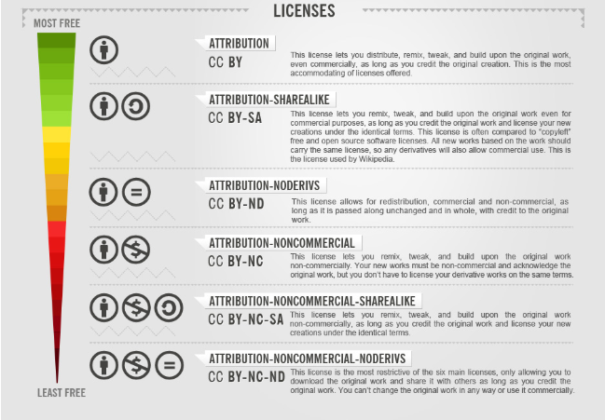
Creative Commons licenses by Foter (CC-BY-SA)
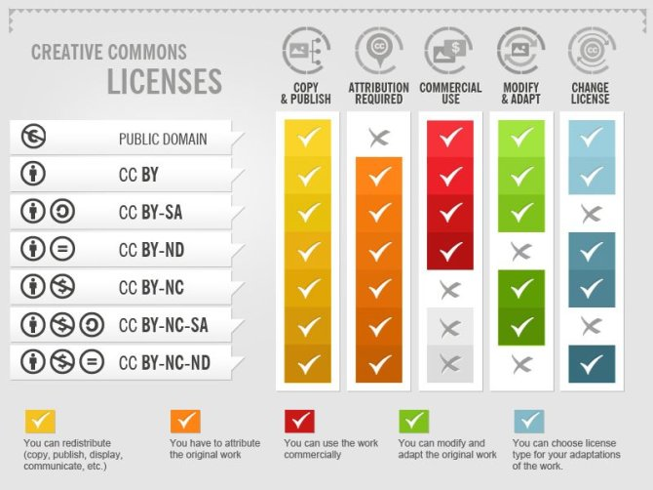
Creative Commons licenses by Foter (CC-BY-SA)

III.IV What are open educational resources (OER)?
Open Educational Resources are part of the changes that education has undergone, as they make knowledge more accessible through the web, allowing anyone to benefit from them or make use of them. “Open Educational Resources (OER) are learning, teaching and research materials in any format and medium that reside in the public domain or are under copyright that have been released under an open license, that permit no-cost access, re-use, re-purpose, adaptation and redistribution by others.” (UNESCO, n.d).
OERs are teaching and learning materials that: i) are freely accessible, ii) exist in the public domain, and iii) are published under an open license allowing users to reuse, revise, remix, retain, and redistribute them. These concepts were developed by David Wiley, a professor at Brigham Young University (Wiley, 2014), and are commonly known as 5R activities (Wiley, 2014). The nonprofit organization Creative Commons provides the following definition of open educational resources (OER): “Open Educational Resources (OER) are teaching, learning, and research materials that are either (a) in the public domain or (b) licensed in a manner that provides everyone with free and perpetual permission to engage in the 5R activities.”
OERs do not necessitate the payment of royalties or licensing fees, allowing users to reuse or adapt the content without prior permission from the copyright holder. (Olivier & Rambow, 2023).

III.V What role do Creative Commons licenses play in OER?
Creative Commons licenses play a very important role in Open Educational Resources, as they allow access to materials that contribute to education and human development. With these licenses, educators can use valuable existing resources that support quality learning for students. “Creative Commons licences are the ones most frequently used when OER content is produced.”(Levey, 2020).
These licenses also allow resources to be modified, making it easier to update or adapt existing materials to different needs in education. In addition, they give anyone the opportunity to access and use these resources, not only to gain knowledge but also to support their personal growth.
Creative Commons and other organisations discuss OER in the context of five key points called the five Rs – reuse, retain, revise, remix, and redistribute.[1] Retain, reuse, and redistribute mean that users have the right to download, distribute, and keep the content without requesting permission from the resource creator. Revise and remix mean that the user may change the content in some way without asking permission. As an example, the stories on African Storybook and Storyweaver can be reused, retained, revised, remixed, and redistributed. At the tertiary level, all OER Africa content carries a CC BY licence. (Levey, 2020).
When sharing Open Educational Resource, both the licence and the file format are important. Text files like Word are easy to edit, but PDFs are harder. Videos are the most difficult to change, even if the licence allows it.
For example, some institutions have a licence that lets them adapt videos, but many institutions or teachers don’t have the tools or skills to do so. Because of this, creators should choose both the right licence and the best format for their work. Some organisations want to maximise distribution but are reluctant to permit adaptation of their resources because of potential problems this might create. Others have no objection to their resources being adapted, but those resources are in a format that cannot be easily revised. Still other organisations are unwilling for their content to be reproduced and monetised by commercial publishers, either for ethical reasons or because it might jeopardise their own financial sustainability. This suggests that we need flexible, less prescriptive definitions of OER that will remain relevant for different contexts and needs and that allow people and organisations to move towards greater degrees of openness in ways that work best for them.

III.VI Why is 'open education' important?
Open Education has the potential to make education more accessible, enable the creation of relevant teaching and learning materials, improve the quality of content, and empower learners to be critical thinkers and knowledge creators. Open Education Week (OE Week), held annually, is an opportunity for actively sharing and learning about the latest achievements in Open Education worldwide.
OE Week provides practitioners, educators, and students with an opportunity to gain a greater understanding of open educational practices and be inspired by the OE community.
The term ‘Open Education’ is often used when discussing open educational resources (OER). However, the term more broadly refers to a commitment to remove unnecessary barriers to access learning while seeking to ensure high-quality educational experiences that will enable success both during and after studies. This commitment includes developing policies and practices of openness in entry requirements (with minimal or no restriction on qualifications), choice of courses, place of study, and time, and so on. An open education approach can inform practice in face-to-face education, distance education, and online and blended learning.[1]
An important element of openness is licensing. Legal frameworks such as Creative Commons help to govern how open a resource is. These licences provide mechanisms to ensure that authors of materials can retain acknowledgement for their work while allowing it to be shared, can restrict commercial activity, and can aim to prevent people from adapting it if they so wish. Open licensing creates possibilities for teachers and learners to access teaching and learning materials that they may not otherwise have been able to access. While e-books for the academic market are becoming more widely available, especially since the COVID-19 pandemic, unaffordable prices, an inability to buy e-books due to a refusal to sell or bundling of titles in packages, and restrictions on research copying are affecting coursework and research in universities. (Gogh, 2020).

Benefits of using cc-licensed open educational resources (OER) in education.
Creative Commons licenses in OER offer many benefits in the educational field, as they provide accessibility, flexibility, adaptation, modification, variety, updating, and lower costs for educational resources. Moreover, they give authors a global reach, allowing their content to be shared widely and their knowledge to be used for different purposes.
According to Misra, in Creative Commons Licenses: Benefits and Implications in Teaching and Research (2020), these are some of the benefits of Creative Commons licenses.
- Don't depend on few resources for teaching, select from a variety of resources. Educationists across the globe have released thousands of useful OER related to different disciplines and subjects at school and higher education level. (Misra, 2020, p.207) Besides that, the most notable aspect about OER is that these are released under CC licenses and contained in digital media collections, and easily accessible via search engines and OER repositories. In a way, these OER offer many opportunities and possibilities for teachers to make their teaching more meaningful and promote learning outcomes.
- Don't create content always, plenty of content is already available. Instead of creating content first, teachers can initially search for relevant content released as OER. And if available, then they can use that content instead of creating a new resource. This measure is supposed to save their precious time and energy.
- Don't use only one type of content, mix contents to create multi-media content. OER allows teachers to createmulti-media reading materials containing text, audio, video, animation, exercises, and many more. The reason is that OER released under the appropriate CC licenses allows users to modify and mix different resources and create a new resource to fulfill teaching-learning needs.
- Don't depend on contents from a particular language, translate them in your language. OER offers a solution to this problem. Teachers can first search the relevant OER related to their subjects. Afterward, they can easily translate identified OER into the preferred languages of their students. This measure is significantly helpful for teachers to overcome the lack of quality material for teaching and learning in local languages.
- Don't keep your resources to yourself, publish them for global use. CC licenses allow one to declare two things at a time. First, this idea or creation belongs to me, which means I have a copyright of the work. Second, I allow others to use my work freely for teaching and learning purposes, but they have to adhere to the terms and conditions of the user license.

IV. DESCRIPTION OF THE ACTIVITIES
Module I “Online Foreign Languages Teaching”
The first module of the specialization course was based on theories of learning in virtual environments, including the use of Learning Management Systems (LMS). Another point was to learn how to use a virtual classroom, allowing the creation of asynchronous activity platforms, such as Moodle, or the development of synchronous activities using platforms like Google Meet or Microsoft Teams.


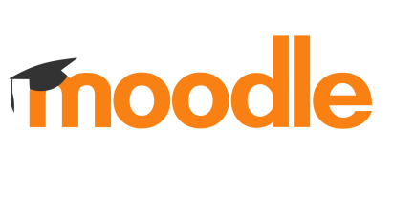

Images were taken from Google Images. © Credits belong to the rightful owners. See references for more information.
Week 1 and 2
In the first class, students introduced themselves using the Padlet tool, where everyone wrote and shared a bit about themselves. Also, the teacher took some time to explain the class policies, session times, and provided an overview of what the overall program would look like for Module I. Moreover, the facilitator shared the answers of students who participated in a social forum on campus. Additionally, the instructor introduced some important learning theories relevant to virtual environments, such as behaviorism, cognitivism, and constructivism. To conclude the first class, students watched a video about these theories and discussed the most relevant information as a group.
In the second class, teachers showed a video about Learning theories. At the end of the class, the facilitator divided the group into small teams to complete an activity. This activity involved watching videos related to the class topic and then presenting using the tool Google Slides the key information to the whole class.
In the second week, the professor started the class by explaining the learning theories. Additionally, during this session, the differences between asynchronous and synchronous learning. To support student engagement and collaboration, Google Slides was used as a digital tool for group activities. This allowed students to create a presentation that provided information and practical insights into the differences, advantages, and disadvantages, and to work together in real time or asynchronously. In addition, the guidelines were provided for the first evaluated task, which involved a forum discussion. Students were required to respond to and discuss some questions.
Week 3 and 4
The professor gave information, and videos were presented about Learning Management Systems (LMS), what it is, why it is important, among other information related to the topic. Furthermore, the instructor explained a significant tool called Pixabay. It is a tool used for searching and downloading free images, and also shows how to create a course in Moodle. Participants practiced adding classmates and some materials to their course.
In addition to Learning Management Systems, the module also covered a variety of educational technology tools designed to enhance teaching and learning experiences. Some of the tools introduced included Padlet, Kahoot, Canvas, among others. Each tool was presented with examples of how it can be used to foster interaction, collaboration, and engagement in both synchronous and asynchronous learning environments.
Finally, the teacher introduced the second evaluated activity, students were required to use Canvas to create an infographic about a selected Learning Management System (LMS). The infographic had to highlight the LMS’s key features, advantages, and disadvantages.
Week 5 and 6
During the week, undergraduates began learning how to use Google Classroom, and students engaged in practical group work using Google Classroom. As part of the activity, each group was tasked with creating a virtual class where they practiced key functions such as posting a forum discussion, sharing a video with their students, creating an assignment, and adding participants to their class. The groups collaboratively developed their virtual classes, preparing to present their work in a live session. At the end, the facilitator presented guidelines to the third evaluation activity.
Week 7 and 8
Students presented and explained their evaluated group activity during a live session on Google Meet. The task involved the creation of a virtual class in Google Classroom.
As part of the assignment, each group was required to organize and include at least four resources, such as YouTube videos, web page links, and other relevant materials, to support their lesson.
In addition, they had to incorporate four core activity types available in Google Classroom, like Forum (Question), Assignment, Quiz, and Material.
During the week, the professor showed a video about other useful tools, such as Google Meet and Microsoft Teams. Its features include video playback, breakout rooms, customizable backgrounds, reactions, screen sharing, and more. Making it a versatile platform for live virtual instruction. Students were practicing using the Meet calendar, how to schedule students, create surveys, add backgrounds (visual effects), and the use of breakout rooms.
In the final evaluated activity of Module 1, students were required to develop and deliver a short virtual class using the Google Meet platform and other didactic resources. During this session, each group presented on different English-related topics, integrating a variety of didactic resources and tools introduced throughout the module.
Module II “Educational Applications for Learning for learning a Foreign Language ”
In this second section of the course, students were able to manage and learn about theoretical fundamentals and the use of technological tools for teaching and learning a foreign language in a virtual modality. Additionally, this module explained concepts related to the use of artificial intelligence in education and immersive learning to create interactive educational environments. Some useful tools taught in this module were: Liveworksheets, Powtoon, Nearpod, Padlet, Classroom Screen, Gamma, Narakeet, and CoSpaces Edu.
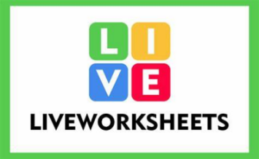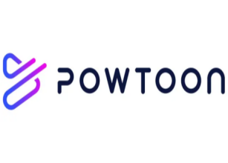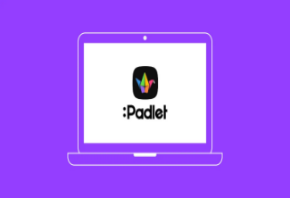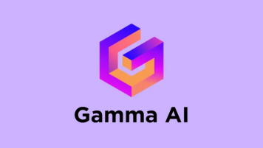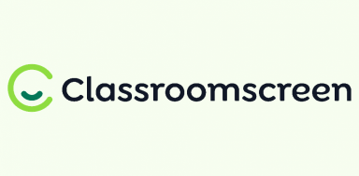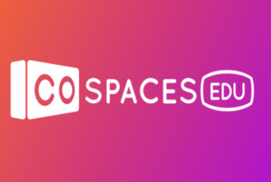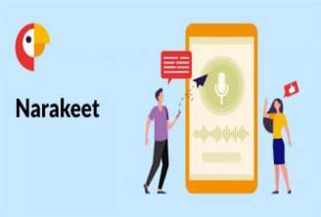
Images were taken from Google Images. © Credits belong to the rightful owners. See references for more information.
Week 1 and 2
During the first week, the teacher explained “The use of technology in an online class”, and an activity was developed by students in order to practice the TPACK Model, which is a framework that identifies the knowledge teachers need for effective educational technology integration. It highlights the intersection of three primary forms of knowledge—Content Knowledge (CK) (what to teach), Pedagogical Knowledge (PK) (how to teach), and Technological Knowledge (TK) (how to use technology). The students created a presentation in groups about what they understood from a video the teacher played during the class. Moreover, students learned about how to use the tool Liveworksheets. First, the teacher incorporated a presentation and a video about the management of this tool.
In the second week, to continue developing meaningful learning, the professor assigned a synchronous practice on how to create an interactive worksheet on Liveworksheets. The activity was carried out in groups; the students had to create 5 items about a topic of general culture. Additionally, the tutor assigned the first task; therefore, students had to create a video explaining how to create a worksheet on Liveworksheet. Furthermore, students learned about how to use Classroomscreen, and there was a practice using it during a class. Besides, students learned about how to use a new tool (padlet), which is an online platform that functions as a digital bulletin board or a virtual post-it wall, allowing users to collaboratively create and share digital content such as text, images, videos, links, and documents. The tutor played a video about how to use it.
Week 3 and 4
In week 3, the participants learned: How AI Is Impacting Teaching and Learning, Ethical AI for Teaching and Learning, APA Guidelines on How to Cite ChatGPT. Moreover, they were taught more about Artificial Intelligence; the tutor presented a video to understand more about the concept. During the class, they learned how to use Gemini, ImageFx, and Padlet, where the students practiced and showed their work during the class. Moreover, learners were taught about the tools Narakeet, which is an online platform for automatically converting presentations, scripts, and other text into narrated videos and audio files using AI-powered text-to-speech technology. The tutor explained the use by using a video and then assigned an activity to practice in the tool, and also students learned about Wordart.com, which is a meaningful platform to use to create creative lesson plans.
In the fourth week, participants developed the second task; they created a video using the platform Powtoon. The tutor covered the use of the tool Powtoon and Narakeet. Additionally, students developed a practice about it, and they presented their work.

Week 5 and 6
In week 5, the tutor developed the topic Immersive Learning for English Teaching Students; she came up with a presentation. Furthermore, learners grasped the tool Delightex, which is a 3D creation and coding platform, formerly known as CoSpaces Edu, that allows users to build, code, and explore interactive virtual and augmented reality (VR/AR) experiences. The participants practice in groups during the class by using Delightex.
In week 6, students continued learning about Artificial Intelligence, and they developed the third task, where they had the opportunity to demonstrate their mastery and good use of technological tools that they learned to utilize during the previous weeks. Learners had the chance to work in groups on the Delightex Platform, and some videos about the use of the platforms were played. Moreover, students presented in groups a topic using different platforms like Miro, Narakeet, Padlet, and Nearpod.
Week 7 and 8
During week 7, students continued to present their work using the different platforms mentioned in week 6. In addition, the tutor assigned the last evaluation of Module II. During the classes, learners were practicing on the Delightex platform in order to carry out the last activity.
Thus, in week 8, students conducted a class where they developed some activities in the Delightex platform.

MODULE III “Design of Didactic Materials for Virtual Environments.”
This module introduced students to a variety of digital tools for creating multimedia resources. They worked with Google Slides for presentations, Adobe Podcast and Soundcloud for podcasts, Pixabay, ReduceImages, and PiZap Photo Editor for images, and Genially for interactive images, they also explored Google Vids.
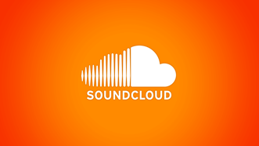

Images were taken from Google Images. © Credits belong to the rightful owners. See references for more information.
Week 1 and 2
The tutor explained the syllabus and all the activities that would be carried out during Module III. The tutor showed a video about multimedia resources and provided the instructions for the assigned practice. The students were divided into three groups, and each group created a presentation in Google Slides and practiced recording audio using their cell phones or computers, which they then inserted into the Google Slides tool.
In the second meeting, the teacher showed some examples of podcasts, introducing the next activity in which the students would be working. To support this, the facilitator presented some key elements for recording a podcast and explained some of the advantages of using podcasts in education. Finally, the tutor explained that the students would be using the Adobe Podcast tool to create their podcasts.
The third class started with a tutorial video on how to use Adobe Podcast. Students had the chance to practice on their own and explore the tool. Finally, the teacher explained Task 1.
The fourth class started with a presentation about the use of images. For practice, students downloaded three images from Pixabay and resized them using the tool ReduceImages. They also navigated the tool PiZap Photo Editor as individual practice and later shared their work. The tutor then explained the written report activity in detail and answered all of the students’ questions. Finally, the tutor concluded the session by showing a video on how to properly attribute images.
Week 3 and 4
The fifth class began with the selection of topics for the written report. A review of the written report was carried out, and some examples were shown. The session continued with a tutorial video on how to create an interactive image in Genially. Finally, the tutor presented the guidelines for the second assessed activity.
The sixth class began with some important reminders about the written report. Afterwards, a video was shown on how to create an interactive image in Genially. Then, the students practiced individually by creating their own interactive images. Some of them shared their work with the class and received feedback.
The seventh class focused on preparing presentations, taking into account the topics, objectives, and audience. In addition, the students learned about color palettes. To put this into practice, they individually created a presentation in Google Slides with the help of a color palette. To conclude, some students shared their work with the class.
The agenda for the following class included: typography, questions on the written report, and Google presentations. The students learned about the importance of typography for different purposes. In addition, each group had the opportunity to ask the facilitator questions about the written report.
Week 5 and 6
In the class, the students focused on the fundamentals of creating presentations. Students started by editing a photo in Photophonia. Then, they were introduced to the use of Google Site and explored different tutorials that explained the main features and functions of the tool. As practice, they worked on creating their own slides in groups. The teacher explained the guidelines for the integrative assignment.
Week 7 and 8
The students focused on the fundamentals of video production. They were introduced to different examples of video editors through tutorials, and websites, which gave them a clearer idea of the tools available for editing. Afterwards, the tutor explained the use of smartphones for video recording, showing how students could apply accessible technology in their projects. The students then explored Google Vids, supported by tutorials, and online resources to guide their learning.

V. ACHIEVEMENTS OF THE SPECIALIZATION COURSE IN THE ADMINISTRATION OF VIRTUAL ENVIRONMENTS FOR FOREIGN LANGUAGES TEACHING AND LEARNING
The specialization course in the administration of virtual environments for foreign languages teaching and learning has equipped learners with the skills to effectively leverage technology for language acquisition. The main achievements of such a course center on developing pedagogical expertise in a digital context, promoting learner engagement, and creating immersive, effective learning experiences.
Key Achievements
- Students master many virtual teaching tools since the course provided practice with various educational technologies, including Learning Management Systems (LMS) like Moodle, and video conferencing platforms (e.g., Google Meet). Students learnt to select, implement, and manage tools to create interactive virtual classrooms.
- Increased Student Engagement and Motivation: By integrating elements like gamification and interactive multimedia, students learnt to make learning more engaging. Virtual Reality was one of the most enjoyable and interesting; the platform Delightex offers tools for individuals and educators to build their own immersive digital content. Generally, the course teaches how to use virtual worlds and interactive content to capture student interest and improve motivation.
- The students learned different concepts related to pedagogy and how they can teach and work virtually as synchronously and synchronously.
- Students learned how to create podcasts for educational purposes. Podcasts consist of digital audio recordings that can be edited, published, and shared online to reach a wide audience. By using tools such as Adobe Podcast for editing and SoundCloud for hosting, students discovered how podcasts can be used to present information in a dynamic and accessible way within virtual learning environments. As future teachers, this is something that will help them make the learning experience more meaningful.
- Students developed skills in designing interactive images using Genially. This tool is an online platform that allows the creation of interactive and animated resources, combining text, images, links, and multimedia elements in a single presentation. Through this tool, students recognized how interactivity enhances learning materials by making them more engaging and visually appealing.

VI. CONCLUSIONS
Finally, this course has empowered students to confidently navigate the complexities of online language teaching and learning. Therefore, the completion of the course "Administration of Virtual Environments for Foreign Languages Teaching and Learning" is a significant step toward this degree, as it provides a crucial and modern skill set for a future language educator.
- Everybody knows that the world is updating every day, and the virtual environment is becoming more and more common; thus, nowadays it is meaningful that teachers as well should update themselves, so this course provided essential and highly relevant skills for a Bachelor of Arts in English with a major in Language Teaching. In an increasingly interconnected and digital world, this competency is no longer an optional add-on but a fundamental requirement for a modern language educator.
- By learning to administer virtual environments, participants have developed the ability to: Create dynamic learning spaces and integrate technology, that is to say, students can now manage tools and platforms to build interactive and accessible virtual classrooms that adapt to diverse learning styles, and also to select and use a variety of digital tools, from learning management systems (LMS) to interactive multimedia.
- Although technology plays a crucial role in education, the active participation of teachers remains essential. Therefore, it is essential to emphasize the importance of the proper use of technology. The integration of virtual tools can promote excellent results, especially in the teaching and learning of the English language. During this course, students learned and demonstrated the use of new tools, such as creating podcasts, creating videos with audio, and interactive images, among others.
- To conclude, this course emphasized the fundamental role of technological tools in enriching educational materials and increasing student participation. Students developed their skills, demonstrating their ability to use and create content with the different tools taught in the course in order to adapt and innovate in the educational environment. However, it is essential that these tools be used ethically and function as a complement, not a substitute, for the human contributions of educators and learners. Therefore, the thoughtful and responsible integration of technology into virtual environments is indispensable for enriching the teaching and learning process, especially in the context of English language teaching.

VII. RECOMMENDATIONS
To the authorities of the Foreign Languages Department:
- Enhance the quality of online instruction and ensure the program stays current with digital education trends. Establish a formal training program in which the faculty can develop in a virtual environment and use digital tools. They should focus on best practices for online language acquisition, like fostering community and engagement in a virtual setting.
- Invest in institutional support and licenses for educational platforms. Access to updated resources will guarantee equal opportunities for all students to engage with digital tools.
To the authorities in charge of the specialization course:
- Continue to encourage the incorporation of innovative digital tools (such as Moodle, Adobe Podcast, Genially, and Google Vids) in future modules. These tools should be integrated as part of a long-term strategy to strengthen digital literacy and multimedia skills across the curriculum.
To the professors of the Foreign Languages Department:
- Establish policies for digital ethics that emphasize responsible use of Creative Commons licenses, copyright, and attribution practices, ensuring that students and faculty apply these principles consistently in their academic work.

VIII. BIBLIOGRAPHY AND IMAGE CREDITS
- Ellis, M. (2024, 10 enero). How to force a refresh/rebuild of Microsoft Teams client cache. Medium. https://medium.com/365uc/how-to-force-refresh-rebuild-of-microsoft-teams-client-cache-e92b7739fca3
- TuCalendi. (2021, 28 mayo). Ahora puedes programar eventos en Google Meet con TuCalendi. TuCalendi. https://www.tucalendi.com/es/blog/programar-eventos-google-meet-163
- Fernández, A. (2020, 13 abril). Moodle: qué es y cómo funciona. El Grupo Informático.
https://www.elgrupoinformatico.com/tutoriales/moodle-que-como-funciona-t77239.html
- Google Classroom | Copnor Primary School. (s. f.).
https://copnorprimary.co.uk/our-school/google-classroom/
- ¿Qué es Liveworksheets y cómo crear fichas interactivas paso a paso en 2025? (s. f.). https://blog.iobit.com/es/que-es-liveworksheets-y-como-crear-146
- Edwards, L. (2022, 28 february). What is Powtoon and How Can It Be Used for Teaching? Tips and Tricks. Tech & Learning. https://www.techlearning.com/how-to/what-is-powtoon-and-how-can-it-be-used-for-teaching-tips-and-tricks
- Team, N. (2023, 27 June). Technology in the Classroom: Nearpod by Daniel Barkes. Nearpod Blog. https://nearpod.com/blog/technology-classroom-nearpod/
- ClassPoint. (2023, 18 December). How to use Padlet and 5 ways to implement it into your classroom - ClassPoint Blog | ClassPoint. https://www.classpoint.io/blog/how-to-use-padlet
- Edwards, L. (2024, 17 July). Gamma: How to Use It to Teach. Tech & Learning. https://www.techlearning.com/how-to/gamma-how-to-use-it-to-teach
- Classroomscreen. (s. f.). ADIGITAL. https://www.upv.es/contenidos/adigital/classroomscreen/
- CoSpaces AR/VR Programming Course – Steam Academy. (s. f.). https://steamacademy.hk/en/courses/cospaces-ar-vr-programming-course/
- Hill, J. (2025, 3 September). Narakeet Reviews: Great AI Text to Speech Generator Online. https://www.hitpaw.com/ai-video/narakeet-text-to-speech.html
- BC OER. (2015). Faculty Guide to Evaluating Open Educational Resources. Available online on the BC campus.
- http://lms.nba.co.za/pluginfile.php/3329/mod_resource/content/1/OER%20E evaluation%20Faculty-Guide-22-Apr-15.pdf. (CC BY)
- Clark, S. (2016). Online Research: Tips for Effective Search Strategies. Available on YouTube: https://youtu.be/LTJygQWYV84. (CC BY)
- Commonwealth of Learning. (2015). OER Search Techniques. Available on YouTube: https://youtu.be/EVK-V2cHYk. (CC BY-SA)
- https://www.oerafrica.org/content/why-open-education-important
- Open Educational Resources (OER): 5 Rs of OER. (n.d.). Retrieved August 23, 2020, from https://nsufl.libguides.com/oer/5rs
- Open Educational Resources: Basics & Beyond Copyright © 2021 by O
- lahoma Council for Online Learning Excellence (COLE) Member Volunteers is licensed under a Creative Commons Attribution 4.0 International License, except where otherwise noted.
- Oklahoma Council for Online Learning Excellence (COLE) Member Volunteers. (2021, 23 abril). Understanding OER. Open Educational Resources: Basics & Beyond. https://open.ocolearnok.org/learnoer/chapter/chapter-1/#:~:text=1994%20%E2%80%93%20Wayne%20Hodgins%20coined%20the,modify%2C%20or%20redistribute%20the%20material
- UNESCO. (2019) Open educational resources. https://www.unesco.org/en/open-educational-resources
- Wageningen University and Research. (n.d). https://www.wur.nl/en/article/what-are-creative-commons-licenses.htm
- Foster blog. (March 4, 2015). How to Attribute Creative Commons Photos. https://foter.com/blog/how-to-attribute-creative-commons-photos/
- Misra. P.K. (2020). Creative Commons Licenses: Benefits and Implications in Teaching and Research. https://www.researchgate.net/publication/357793497_Creative_Commons_Licenses_Benefits_and_Implications_in_Teaching_and_Research

IX. APPENDIXES

