UNIVERSITY OF EL SALVADOR
SCHOOL OF ARTS AND SOCIAL SCIENCES

DEPARTMENT OF FOREIGN LANGUAGES

TOURIST SERVICE: “LUNA TOURS”
PRESENTED BY:
MARIA DINORA GONZÁLEZ ALFARO (GA09096)
VICTOR MANUEL HERNÁNDEZ SALINAS (HS17032)
FINAL REPORT OF SPECIALIZATION COURSE ON TOURISM
IN ORDER TO OBTAIN THE DEGREE OF:
BACHELOR OF ENGLISH TEACHING
SPECIALIZATION PROFESSOR
LICENCIADA FRANCISCA AGUILLÓN RIVERA
GENERAL COORDINATOR OF THE GRADUATION PROCESS
LICENCIADO MIGUEL ÁNGEL CARRANZA CAMPOS, MSE
UNIVERSITY CAMPUS, DR. FABIO CASTILLO FIGUEROA, SAN SALVADOR
CENTRO, EL SALVADOR, CENTRAL AMERICA, OCTOBER 30TH, 2025

AUTHORITIES OFTHE UNIVERSITY OF ELSALVADOR
MSC. JUAN ROSA QUINTANILLA QUINTANILLA
RECTOR
DRA. EVELYN BEATRIZ FARFAN MATA
VICE-RECTOR
MSC. ROGER ARMANDO ARIAS ALVARADO
ADMINISTRATIVE VICE-RECTOR
LIC. PEDRO ROSALIO ESCOBAR CASTANEDA
GENERAL SECRETARY
LICDA. ANA RUTH AVELAR
DEFENDER OF UNIVERSITY RIGHTS
LIC. CARLOS AMÍLCAR SERRANO RIVERA
PROSECUTOR GENERAL AUTHORITIES OF THE SCHOOL OF ARTS AND SCIENCES
MSC. JULIO CESAR GRANDE RIVERA
DEAN
MSC. MARIA CRUZ JURADO
VICE-DEAN
MSC. NATIVIDAD THESHÉ PADILLA
SECRETARY OF SCHOOL OF HUMANITIES AUTHORITIES OF THE DEPARTMENT OF FOREIGN LANGUAGES
LIC. JOSÉ ISRAEL OLIVA
INTERIM COORDINATOR OF THE FOREIGN DEPARTMENT
LIC. MIGUEL ÁNGEL CARRANZA CAMPOS, MSE
GENERAL COORDINATOR OF THE GRADUATION PROCESS
LICDA. FRANCISCA AGUILLÓN RIVERA
SPECIALIZATION PROFESSOR

Abstrac 6
Introduction 7
CHAPTER I: 9
1.1 Objectives 10
1.1.1 General Objective: 10
1.1.2 Especific Objectives: 10
1.2Justification 11
1.3Description of the tourist service: 12
1.3.1 Peculiarities of Night Tours 12
1.3.2 Specific market segment 12
1.3.3 Attractive tourist packages 12
1.3.4 Affordable Schedules and Prices 12
CHAPTER II 14
2.1 History of Tourism 15
2.2History of Tourism in El Salvador 19
2.3 Natural Resources of the destination areas, location on the tourist map of El Salvador. 22
2.3.1 El Boquerón National Park 22
2.3.4 Walter Thilo Deininger Surf City Adventure Park 23
2.3.5 Apulo Recreational Park 25
2.3.6 Balboa Natural Park 26
2.3.7 Coastal area of ​​El Salvador (La Libertad and La Paz): 28
2.4 Location on the tourist map of El Salvador 29
2.5 Local Soil Types in El Salvador 30
2.6 Cultural Identity of El Salvador 35
2.6.1 Language 36
2.6.2 Cultural and Religious Festivals 36
2.7 Syncretism in El Salvador and Intangible Tourism Resources 41
2.7.1 Cultural Syncretism in El Salvador 42
2.7.2 Syncretism in El Salvador and Intangible Tourism Resources 42
2.8The Sustainable Development Goals (SDGs) 47
2.8.1 Sustainable Development Goals (SGs) and Principles for Luna Tours’ Night Tourism in El Salvador 54
2.8.2 Quality Control Strategy Plan of Luna Tours 57
2.8.3Customer Satisfaction Strategic Plan 59
CHAPTER III 63
3.1 Entrepreneur Profile 64
3.1.1 Social responsibility of the entrepreneur 66
3.2 Market Niches 68
3.2.1Definition 69
3.2.2 Types of Market Niches 70
3.2.3 Importance of Focusing on Market Niches 71
3.2.4 Key Elements for Selecting an Effective Market Niche 72
3.2.5 Strategies for Incorporating Market Niches into Luna Tours (El Salvador) 73
3.2.7 How This Approach Can Generate Integrated Niche Strategies for Luna Tours 74
3.3.1 Logo 76
3.4.1 Slogan 77
3.5.1 Mission 77
3.6.1 Mission 77
3.7.1 Values 78
4.1 References 79

Abstrac

Luna Tours emerges as an innovative Salvadoran tour operator focused on nighttime tourism experiences designed to promote cultural identity, sustainable development, and local entrepreneurship. Grounded in an ethical and socially responsible business philosophy, the project integrates creativity, adaptability, and community collaboration to deliver high-value, immersive travel services. Its strategic vision centers on curated night-themed tours such as wellness escapes, astronomical observation, cultural folklore experiences, and eco-night adventures that serve specific market niches previously underserved in El Salvador
By emphasizing specialized customer interaction, environmental stewardship, and partnerships with local businesses, Luna Tours strengthens territorial development and generates inclusive economic opportunities. Through targeted segmentation, personalized experiences, and innovation-driven strategies, the company positions itself as a transformative agent in the tourism sector, capable of enhancing national competitiveness and elevating El Salvador’s image as a sustainable, culturally enriched, and experiential travel destination.

Keywords: Sustainable tourism; niche strategy; cultural identity; experiential travel; local development.

Introduction

The tourism sector has experienced tremendous growth in recent years across the continent, and El Salvador is no exception. The importance of tourism is essential for tourism companies, small businesses, and entrepreneurs who provide tourism products and services. This is why Luna Tours, a tour operator, has emerged in the market to offer tour packages to people who enjoy experiencing, traveling, recreation, and appreciating natural and cultural heritage, focusing on nighttime tourism. This is primarily aimed at those who are busy during the day with work or studies, making it difficult for them to travel during the daytime, or simply those who love nightlife.
The first chapter highlights the objectives set by Luna Tour, its justification, the description of the tour packages offered showing the tourist attractions that will be visited in the future, and also the schedules adjustable to the budget and time of each tourist, in addition to describing the peculiarities of doing night tourism.
The second chapter highlights the theoretical richness on tourism, such as the history of tourism in general, the history of tourism in Latin America and in El Salvador; likewise, it highlights the important tourist destinations in our country which are in the surroundings of San Salvador which are the point of origin of each tourist route offered by Luna Tours.
Chapter three highlights the entrepreneur's profile, the characteristics and principles that govern Luna Tours; it also emphasizes the entrepreneur's social responsibility, identifies Luna Tours' market niche, and points out the importance of identifying market niches in the tourism sector.
Finally, the Luna Tours logo and slogan are displayed, which seeks to capture the tourist's attention, as well as the mission, vision and values ​​that make the Luna Tours unique and respectable.

CHAPTER I:

PROFILE OF A TOURISM PRODUCT OR SERVICE

1.1 Objectives

1.1.1 General Objective:

- Implement nighttime tourist packages focused on the segment of people who work or study during the day.

1.1.2 Especific Objectives:

- Develop unique nighttime experiences that merge natural beauty, cultural value, and wellness practices, ensuring short but transformative activities that generate a true disconnect from the work routine.

- Consolidate collaborative networks with local entrepreneurs and businesses through strategic alliances that promote sustainable tourism and local economic development.

- Provide a comprehensive nighttime mobility system that prioritizes tourist safety, efficiency, and comfort, reinforcing service quality and raising the standard of the post-workout tourist experience.

Justification

Today, the need for tourism has become a necessity; therefore, the implementation of various products and services has become an important investment opportunity in the current tourism sector. People often travel to escape work and stress, and they are constantly looking for recreational and leisure options. This is where the idea of ​​offering our tourism service, a tour operator, was born. This service is geared toward offering tourist packages that meet the tourism demands of the established market segment.
The service will be geared toward meeting the needs of those seeking relief from the work and academic stress of the day or week. For this reason, dynamic and recreational activities are designed throughout the tour so that tourists feel comfortable from the moment they board the bus and the fun begins from the moment they begin their journey. Some tours will also sometimes cover meals, accessible meeting points, etc.
The service will be designed with an "after-work" theme to identify the target market as people who don't have time for sightseeing during the day and can do so at night.
Based on the above, the implementation of this tourism service, in addition to generating leisure and recreation, will also improve the mental health of tourists and help combat stress.

Description of the tourist service:

Peculiarities of Night Tours

The service that Luna Tour attention offers is geared toward attracting tourists by offering nighttime tourist services, generating exciting tourist circuits that promote nightlife to unique places of common interest that are often difficult to access on your own.

Specific market segment

The market segment is well-defined, as it is geared toward people who perform academic or work activities during the day and, for this reason, would opt for nighttime tourism under the "after-work" theme.

1.3.3 Attractive tourist packages

Offering attractive tour packages will be a draw, as creating tour packages of common interest will help you better sell your service. For example, tour circuits to places with nightlife, such as beaches, viewpoints, beach clubs, the historic centers of different cities, etc. Occasionally, tours will be designed to include a variety of destinations in a single trip.

Affordable Schedules and Prices

Luna Tour offers schedules tailored to the availability of tourists at different times, such as 4:00 pm, 5:00 pm, and 6:00 pm, so that visitors can explore the city after work or school hours. Departure points are always tailored to meet the needs of tourists. Prices are also affordable, and sometimes promotions are available, such as two for the price of one; as well as dynamic offers and discounts through social media interactions, etc.

CHAPTER II

ELEMENTS FOR THE DESIGN OF A TOURISM PRODUCT OR SERVICE.

2.1 History of Tourism

Today, tourism has become an economic source for most nations around the world through tourism developments in every town. Over time, tourism has evolved, and it is therefore important to understand the history of tourism. The University of Girona, Spain (2007), "The Origin of Tourism: Let's Get Historical," notes:

The Origin
In the early 1930s, one of the first theorists of the German School of Tourism Studies, Arthur Bormann, defined tourism as the set of trips made for pleasure, business, and other similar reasons, during which the absence from one's usual residence is temporary. Trips made to travel to a workplace are not considered tourism. According to the OMT, a visitor (domestic, inbound, or outbound) is classified as a tourist (or overnight visitor) if their trip includes an overnight stay, or as a day visitor (or day tripper) otherwise. In other words, a day tripper is a person who visits a destination but does not spend the night there.
The pioneering theorists in tourism, Walter Hunziker and Kurt Krapf, stated in 1942 that "Tourism is the set of relationships and phenomena produced by the movement and stay of people away from their homes, as long as such movements and stays are not motivated by a lucrative activity." Both Hunziker and Krapf come from the St. Gallen school (Switzerland), which proposed the idea of ​​studying tourism as a mechanism centered on the socioeconomic reproduction of a society. Tourism consumption reflects the cultural values ​​of a society.
Tourism in Ancient Rome
Other historical data we can find regarding the beginnings of tourism dates back to the splendor of ancient Rome. Religious and sporting trips continued to be enjoyed, as well as other types of travel, such as health tourism in the spas or the vacations enjoyed by emperors.
During this period, new communication routes began to open up, which patricians and nobles used to go to the beach or explore places throughout the empire. Could this be the beginning of beach vacations?
And, as early as the Middle Ages, pilgrimages to sacred sites began. Jerusalem, Rome, and Santiago de Compostela acquired great importance in the medieval era. Pilgrims hired a guide to guide them along the best route, as well as soldiers to protect them during their journey. These are the first records of organized trips in the full sense of the word.

Contemporary Age
In 1841, Thomas Cook organized the first package tour in history. Although it was a financial failure, it is considered a resounding success in terms of setting a precedent for package tourism, as he recognized the enormous economic potential this activity could offer, thus creating the world's first travel agency, Thomas Cook and Son, in 1851.
World War II completely paralyzed tourism worldwide, its effects lasting until 1949. Between 1950 and 1973, talk of a tourism boom began. International tourism grew at a faster rate than ever before. This development was a consequence of the new international order, social stability, and the development of leisure culture in the Western world. During this period, legislation began to govern the sector.
The economic recovery, especially in Germany and Japan, was astonishing, raising income levels in these countries and giving rise to a wealthy middle class that began to take an interest in travel. The recovery raised the standard of living of the most important sectors of the population in Western countries. The so-called welfare society emerged, in which once basic needs were met, educational attainment and an interest in traveling and cultural exploration developed.
Furthermore, new labor legislation adopting paid vacations, the 5-day English work week, the reduction of the 40-hour work week, and the expansion of social coverage (retirement, unemployment, etc.) greatly boosted the development of leisure and tourism.

Tourism in Latin America
According to the University of Quilmes, Argentina (2018), "Tourism Development in Latin America: Phases, Approaches, and Internalization," it highlights that the beginning of tourism on the continent was in Argentina and mentions that:
For decades, the ups and downs of national politics and the economy allowed tourism, which was not yet politically and commercially organized, to be destined for a limited upper class that, driven by economic power, began to enjoy free time to which they attached great social importance. Initially, due to the absence of tourist centers, they spent their extended summer vacations in their country residences. In this way, demand anticipated supply and led to the rapid emergence of the country's first tourist centers, initially taking advantage of certain natural resources and later sustaining certain milestones.
The starting point is located on the coastal maritime coastline that gave rise to Mar del Plata (1874) as the first Argentine tourist center, and had as its main attraction the maritime climate and the healing properties of the sea.

History of Tourism in El Salvador

Throughout El Salvador's history, important events have emerged, such as the emergence of tourism. Institutions for tourism have also been created:
The ISTU website, in its institutional framework, states:
The Civic-Military Directorate of El Salvador, which had overthrown then-President General José María Lemus, considered it essential that the National Tourism Board have autonomy and legal status, guaranteeing its stability and efficiency in its work. It decreed, sanctioned, and promulgated the Law Creating the SALVADORAN INSTITUTE OF TOURISM, known by its acronym ISTU, on December 13, 1961. This law, attached to the Ministry of Economy, consisted of 50 articles (Official Gazette, December 22, 1961).
In 1963, regulations were established for the classification of hotels into categories from 1 to 5 stars, with the ISTU being responsible for determining these categories.
During the administration of Colonel Julio Adalberto Rivera, the Legislative Assembly, through Decree No. 367, created the Tourism Industry Promotion Law, the objective of which is to promote the tourism industry, including hotels, restaurants, travel agencies, and other similar businesses providing tourism services. At the same time, the NATIONAL TOURISM SYSTEM was created, comprising all companies designated as members by the Salvadoran Tourism Institute.
The National Tourism Board was formed by Mr. Raúl Contreras from 1949 to 1959, who is largely responsible for the construction of several tourism projects. He was the initiator of the Tourist Centers, currently known as Recreational Parks.
In 1996, the ISTU (National Tourism Institute) implemented a decentralized tourism strategy at the initiative of the Central Government to become more competitive globally, with the creation of the SALVADORAN TOURISM CORPORATION.
Under the administration of President Elías Antonio Saca of El Salvador, the Ministry of Tourism, known by its acronym MITUR, was created by Executive Decree No. 1 of May 24, 2004. This institution will be the governing body for tourism matters and will be responsible for determining and ensuring compliance with the National Tourism Policy and Plan. (Official Gazette, June 1, 2004).
On October 2, 2008, the Salvadoran Tourism Institute Law was amended, making it responsible for promoting and encouraging family recreation and hiking with regard to attracting visitors to these centers. The reform of the ISTU Law also has the primary purpose of promoting the country's industrial and cultural development through tourism, strengthening Family Recreation, which stipulates the mental and physical health of Salvadorans, comprehensively meeting the population's recreational needs, and, above all, promoting family unity, as it is the fundamental foundation of society. (Official Gazette, October 30, 2008)
The CORSATUR website, in its institutional framework, states:
The Salvadoran Tourism Corporation, abbreviated as CORSATUR, was established on July 25, 1996, by Legislative Decree No. 719, published in the Official Gazette No. 156, Volume 332, of August 23, 1996. It is an autonomous institution with legal personality and its own assets, with full powers to exercise rights and enter into obligations. It carries out its administrative management with absolute independence, adhering to the decisions of the highest authority, its Board of Directors, which must make them in accordance with the Laws of the Republic and will be fully responsible for its management. The President of CORSATUR will be the Secretary of State for Tourism, who is vested by law with the responsibility of judicial and extrajudicial representation of the Corporation.
The creation of various institutions and the promotion of tourism by the country's various communities have definitely positioned El Salvador as a popular tourist destination. The country's security conditions contribute to the growth of this sector, thus generating greater revenue for the tourism sector.
Over time, the ways of doing tourism have changed. Currently, there are a variety of types of tourism available in the country. Likewise, there are new methods of doing tourism, such as traveling with a travel agency or tour operator, which facilitates logistics and reservation mechanisms that can be tedious for tourists. Nowadays, tourists can easily secure their stay anywhere in the world using a mobile device and online payments.

Natural Resources of the destination areas, location on the tourist map of El Salvador.

El Salvador has a wealth of tourist resources that beautify and contribute significantly to the biosphere. Based on location and schedule, the following tourist destinations are listed that fit the needs of tourists and the tourism focus offered by Luna Tour. This tour service offers tours after work or school hours to relieve stress.
Information provided by the Salvadoran Tourism Corporation on its website.
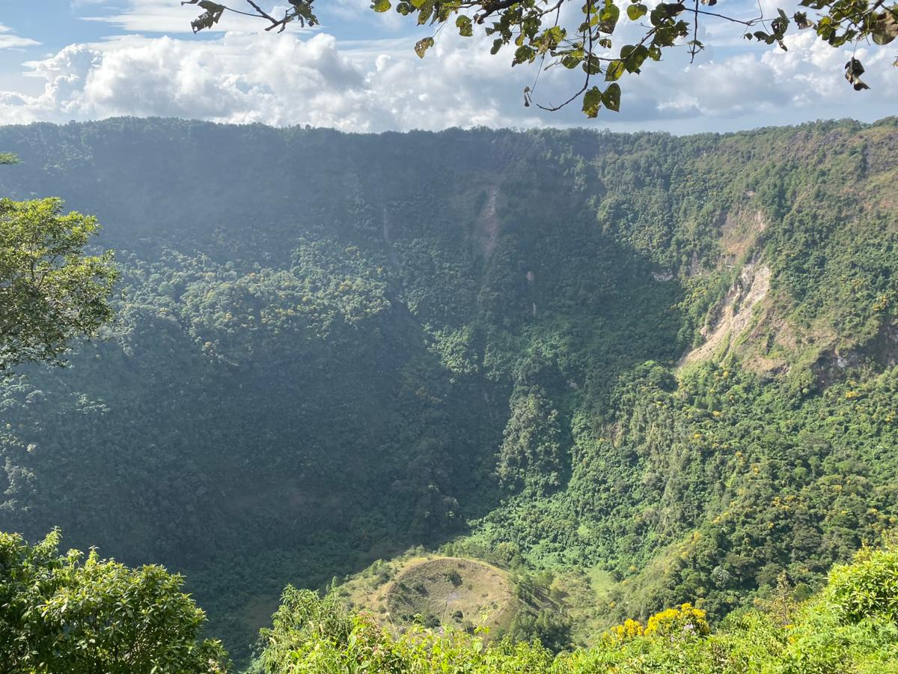
- 2.3.1 El Boquerón National Park:

Illustration 1. El Boquerón National Park, source: ISTU.
El Boquerón National Park is a protected natural area managed by CORSATUR. It is located at the summit of the San Salvador volcano, approximately 1,950 meters above sea level. The temperature there ranges from 18 to 22 degrees Celsius during the day and drops to 12 to 8 degrees Celsius at night.
It has an interpretive center, pedestrian trails, tourist lookout points, visitor restrooms, and parking.
From this location, you will have the most spectacular view of the city of San Salvador, and if visibility is good, you can even see Lake Ilopango. At its summit, there are exotic flower plantations and many other beautiful floral varieties growing wild, as well as cypress and pine trees.
Information provided by the Salvadoran Tourism Institute on its website.
- 2.3.4 Walter Thilo Deininger Surf City Adventure Park:
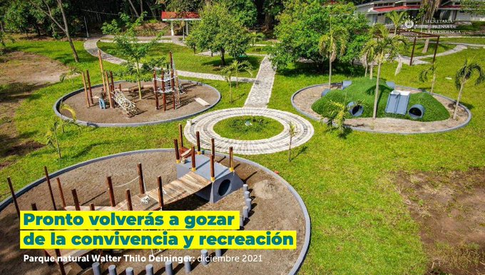

.

Illustration 2. Surf City Adventure Park Walter Thilo Deininger, source: web portal, presidential secretariat.

This park is located 39 kilometers from San Salvador, in the Hacienda San Diego Canton, Km. 55, Carretera Litoral, La Libertad. Covering 1,047 acres of land donated by philanthropist Walter Thilo Deininger, it is within the 21-kilometer tourist zone of national interest, which is being developed through the Surf City strategy to transform public spaces for tourism.
Due to its forest reserve, with a wide diversity of flora and fauna, it has become one of the most important natural spaces in the country, becoming a protected natural area; a biological island where remnants of El Salvador's earliest vegetation can be found. It contains three types of forest: gallery forest, dry forest, deciduous forest, and secondary forest.
This natural site is a model for conducting research in various branches of ecology and environmental science. If you want to immerse yourself in nature, you have the option of taking tours led by specialized guides, starting with the "Mirador al Pacifico" trail with panoramic views of the Pacific Ocean, where you will find a spectacular "Cueva del Encanto" (Cave of Enchantment), which hides a local legend. You will also delight in the trails "La Ruta de la Mariposa" (The Butterfly Route), "Camino a la Aventura" (Adventure Road), with lush landscapes and deciduous vegetation, and the Madre Cacao trail, exclusively for mountain biking and trail runners.

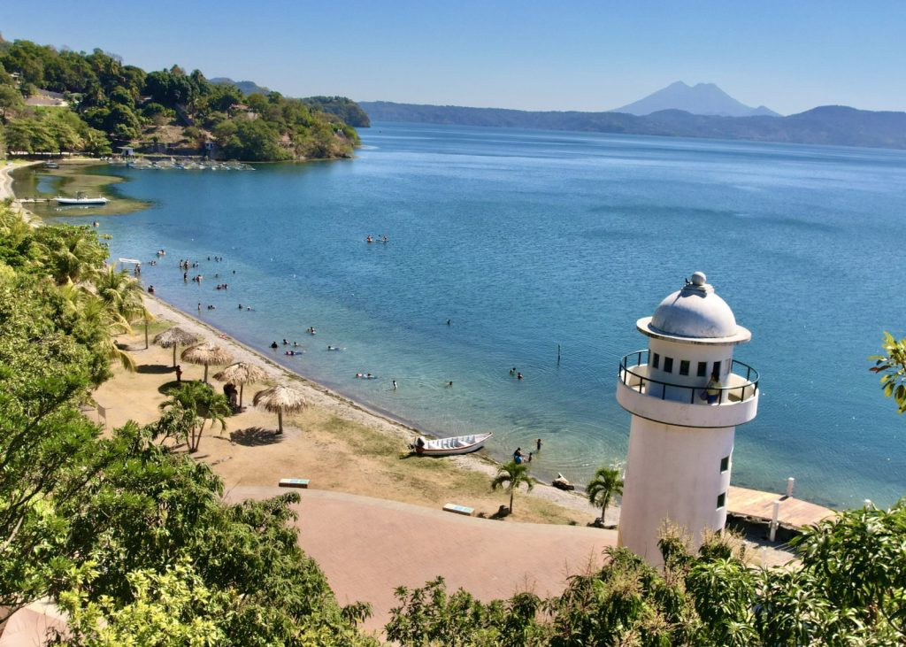
- 2.3.5 Apulo Recreational Park:

Illustration 3. Lake Ilopango, source: El Salvador Travel.

Apulo means "Place that sinks into the water" in Nahuatl; this site is located in the Dolores Apulo Canton, Ilopango, 16 kilometers from the capital, between the departments of San Salvador, Cuscatlán, and La Paz. It covers 42.8 acres of land, 16 of which are developed.
Lake Ilopango, the main attraction of this recreational park, is of volcanic origin. Its crater is located right at the bottom of the lake. According to historical data, the caldera was formed as a result of a cataclysmic eruption, producing enormous pyroclastic flows that destroyed several Mayan cities.
This park's main attractions include a boardwalk, a pier, and an impressive lighthouse. It also offers two swimming pools, ample parking, picnic areas, and restaurants; it also has a modern beach soccer stadium.
Additionally, Lake Ilopango offers a variety of nighttime tourist activities in local restaurants and hotels.


- 2.3.6 Balboa Natural Park:

Illustration 4. Balboa Park, source: El Salvador Travel.

Located in the Planes de Renderos Canton, 12 kilometers from San Salvador, Balboa Park was inaugurated in 1949 thanks to the vision of Raúl Contreras, president of the National Tourism Board at the time. The park is named after the Spanish navigator Vasco Núñez de Balboa, credited with the discovery of the Pacific Ocean.
This natural park is considered the country's first "tourist center" and covers 44 blocks, with an area of ​​abundant vegetation, forming one of El Salvador's main ecological reserves.
When you visit this space, you'll find various entertainment areas, playgrounds, a modern soccer field with synthetic grass, bike paths, children's playgrounds, picnic areas, a castle, and a labyrinth. In addition, one of the main attractions are the pre-Columbian monuments such as the "Goddess of Rain," the "God of Fire," and the "God of Spells," as well as other sculptures such as the "Plaza de los Próceres" and the "Obelisk."
Balboa Park has also been characterized as a place where the most beloved traditional dish of Salvadorans, the famous pupusas, is sold in a clean and friendly environment. There is also the Corn Plaza, where a wide variety of traditional corn-based dishes are offered.
Additionally, near Balboa Park is "Devil's Gate," another natural site offering a variety of activities, including extreme sports, panoramic views, a cool climate, and a wide variety of cuisines. There are also numerous viewing points, restaurants, and hotels nearby.


- 2.3.7 Coastal area of ​​El Salvador (La Libertad and La Paz):

Illustration 5. El Tunco Beach, source: El Salvador Travel.

El Salvador's coastal area is a top tourist attraction, and is therefore considered a must-visit destination for its stunning sunsets and nightlife. Many of these destinations, such as El Tunco Beach and the port of La Libertad, are also popular, as are the attractions of Surf City and the Costa del Sol. Specifically, the coastal areas of La Libertad and La Paz, which are geographically closer to the Salvadoran capital.

2.4 Location on the tourist map of El Salvador
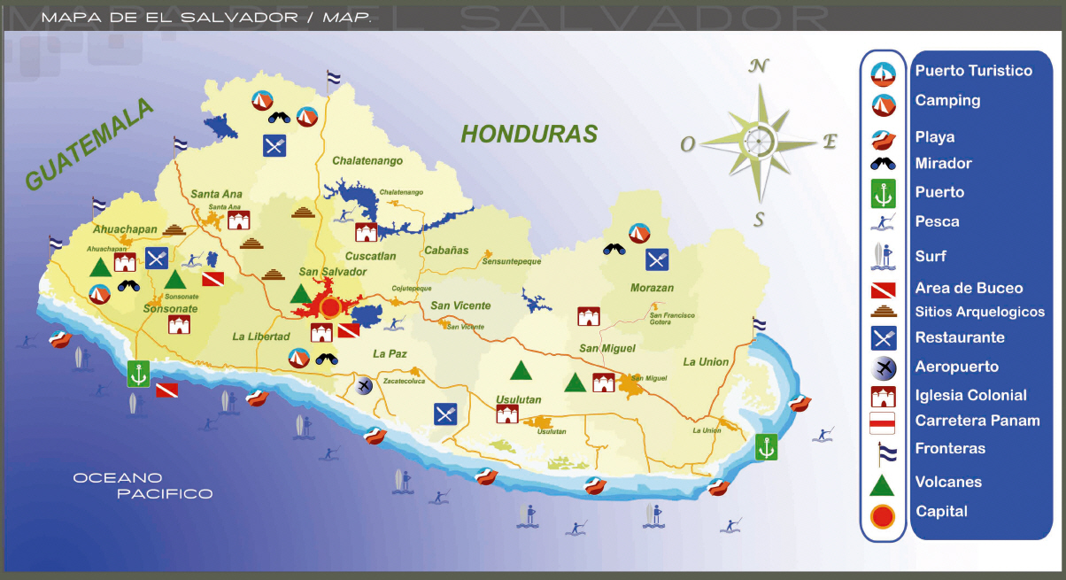

Illustration 6. El Tunco Beach, source: El Salvador Travel.

El Boquerón Lago de Ilopango Parque Balboa

Parque de Aventuras Surf City Walter Thilo Deininger
Zona Costera

2.5 Local Soil Types in El Salvador

El Salvador presents a diverse range of soil types shaped by its volcanic origins, river valleys, and coastal ecosystems. These soils not only influence the country’s agricultural potential but also determine patterns of settlement, land use, and environmental management. From fertile volcanic Andisols that sustain coffee and sugarcane production to saline halomorphic soils in mangrove areas, each soil type carries distinct characteristics that define its productivity, limitations, and economic value. Understanding these variations is essential for sustainable agriculture, infrastructure planning, and natural resource conservation in the country. (FAO, 2020; Magaña & Monterrosa, 2017).
Local Soil Type | Main Location in El Salvador | Common Uses | Main Characteristics
Andisols (volcanic) | Volcanic mountain ranges of the west and center (Santa Ana, Sonsonate, San Salvador, San Miguel) | Coffee, sugarcane, vegetables, intensive crops | Very fertile, good water retention, easy to work
Alluvial (valleys, coastal plains) | Valleys of the Lempa River, Bajo Lempa (Usulután, San Vicente), coastal plains of La Paz and La Libertad | Rice, vegetables, fruit trees | Very productive soils, variable texture (sand to clay), good fertility
Reddish Latosols | Chalatenango, Cabañas, mountains of Santa Ana | Corn, beans, pastures, coffee on slopes | Clayey, reddish color due to iron, fertile in protected areas but prone to erosion
Acidic Latosols | North/east (Morazán, La Unión, high Chalatenango) | Reforestation, crops with special management | Deep soils, acidic, low natural fertility
Grumosols (heavy clay soils) | Interior valleys: San Miguel, Usulután, La Unión | Basic crops under irrigation, livestock | Expansive black clays, cracked in drought, swell with water
Regosols (young, sandy) | Coasts (La Libertad, Usulután, La Unión), recent volcanic ash | Coconut, cashew, pastures, tourism/beaches | Sandy, poorly consolidated, very permeable, low nutrient retention
Lithosols (thin over rock) | Mountains and volcanoes (Bálsamo range, volcanoes of Santa Ana, San Vicente, San Miguel) | Pines, hillside coffee plantations | Very shallow, stony, low agricultural capacity
Halomorphic (saline, mangroves) | Mangroves of Jiquilisco (Usulután), Jaltepeque Estuary (La Paz), Gulf of Fonseca (La Unión) | Mangrove palm, fishing, salt flats | Saturated and saline soils, low agricultural aptitude, high corrosivity
Coastal Clays of La Libertad | Low areas of the La Libertad coast (Majahual, San Diego, Chilama, Jicalapa) | Construction with precautions, local basic crops | Soft, expansive clays, highly compressible, risk of settlement in foundations

- Andisols (volcanic)
Accordding to Food and Agriculture Organization of the United Nations (2015), The Andisols are located mainly in the volcanic mountain ranges of the west and center of El Salvador, including Santa Ana, Sonsonate, San Salvador, and San Miguel. These soils are considered highly fertile, with excellent water retention and ease of tillage, which makes them especially suitable for intensive crops such as coffee, sugarcane, and vegetables.
- Alluvial Soils (valleys and coastal plains)
In order to Centro Nacional de Tecnología Agropecuaria y Forestal (2019), the Alluvial soils are concentrated in the valleys of the Lempa River, particularly in Bajo Lempa (Usulután and San Vicente), as well as in the coastal plains of La Paz and La Libertad. Their variable texture, ranging from sand to clay, provides good fertility and high productivity. These soils are commonly used for crops such as rice, vegetables, and fruit trees, contributing significantly to food production in the region.
- Reddish Latosols
Depending on the information of Ministerio de Medio Ambiente y Recursos Naturales (2018), Reddish latosols are found in Chalatenango, Cabañas, and in the mountainous areas of Santa Ana. They are characterized by their clayey texture and reddish coloration due to high iron content. While these soils can be fertile when managed correctly, they are highly prone to erosion in unprotected slopes. They are commonly used for crops like corn, beans, pastures, and coffee on hillside areas.

- Acidic Latosols
Under the inform of Food and Agriculture Organization of the United Nations (2015), Acidic latosols are located in northern and eastern regions such as Morazán, La Unión, and high-altitude areas of Chalatenango. These soils are deep but present low natural fertility due to their acidity. Consequently, they are better suited for reforestation or for crops requiring specialized management practices.
- Grumosols (heavy clay soils)
In accordance with what is stated by CENTA (2019), Grumosols occur in interior valleys, especially in San Miguel, Usulután, and La Unión. They are expansive black clays that crack during dry seasons and swell when moistened, creating challenges for agricultural practices. However, under irrigation they are valuable for basic crops and livestock raising.
- Regosols (young, sandy soils)
In opinion of MARN (2018), Regosols are young soils, often found in coastal areas such as La Libertad, Usulután, and La Unión, as well as in areas with recent volcanic ash. These soils are sandy, poorly consolidated, and highly permeable, with low nutrient retention. They are mainly used for coconuts, cashews, pastures, and support tourism activities along the beaches.
- Lithosols (thin soils over rock)
As established by FAO (2015), Lithosols are shallow, stony soils that occur in the Bálsamo mountain range and around volcanoes in Santa Ana, San Vicente, and San Miguel. With very low agricultural capacity due to their limited depth, these soils are commonly used for pines and hillside coffee plantations.
- Halomorphic Soils (saline, mangrove areas)
From the perspective of CRESPIAL (2018), Halomorphic soils are found in mangrove ecosystems such as Jiquilisco (Usulután), the Jaltepeque Estuary (La Paz), and the Gulf of Fonseca (La Unión). They are saturated and saline, with low agricultural aptitude and high corrosivity. Nevertheless, they play a critical role in supporting fishing activities, mangrove palm production, and traditional salt flats.
- Coastal Clays of La Libertad
In reference to what was set forth by CENTA (2019), The coastal clays of La Libertad are present in low coastal areas such as Majahual, San Diego, Chilama, and Jicalapa. These clays are soft, expansive, and highly compressible, creating risks of settlement in construction foundations. While local communities use them for basic crops, they require special precautions in building projects.

2.6 Cultural Identity of El Salvador

The cultural identity of El Salvador is a complex and vibrant tapestry that merges indigenous traditions, colonial influences, and contemporary expressions. This identity manifests in various aspects of everyday life, from language to festivities, as well as gastronomy, music, and legends. This report provides a detailed analysis of the elements that make up Salvadoran cultural identity, highlighting 15 representative examples and their relevance in the current context. (Cultura.gob.sv. (2024).

2.6.1 Language

Spanish is the official language of El Salvador; however, Nahuat, the indigenous language of the Pipil people, remains an essential part of the country’s linguistic heritage. Although its use has declined, efforts are underway to revitalize it through educational and cultural programs.

2.6.2 Cultural and Religious Festivals

a. Day of the Divine Savior of the World
Celebrated on August 6, this festival honors the national patron saint. It includes masses, processions, and cultural events that reflect religious devotion and a sense of community.
b. The Processions of Izalco
Declared Intangible Cultural Heritage, these processions represent a fusion of indigenous and Catholic traditions, highlighting the cultural richness of the region.
Ministerio de Cultura.

- Religious Celebrations
a. Holy Week in Sonsonate
Recognized by Asamblea Legislativa de El Salvador (2013), this celebration is notable for its sawdust and flower carpets, created by the community to adorn streets during processions.
b. Fiesta of the Cross of May
A tradition that combines pre-Hispanic and colonial elements, with rituals and celebrations in honor of the cross. (Asamblea Legislativa de El Salvador. (2013). 2.6.3 Gastronomy
a. Pupusas
The national dish, made from corn dough and filled with various ingredients such as beans, cheese, and pork.
b. Yuca with Chicharrón
A traditional dish combining boiled yuca with fried pork pieces, served with curtido (pickled cabbage) and red sauce.
c. Tamales
Made from corn dough filled with meat, chicken, or beans, wrapped in banana leaves, and steamed.
2.6.4 Stories and Legends
a. La Siguanaba
A popular legend about a woman who lures men with her beauty, only to transform into a monstrous being.
b. El Cadejo
A tale of a black or white dog that appears at night, guiding or protecting people.
- Music
a. Marimba
A traditional instrument accompanying folk dances and celebrations, symbolizing Salvadoran musical identity.
Van Grupo
b. Cumbia
A popular musical genre that fuses African and indigenous rhythms, widely heard during festivities and social gatherings.
- Handicrafts
a. Pottery of Santo Domingo de Guzmán
Renowned for its handcrafting technique without the use of a potter’s wheel, producing unique pieces reflecting the country’s artisanal tradition.
b. Ilobasco Crafts
Famous for hand-painted clay figures representing daily life and religious scenes.

- Dance
a. Xuc Dances
Theatrical and dance performances that narrate traditional stories, performed during religious festivals.
b. Moors and Christians Dances
Performances that reenact the historical battles between Moors and Christians, combining music, dance, and theater.

- Colonial Architecture
Buildings such as the Metropolitan Cathedral and the National Palace in San Salvador reflect the colonial influence on the country’s architecture.
- Literature
Authors such as Roque Dalton and Claudia Hernández have contributed to Salvadoran literature, addressing themes of identity, history, and culture.
- Oral Traditions
Stories passed down through generations that preserve myths, legends, and ancestral knowledge. Some examples:

- The legend of El Tabudo
- The legend of Chasca, the Virgin of Water
- The legend of El Cipitío
- The legend of El Cadejo
- La Cuyancúa, icon of Izalco
- The legend of The Screeching Cart
- The legend of The Nahuales of Panchimalco
- The legend of The Midnight Screamer
- The legend of La Siguanaba
- The legend of The Amate Flower

- Traditional Clothing
Traditional garments worn during festivities, such as the “cucurucho” outfit for Holy Week or formal attire for patron saint celebrations.
- Traditional Games
Activities such as the “balero-chibolas” and “trompo” (spinning top), which have been part of children’s entertainment for generations.
- Pre-Hispanic Architecture
Sites like Joya de Cerén, a World Heritage Site, provide insight into the daily lives of indigenous peoples before the arrival of colonizers.

- Agricultural Traditions
Practices such as corn cultivation and the use of traditional agricultural techniques that have been passed down through centuries.

2.7 Syncretism in El Salvador and Intangible Tourism Resources

In opinion to Lopez (2023), Cultural syncretism constitutes an essential mechanism in the construction and evolution of societies, particularly in contexts where historical interaction between different human groups has generated processes of fusion and assimilation of traditions. In El Salvador, a country with a rich history marked by indigenous presence, Spanish colonization, and African influence, syncretism is evident in social, religious, and cultural life, shaping intangible tourism resources that reflect the country’s cultural identity. These resources, which include festivals, religious practices, gastronomy, music, and handicrafts, represent a living heritage that not only preserves collective memory but also becomes a strategic attraction for tourism, promoting cultural and economic sustainability.
This report analyzes syncretism in El Salvador, showing how mixed cultural practices have consolidated over time and generating an inventory of intangible tourism resources. As noted by the Ministerio de Cultura de El Salvador (Cultura.gob.sv, 2024),these cultural expressions highlight the richness of traditions that fuse different origin. In words of Crespial (2018), fifteen concrete examples are included, demonstrating cultural richness and the integration of diverse elements, accompanied by an analysis of their relevance for tourism and national identity.

2.7.1 Cultural Syncretism in El Salvador

As argued by Lopez (2023), Cultural syncretism is evident when indigenous, African, and European traditions merge to generate new expressions that reflect the historical diversity of the country. This process has produced unique religious, artistic, and social practices that are part of El Salvador’s intangible heritage. For example, many religious festivals integrate pre-Hispanic rituals with Catholic ceremonies, generating authentic cultural experiences that strengthen community identity (Cultura.gob.sv, 2024).

2.7.2 Syncretism in El Salvador and Intangible Tourism Resources

In opinion to Lopez (2023), Cultural syncretism constitutes an essential mechanism in the construction and evolution of societies, particularly in contexts where historical interaction between different human groups has generated processes of fusion and assimilation of traditions. In El Salvador, a country with a rich history marked by indigenous presence, Spanish colonization, and African influence, syncretism is evident in social, religious, and cultural life, shaping intangible tourism resources that reflect the country’s cultural identity. These resources, which include festivals, religious practices, gastronomy, music, and handicrafts, represent a living heritage that not only preserves collective memory but also becomes a strategic attraction for tourism, promoting cultural and economic sustainability.
This report analyzes syncretism in El Salvador, showing how mixed cultural practices have consolidated over time and generating an inventory of intangible tourism resources. As noted by the Ministerio de Cultura de El Salvador (Cultura.gob.sv, 2024),these cultural expressions highlight the richness of traditions that fuse different origin. In words of Crespial (2018), fifteen concrete examples are included, demonstrating cultural richness and the integration of diverse elements, accompanied by an analysis of their relevance for tourism and national identity.
Cultural Syncretism in El Salvador
As argued by Lopez (2023), Cultural syncretism is evident when indigenous, African, and European traditions merge to generate new expressions that reflect the historical diversity of the country. This process has produced unique religious, artistic, and social practices that are part of El Salvador’s intangible heritage. For example, many religious festivals integrate pre-Hispanic rituals with Catholic ceremonies, generating authentic cultural experiences that strengthen community identity (Cultura.gob.sv, 2024).

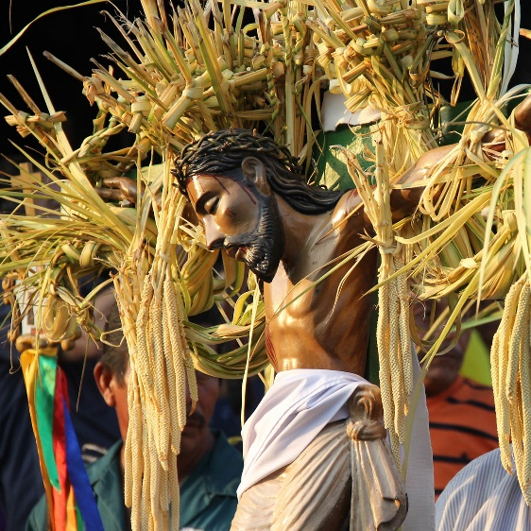

Illustration 7. Traditions in El Salvador, source: El Salvador Travel.

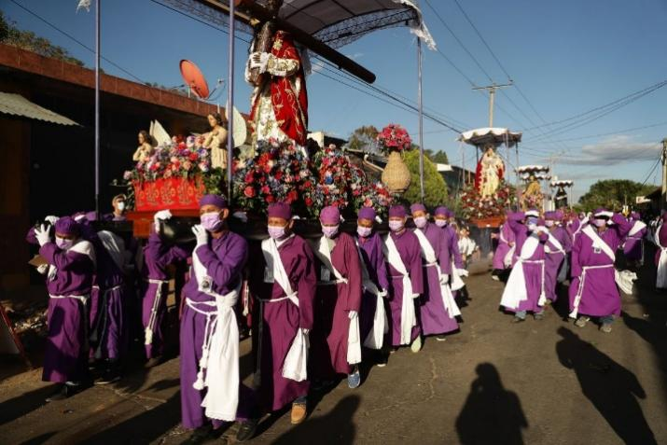

Illustration 8. Traditions in El Salvador, source: El Salvador Travel.
Importance of Syncretism for Tourism
Cultural syncretism enhances tourism by offering authentic and unique experiences that connect visitors with the country’s history and identity. Preserving these practices strengthens collective self-esteem, promotes the local economy, and generates a positive social impact through the valorization of communities and traditions.(Cultura.gob.sv, 2024).
Intangible Tourism Resources
Intangible tourism resources in El Salvador include cultural manifestations that are non-material but hold significant symbolic and emotional value. Notable examples include:
- Processions of Izalco: Religious ritual with processions of the Black Christ, combining indigenous traditions with Catholic practices (Cultura.gob.sv, (2024).
- Brotherhood of Flowers and Palms of Panchimalco: Celebration that mixes pre-Hispanic rituals with Catholic ceremonies.
- Day of the Lanterns in Ahuachapán: Popular tradition integrating indigenous and colonial elements.
- Christmas Pastorelas: Theatrical plays combining biblical narrative with local folkloric elements.
- Dance of the Little Devils in Nejapa: Cultural expression merging indigenous beliefs with Catholic festivities.
- La Calabiuza in Cuscatlán: Ancestral festival mixing pre-Columbian myths and Christian rituals.
- Feast of Saint Michael the Archangel in La Unión: Ritual combining Catholic liturgy with native dances.
- Holy Week Rituals in Sonsonate: Processions incorporating indigenous and European elements.
- Corn Festival in Chalatenango: Agricultural celebration with pre-Hispanic and colonial symbolism.
- Pupusa Day Gastronomy: Integration of indigenous ingredients with Spanish influences.
- Traditional music with marimba: Fusion of African, indigenous, and European rhythms.
- Oral narratives and traditional tales: Mix of local myths and narratives introduced by colonizers.
- Syncretic religious art in colonial churches: Images integrating indigenous iconography with Catholic symbols.
- Folk dances in patron saint festivals: Choreographies combining native and European steps.
- Rituals of gratitude to nature: Combination of animist beliefs with Christian practices.
Moreover, intangible tourism resources foster intercultural dialogue, consolidating El Salvador as an attractive and distinctive destination within Central America. Syncretism in El Salvador not only demonstrates cultural adaptation and resilience in the face of historical processes of colonization and migration, but it also constitutes a strategic asset for the development of cultural tourism. The interaction of indigenous, African, and European elements has produced unique manifestations that extend beyond religious or artistic domains, encompassing everyday and social life, making them an intangible resource of significant economic, cultural, and emotional value. ((FUSADES, 2016).

The Sustainable Development Goals (SDGs)

They are adopted by the United Nations in 2015, represent a universal call to action to end poverty, protect the planet, and ensure peace and prosperity for all by 2030. These 17 interconnected goals provide a comprehensive framework that addresses global challenges such as inequality, climate change, environmental degradation, and social justice. Tourism, as one of the world’s largest and fastest-growing industries, plays a pivotal role in advancing the SDGs. By fostering inclusive growth, creating employment, supporting local communities, and promoting environmental sustainability, tourism becomes a powerful engine for sustainable development and global transformation. (UNWTO. (2017).
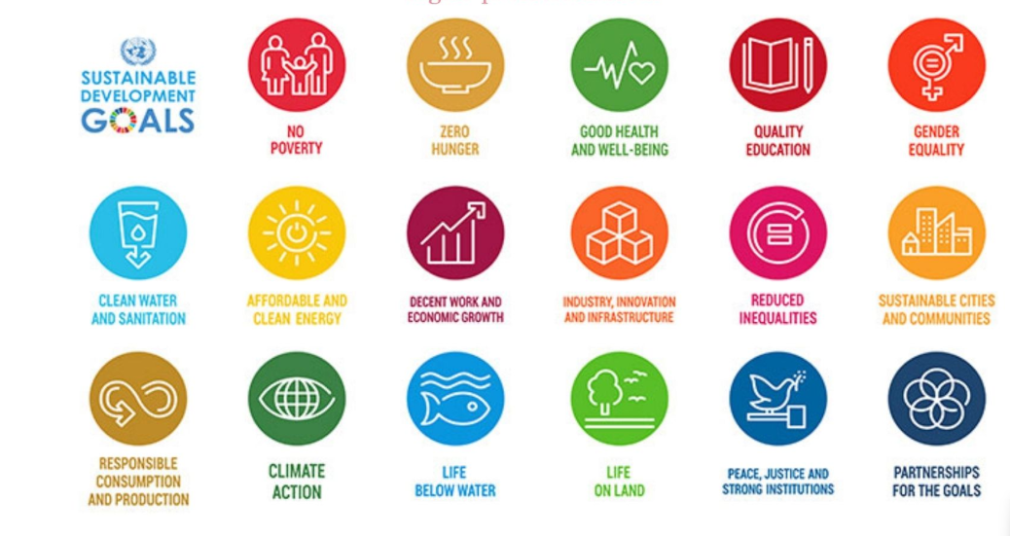

Illustration 9. The Sustainable Development Goals, source: United Nations


GOAL 1: NO POVERTY
Being one of the largest economic sectors in the world and one of the fastest-growing, tourism is well-positioned to promote economic growth and development at all levels and generate income through job creation. The development of sustainable tourism and its impact on communities can be linked to national poverty reduction goals, those related to promoting entrepreneurship and small businesses, and the empowerment of disadvantaged groups, particularly women and youth.

GOAL 2: ZERO HUNGER
Tourism can stimulate agricultural productivity by promoting the production, use, and sale of local products at tourist destinations and their full integration into the sector’s value chain. Additionally, agrotourism, a growing segment, can complement traditional agricultural activities. Increasing income in local communities can lead to more resilient agriculture while also adding value to the tourist experience.

GOAL 3: GOOD HEALTH AND WELL-BEING
Tourism’s contribution to economic growth and development can also have a positive effect on health and well-being. Revenue and taxes generated from tourism can be reinvested in healthcare services, which should help, among other things, improve maternal health, reduce child mortality, and prevent diseases.

GOAL 4: QUALITY EDUCATION
For tourism to thrive, a well-trained and competent workforce is required. The sector can provide incentives to invest in education and vocational training and help labor mobility through cross-border agreements on qualifications, standards, and certifications. In particular, funding for education should benefit youth, women, the elderly, indigenous peoples, and persons with special needs, as tourism has the capacity to promote inclusivity, a culture of tolerance and peace, and global civic engagement.

GOAL 5: GENDER EQUALITY
Tourism can empower women in multiple ways, particularly by providing jobs and income-generating opportunities in large, medium, and small tourism-related enterprises. Being one of the sectors with the highest percentage of employed and entrepreneurial women, tourism can unlock women’s potential and help them fully participate and gain independence in all areas of society.

GOAL 6: CLEAN WATER AND SANITATION
Tourism can play a crucial role in achieving access to water and sanitation for all. Efficient water use in the tourism sector, combined with proper safety measures, wastewater management, pollution control, and technological efficiency, can be key to safeguarding our most precious resources.

GOAL 7: AFFORDABLE AND CLEAN ENERGY
As a sector that requires substantial energy input, tourism can accelerate the transition to renewable energy and increase its share in the global energy mix.

By promoting strong, long-term investments in sustainable energy sources, tourism can help reduce greenhouse gas emissions, mitigate climate change, and implement new and innovative energy solutions in urban, regional, and remote areas.
GOAL 8: DECENT WORK AND ECONOMIC GROWTH
Tourism is a driving force of global economic growth and currently accounts for the creation of 1 in 11 jobs worldwide. Providing access to decent work opportunities in the tourism sector can benefit society, particularly youth and women, through skills development and career advancement. The sector’s to employment is highlighted in Target 8.9: “By 2030, devise and implement policies to promote sustainable tourism that creates jobs and promotes local culture and products.”

GOAL 9: INDUSTRY, INNOVATION, AND INFRASTRUCTURE
contribution Tourism development requires quality public and private infrastructure and an innovative environment. The sector can also encourage national governments to upgrade infrastructure and modernize industries, making them more sustainable, resource-efficient, and cleaner, which in turn attracts tourists and foreign investment. This should also facilitate more sustainable industrialization, necessary for economic growth, development, and innovation.

GOAL 10: REDUCED INEQUALITIES
According to World Tourism Organization UNWTO et al.(2014), Tourism can be a powerful tool for community progress and reducing inequality if it involves local populations and key stakeholders in its development. The sector can contribute to urban renewal and rural development and reduce regional disparities by giving communities opportunities to prosper locally. Tourism is also an effective means for developing countries to participate in the global economy. In 2014, the Least Developed Countries (LDCs) received USD 16.4 billion in international tourism exports, up from USD 2.6 billion in 2000. As stated by UNWTO et al. (2017),This significant increase has made tourism a major pillar of their economies accounting for 7% of total exports) and has helped some countries move beyond LDC status.



GOAL 11: SUSTAINABLE CITIES AND COMMUNITIES
A city that is not well-equipped for its residents is not equipped for tourists. Sustainable tourism can improve urban infrastructure and universal accessibility, promote the regeneration of declining areas, and preserve cultural and natural heritage—assets upon which tourism depends. Increased investment in green infrastructure (more efficient transport, reduced air pollution, conservation of heritage sites and open spaces, etc.) should result in smarter, greener cities benefiting both residents and tourists.
GOAL 12: RESPONSIBLE CONSUMPTION AND PRODUCTION
A tourism sector that adopts sustainable consumption and production practices can play a significant role in the transition to sustainability. As noted in Target 12.b of Goal 12, it is essential to “develop and implement tools to monitor sustainable development impacts, in order to achieve sustainable tourism that creates jobs and promotes local culture and products.”( UNWTO. (2017). The Sustainable Tourism Program under the 10-Year Framework of Programs on Sustainable Consumption and Production (10YFP) aims to develop these practices, including initiatives for resource efficiency that improve economic, social, and environmental outcomes.

GOAL 13: CLIMATE ACTION
Tourism contributes to climate change while also being affected by it. Therefore, it is in the sector’s own interest to play a leading role in the global response to climate change. By reducing energy consumption and using renewable sources, especially in transport and accommodation, tourism can help address one of the most pressing challenges of our time.

GOAL 14: LIFE BELOW WATER
Coastal and marine tourism—the largest tourism segment, especially for Small Island Developing States (SIDS), depends on healthy marine ecosystems. Tourism development must be part of integrated coastal management to help conserve fragile marine ecosystems and serve as a vehicle to promote the blue economy, in line with Target 14.7: “By 2030, increase the economic benefits to SIDS and LDCs from sustainable use of marine resources, including through sustainable management of fisheries, aquaculture, and tourism.” ( UNWTO. (2017).


GOAL 15: LIFE ON LAND
Experiencing majestic landscapes, pristine forests, abundant biodiversity, and sites classified as natural heritage is often a primary reason tourists visit a destination. Sustainable tourism can play an important role not only in conserving biodiversity but also in respecting terrestrial ecosystems through efforts to reduce waste and consumption, conserve native flora and fauna, and conduct awareness activities.

GOAL 16: PEACE, JUSTICE, AND STRONG INSTITUTIONS
As tourism involves billions of interactions among people from diverse cultural backgrounds, the sector can promote tolerance and multicultural and interfaith understanding, laying the foundations for more peaceful societies. Sustainable tourism that benefits and involves local communities can also provide livelihoods, strengthen cultural identity, and promote entrepreneurial activities, helping to prevent violence and conflict and consolidate peace in societies that have experienced recent conflicts.

GOAL 17: PARTNERSHIPS FOR THE GOALS
Due to its cross-sectoral nature, tourism has the capacity to strengthen public-private partnerships and involve multiple stakeholders international, national, regional, and local to work together to achieve the SDGs and other common goals. Cooperation and public-private partnerships are essential foundations for tourism development, as is increased awareness of tourism’s role in fulfilling the post-2015 development agenda.

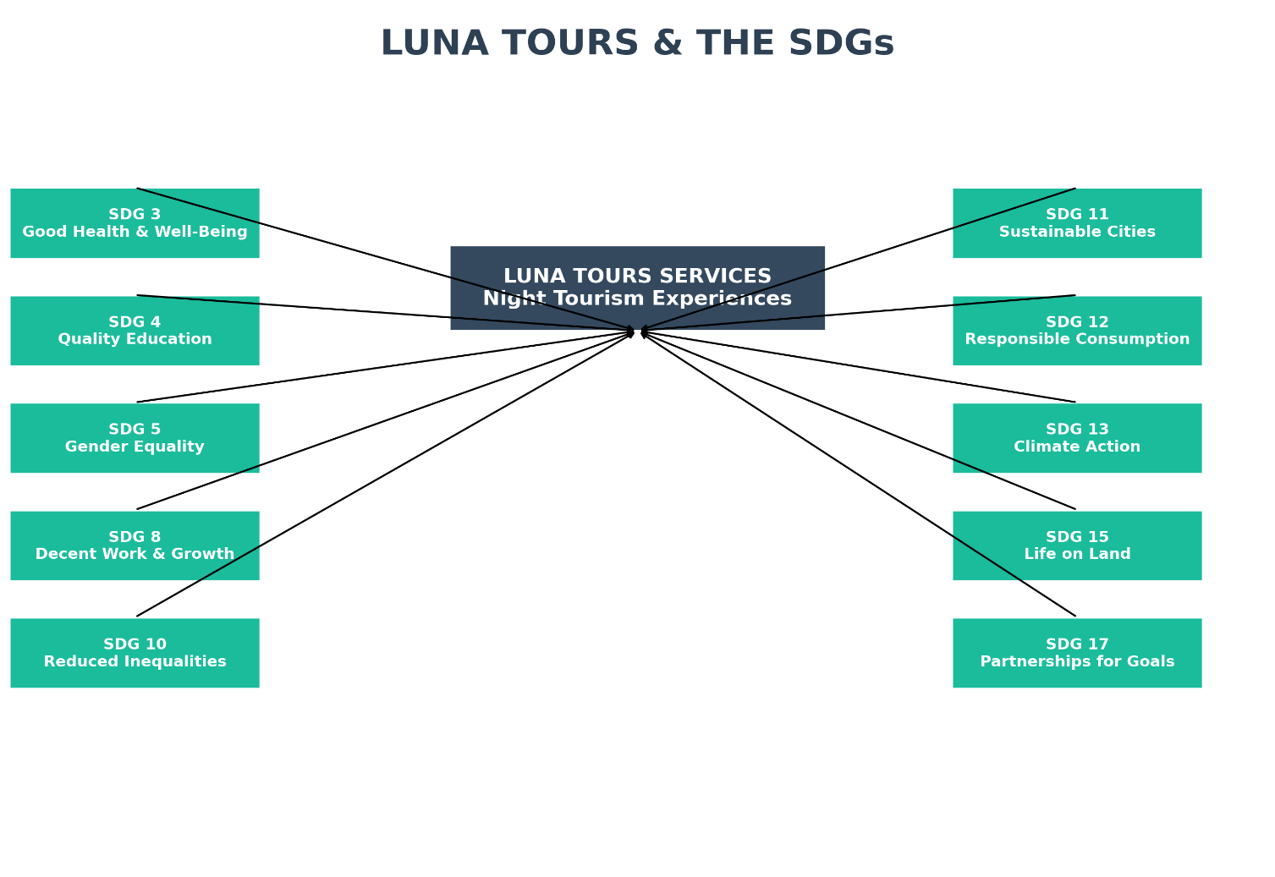

Illustration 9. SDGs, source: own

2.8.1 Sustainable Development Goals (SGs) and Principles for Luna Tours’ Night Tourism in El Salvador

As expressed by UNDP (2024), Luna Tours positions itself as a transformative night-tourism project that not only provides recreation and stress relief for workers and students in San Salvador but also actively contributes to the global agenda of Sustainable Development Goals (SDGs). Through hybrid tourism cultural, wellness, gastronomic, nature, and adventure; Luna Tours aligns with key international principles to foster sustainability, inclusivity, and innovation in El Salvador’s tourism sector.

Alignment with the United Nations SDGs
- SDG 3: Good Health and Well-Being
By offering wellness experiences such as yoga, meditation, and stress-relieving activities under the stars, Luna Tours enhances mental health and promotes healthier lifestyles for urban populations seeking balance after work.
- SDG 4: Quality Education
Guided tours integrate cultural storytelling, environmental awareness, and local knowledge-sharing. These elements transform each journey into an informal learning experience that promotes appreciation of Salvadoran heritage and sustainability.
- SDG 5: Gender Equality
Luna Tours promotes inclusion by engaging women as guides, entrepreneurs, and cultural leaders, empowering them within the tourism economy and fostering gender equity in the sector.
- SDG 8: Decent Work and Economic Growth
The project generates direct and indirect employment through partnerships with cafés, musicians, artisans, and wellness practitioners. This stimulates the local economy and creates sustainable jobs for young people and women.
- SDG 10: Reduced Inequalities
Through accessible pricing, inclusive transportation, and collaborations with marginalized communities, Luna Tours ensures that urban nightlife and cultural tourism are available to diverse social groups, reducing inequalities in leisure and cultural access.
- SDG 11: Sustainable Cities and Communities
Luna Tours revitalizes urban nightlife safely and sustainably. By using strategic transport routes, it reduces congestion, improves mobility, and fosters the responsible use of cultural and natural spaces within and around San Salvador.
- SDG 12: Responsible Consumption and Production
The project adopts sustainable practices by promoting local food, eco-friendly activities, and responsible visitor behavior, ensuring minimal environmental impact while maximizing community benefits.
- SDG 13: Climate Action
By encouraging eco-conscious transportation, energy-efficient operations, and nature-focused itineraries, Luna Tours integrates climate-friendly practices in its tourism circuits.
- SDG 15: Life on Land
Activities such as night hikes and visits to ecological parks emphasize conservation of biodiversity and respect for natural ecosystems, fostering environmental stewardship among tourists.
- SDG 17: Partnerships for the Goals
Collaboration is central to Luna Tours. Strategic alliances with local businesses, artists, and wellness professionals ensure shared value creation, sustainable development, and long-term impact.
Universal Principles of Sustainable Development for Tourism (UN Framework)
According to the UNDP and UN Tourism, sustainable tourism must:
- Promote inclusive economic growth (SDG 8)
- Respect cultural and natural heritage (SDG 11, 15)
- Foster responsible consumption and production (SDG 12)
- Encourage social inclusivity and equality (SDG 5, 10)
- Support climate resilience (SDG 13)
- Build strong partnerships for innovation (SDG 17). (UNDP. (2024)
Luna Tours embodies these principles through its “after-work” night-tour model, positioning itself as a pioneer of hybrid, sustainable, and culturally immersive tourism in El Salvador.

2.8.2 Quality Control Strategy Plan of Luna Tours
The success of Luna Tours lies not only in offering unique and memorable travel experiences but also in ensuring that every service provided consistently meets the highest standards of quality. To achieve this, a structured Quality Control Strategy Plan has been designed to strengthen customer satisfaction, optimize operations, and enhance brand positioning in the tourism market. This plan focuses on four key actions: innovative promotional campaigns, a personalized customer support system, a loyalty rewards program, and a continuous monitoring process. Each action is strategically assigned to leadership roles, ensuring accountability and measurable improvements. Together, these initiatives establish a solid framework for sustainable growth, operational excellence, and long-term customer loyalty.

ACTION | ROLES | IMPROVEMENTS
1. Implement paid social media campaigns to promote Luna Tours services. | Promotion Manager – Víctor Manuel Hernández Salinas | - Track ROI with analytics dashboards.  - Run seasonal campaigns (e.g., Full Moon Experience).  - Targeted ads for international markets.
2. Create a personalized support channel via WhatsApp (AI chatbot + human support). | Customer Experience Leader – María Dinora González Alfaro | - Launch Luna Assist Bot for FAQs.  - Personalized follow-up by agents.  - 24/7 availability guarantees instant answers.
3. Launch Luna+ loyalty program with raffles and exclusive rewards. | Marketing & Loyalty Coordinator – María Dinora González Alfaro | - Program: Travel, Collect & Win.  - For every $10 spent = 1 point.  - 30 points = 20% discount.  - Monthly raffle: 5 travel backpacks with Luna merchandise.
4. Establish continuous quality monitoring system (QR surveys + NPS). | Quality Control Supervisor – Víctor Manuel Hernández Salinas | - Real-time data dashboard.  - Weekly team meetings for service improvements.  - Benchmark satisfaction rate: >90%.

Customer Satisfaction Strategic Plan

In today’s highly competitive tourism industry, excellence in service and authentic experiences are the foundation for building lasting connections with travelers. Luna Tours embraces this vision by combining personalized attention, emotional and sensory experiences, continuous improvement, and sustainable practices to create unforgettable journeys that go beyond traditional tourism. Through innovative strategies such as 24/7 communication, immersive activities, constant evaluation, local integration, and community-building, Luna Tours positions itself not only as a provider of night tours but as a creator of meaningful memories that inspire trust, loyalty, and cultural appreciation.

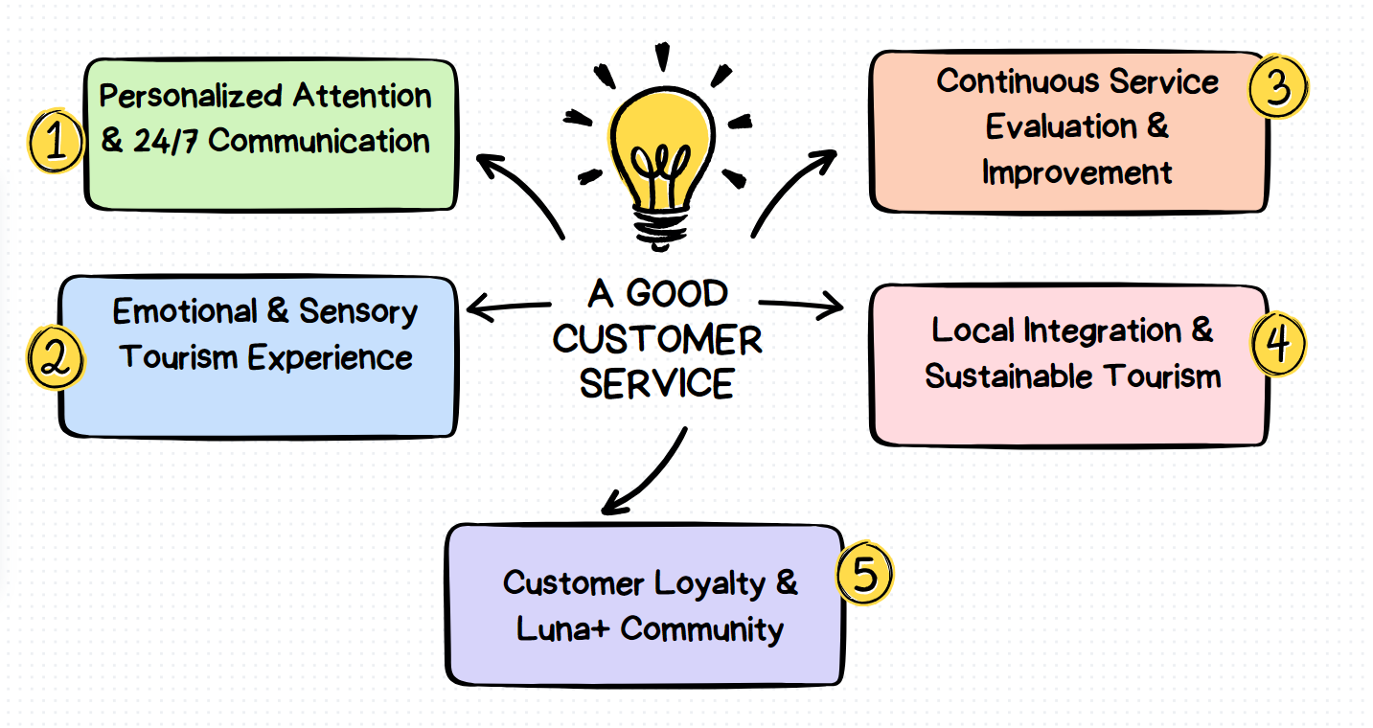

Illustration 10. Customer Satisfaction Strategic Plan, source: own

- Personalized Attention & 24/7 Communication
With the propose of build closeness and trust from the first contact.
Strategies:
- Intelligent chatbot + human WhatsApp support.
- Exclusive promotions and personalized alerts.
- 24/7 rapid and effective response.
2. Emotional & Sensory Tourism Experience
Also, to Enrich tours with immersive and emotional activities.
Strategies:
- Yoga under the stars, coffee routes, bonfires, viewpoints.
- Sensory narratives & ambient music.
- Certified guides trained in history, safety, and emotional storytelling.
3. Continuous Service Evaluation & Improvement
In addition, this adjusts processes based on real customer perception.
Strategies:
- QR surveys at the end of tours.
- Use of NPS (Net Promoter Score) for loyalty measurement.
- Online review analysis for constant optimization.
4. Local Integration & Sustainable Tourism
To Promote authentic and sustainable experiences.
Strategies:
- Partnerships with local cafés, guides, musicians, and artisans.
- Sustainable activities that protect the environment.
- Inclusion of rural communities in tourist circuits.
5. Customer Loyalty & Luna+ Community
This Create emotional connection and belonging.
Strategies:
- Luna+ points program.
- Monthly raffles, referral discounts, exclusive events.
- Emotional newsletter for frequent customers.
Expected Results
- Increase in customer satisfaction & retention.
- Strengthened brand identity as leader in night tourism.
- Sustainable growth with positive social & cultural impact.

CHAPTER III

LOCAL DEVELOPMENT THROUGH A TOURIST SERVICE OR PRODUCT

3.1 Entrepreneur Profile

In the current era, entrepreneurship has become easier and represents an unparalleled opportunity to generate income that can provide financial support or be a primary source of income. Therefore, it is necessary to understand some concepts on this topic.
First and foremost, it is necessary to highlight the definition of entrepreneurship. The National Institute of Agricultural Technology of Buenos Aires, Argentina, states that "an entrepreneurship is carried out by a person called an entrepreneur. The word entrepreneur originates from the French entrepreneur (pioneer), and was initially used to refer to those who embarked on the adventure of traveling to the New World, just as Columbus had done, without having any certainty about what they would find there."
As this concept highlights, "Entrepreneurship is the pursuit of opportunity beyond the resources currently controlled" (Stevenson 1983, 1985, 1990, 2000).
Based on the above definitions, we can identify certain skills and characteristics that an entrepreneur must possess to be successful in the market in which they work. Each entrepreneurial profile is based on the very specific characteristics of each person or company. However, for Rafael Alcaraz Rodríguez (2011, p. 5), cited by Abambari, M. Entrepreneurship and the Entrepreneur's Profile, "Entrepreneurs possess characteristics that facilitate not only entrepreneurship, but also success. Among them, some of the most frequently mentioned are: Creativity and innovation; Confidence in themselves and their abilities; Perseverance; Ability to manage problems; Risk acceptance."
For the specific case of our tour operator, Luna Tours, we highlight some very important characteristics of our business, such as:
- Creativity and innovation: This characteristic is very important because through creativity, various dynamic activities can be employed that contribute to the relationship and satisfaction of our tourists. Likewise, innovation is essential, as sales strategies, advertising campaigns, and promotions, among other things, will be constantly updated.

- Flexibility and the ability to adapt to circumstances: Within the business sector, there are various stages in which there will be significant revenue and periods in which there will be limited revenue. Therefore, we must be aware of these circumstances. Likewise, times and people are changing, and there will be greater demands from tourists, and the way we travel is also changing.

- Ability to communicate and socialize: Within the tourism sector, communication and socialization are essential because we must always be in constant contact with our clients so that they experience the hospitality of our tour operator and feel confident traveling with us and using our tour packages.

3.1.1 Social responsibility of the entrepreneur

Nandedkar S. On the Plutus Education website, he highlights the following concepts regarding the social responsibility of entrepreneurs:
The ethical and socially responsible behavior of an entrepreneur is relevant to business. Entrepreneurs must apply moral values ​​to their businesses. Ethical business conduct encompasses integrity, fairness, and transparency in business operations.
Ethical entrepreneurs generate a positive image for their brands. This is an advantage for consumers, employees, and investors. Ethical standards also limit the risks of legal liability and maximize potential long-term profits.
• Honesty and Integrity: They must maintain the truth about their products and services.
• Fair Trade Practices: Ensures fair wages and safe working conditions for employees.
• Environmental Responsibility: One should always strive to minimize waste while adhering to sustainable business practices.
• Customer Respect: One gains loyal customers by delivering quality products and services.
• Community Commitment: A person's dedication to local communities through charitable efforts is a sign of an ethical entrepreneur.
As Luna Tour, we are focused on faithfully fulfilling our social responsibilities through ethical values ​​and the quality service we can provide our tourists. We also strive to preserve natural resources, maintain honesty, and be transparent in each of our activities. We also strive to support small businesses that offer tourism products in the areas we visit through our tours. We also strive to maintain fair prices that meet the needs of the population and the social realities of El Salvador.

3.2 Market Niches

We live in an era where market competition is intensifying, customers are more demanding, marketing resources are increasingly diverse, and market saturation means that generic products or services are no longer enough to succeed. In this environment, emerging, standing out, and thriving requires much more than offering the same thing as everyone else with a different logo or a slightly lower price. The key lies in identifying that strategic space among the many unmet or poorly met and needs of specific consumer groups, and positioning oneself there in an authentic, specialized, and valuable way. That strategic space is known as a market niche.
A market niche is not simply a subset of the general market but a coherent segment: individuals who share common characteristics, desires, priorities, values, lifestyles, and specific expectations that are not yet satisfactorily addressed or where the existing offer could be substantially improved. In this space, those who enter later but do so with deep understanding, a clear identity, specialized service, and effective communication can generate high loyalty, better profit margins, a solid reputation, and a competitive advantage that is difficult to replicate quickly.
For a tour operator like “Luna Tours”, with its identity (“After work, your best night starts here”) and its mission to satisfy the tourism needs of the Salvadoran population while promoting local tourism entrepreneurship, a niche strategy can be transformative. Through it, Luna Tours can not only attract customers but also become a benchmark for differentiated, creative, and meaningful proposals that connect emotionally and experientially with its audiences.
This seeks to analyze in depth what market niches are, what types exist, which essential elements define them, why it is important to focus on them, how to integrate specific niche strategies into a tourism enterprise, and how to apply all of this to the concrete case of Luna Tours in El Salvador. The goal is not only to understand current theory, but to translate it into practical, bold proposals that enable Luna Tours to innovate, grow, and stand out in a competitive market.

Definition

a) Operational Definition:
A market niche is a specialized portion of a broader segment composed of consumers who share homogeneous characteristicsv, alues, habits, needs, lifestyles that are not fully satisfied by general market offerings (HubSpot, 2023; Clientify, 2024).

b) Strategic Approach:
A market niche strategy involves identifying a specific unmet need or group, designing an adapted offer, defining highly precise segmentation, crafting directed communication, and positioning strongly within that niche (HubSpot, 2023).

c) Differentiation vs. Specialization:
Unlike broad segmentation, a niche requires deep specialization. Rather than covering many segments moderately well, the goal is to serve a narrow group exceptionally well, fostering loyalty, high perceived value, and limited direct competition (MarketinHouse, 2025; Camaloon, 2023).

3.2.2 Types of Market Niches

Type | Main Characteristics | Relevant Examples
Demographic | Age, gender, income, occupation, education—specific needs based on these variables | Ice cream for adults, products for people over 50, clothing for plus-size women (HubSpot, 2023)
Values / Lifestyle / Beliefs | Buyers whose purchasing behavior is driven by values (sustainability, ecology, authenticity, veganism) | (HubSpot Blog)
Special Needs | Disabilities, dietary restrictions, health requirements, accessibility concerns | (HubSpot Blog)
Specific Interests or Hobbies | Passions such as photography, astronomy, adventure, nature, local culture | (Camaloon, 2023; HubSpot, 2023)
Geographical | Underserved regions, rural areas, low light-pollution zones, specific local communities | (MarketinHouse, 2025)

3.2.3 Importance of Focusing on Market Niches

Enhanced Marketing Efficiency: More precise messages, less wasted advertising, and higher conversion rates (HubSpot, 2023).

Premium Pricing Potential: Niches value specialization and are often willing to pay more for customized experiences (MarketinHouse, 2025).

Customer Loyalty and Reputation: When clients feel a service is made for them, not for the masses, it breeds loyalty, referrals, and user-generated advocacy.

Differentiation from Competitors: While many firms follow generic formulas, offering something distinct increases visibility and competitive advantage.

Adaptability and Innovation: Niche strategies encourage creativity and rapid adaptation to cultural, social, or technological changes.

3.2.4 Key Elements for Selecting an Effective Market Niche

Element | Description

Real Demand & Sufficient Volume | Existence of a minimum viable number of people or businesses willing to purchase.

Economic Capacity | The niche must have purchasing power and a willingness to pay for added value.

Specific Unmet Problem | A clear “pain point” or unfulfilled need that general offerings overlook.

Differentiation & Barriers to Entry | The current market lacks strong solutions, or differentiation can be achieved through value or experience.

Internal Resources | The company must possess the operational, human, and logistical capabilities to serve the niche with quality.

Sustainable Profitability | Cost structures should allow for acceptable margins and long-term maintenance.

Scalability / Adaptability | Even a narrow niche should allow for future diversification or seasonal expansion.

Alignment with Mission and Values | The chosen niche should be coherent with the company’s identity, image, and purpose.

3.2.5 Strategies for Incorporating Market Niches into Luna Tours (El Salvador)

a) Develop Ultra-Specific Themed Tourism Products
Design highly specialized tour packages: full-moon astronomical observation, night photography, evening folklore tours, nocturnal wellness retreats, women-only travel experiences, etc.

b) Hyper-Segmented Communication and Digital Marketing
Define detailed buyer personas for each niche. Use social media, video content, and storytelling that inspire each audience. Implement geographic and demographic targeting and engage in niche-specific online communities (astronomy groups, cultural forums, etc.).

c) Local Partnerships and Authentic Experiences
Collaborate with local guides, artisans, astronomers, chefs, and storytellers. Integrate authentic elements that niche clients value—starlit dinners, local myths, and culturally immersive stays.

d) Personalization, Flexibility, and Superior Quality
Allow travelers to tailor itineraries, comfort levels, and added services (specialized guides, photography, telescopes). Maintain small groups and meticulous attention to detail.

e) Geographic / Seasonal Segmentation and Tiered Pricing
Identify regions with clear skies and low light pollution; leverage astronomical events or full-moon seasons. Adjust pricing for locals vs. international tourists and weekdays vs. weekends.

3.2.6 Potential Market Niches for Luna Tours in El Salvador

- Astronomical Tourism / Night Photography
- Cultural Experiences Based on Folklore and Night Legends
- Nocturnal Wellness / Urban Escapes After Work
- Women-Only Travel Experiences
- Eco-Night Tourism / Soft Adventure (Night Hikes, Wildlife Observation, Sunrises)

3.2.7 How This Approach Can Generate Integrated Niche Strategies for Luna Tours

- Integrate niche studies into the business plan, including demand estimation and cost analysis (equipment, lighting, night transport).

- Develop pilot programs for one or two niches first to gather feedback before scaling.

- Create a distinct brand identity, positioning Luna Tours as the specialist in unforgettable nights and moonlit experiences.

- Monitor niche-specific metrics: satisfaction, repeat bookings, recommendations, acquisition cost, and profitability.

- Adapt operations and customer service for niche requirements: nighttime availability, specialized guides, safety, reliable transport, and proper permits.

- Market niches represent a high-value strategic opportunity for Luna Tours, allowing the company not only to compete but to stand out. Rather than diluting its proposal with general offerings, focusing on specific segments enables differentiation, loyalty, profitability, and brand prestige. Success will depend on choosing viable niches aligned with Luna Tours’ identity, backed by real demand and purchasing capacity, and empowering strategies that harmonize product, communication, quality, and operations.

3.3.1 Logo
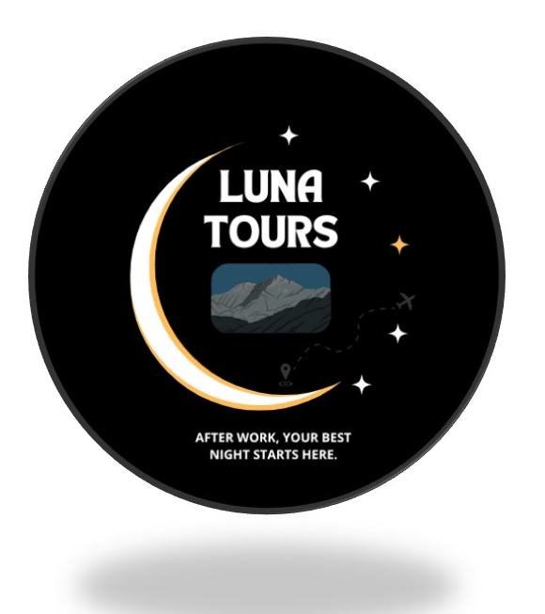

Illustration 11. logo, source: own

- The Luna Tours logo is a circle, which means that our tour operator has everything necessary to meet the needs of tourists.
- The waning moon symbolizes the name of the tour operator, which contrasts with the 5 stars within the logo.
- The 5 stars symbolize the quality of Luna Tour's tourist service, and the bright star symbolizes the success and impact that our company generates in the market.
- In the center of the logo it can see a mountain with a shadow in the middle, which represents the time when Luna Tours will conduct the tours (at night).
- The airplane at the center of the stars represents Luna Tour's projection into the future of implementing tourist tours outside the country.

3.4.1 Slogan

AFTER WORK, YOUR BEST NIGHT STARTS HERE.

Our slogan emphasizes Luna Tour's market segmentation, focused on people who work or study during the day.

3.5.1 Mission

To satisfy the tourism needs of the Salvadoran population, while promoting the development of entrepreneurs in the tourism sector.

3.6.1 Mission

To be the best option in El Salvador for package tours and transfers within and outside the country.

3.7.1 Values

Responsibility: It is a characteristic value of Luna Tour, as it highlights the responsibility that is taken towards the tourist, the environment and all the components governed by the tourism sector.

Loyalty: It involves trust, closeness and loyalty with tourists, as well as transparency and empathy with the customer.

Excellence: It lies in the efficiency and quality of tourist service provided to the tourist, which allows customers to feel satisfied and acquire our services.

Credibility: The quality of service we offer will allow us to position ourselves in the market and be the best option.

4.1 References

- University of Girona, Spain (2007), "The Origin of Tourism: Let's Get Historical," https://mediterrani.com/el-origen-del-turismo-nos-ponemos-historicos/
- Ministerio de turismo de El Salvador (2025). Institutional framework on the history of tourism in El Salvador. https://www.mitur.gob.sv/historia/
- Instituto Salvadoreño de turismo (2025). Institutional framework on the history of tourism in El Salvador. https://istu.gob.sv/marco-institucional/
- University of Quilmes, Argentina (2018), "Tourism Development in Latin America: Phases, Approaches, and Internalization. chrome-extension://oemmndcbldboiebfnladdacbdfmadadm/https://webquery.ujmd.edu.sv/siab/bvirtual/Fulltext/ADDE0000662/C1.pdf
- FAO. (2020). Evaluación de los recursos de suelos en América Latina y el Caribe. Organización de las Naciones Unidas para la Alimentación y la Agricultura. http://www.fao.org/3/ca8640es/ca8640es.pdf
- Magaña, M. A., & Monterrosa, R. (2017). Recursos edáficos y potencial productivo de El Salvador. Universidad de El Salvador, Facultad de Ciencias Agronómicas.
- Ministerio de Medio Ambiente y Recursos Naturales [MARN]. (2019). Diagnóstico ambiental de El Salvador: Suelos y uso de la tierra. Gobierno de El Salvador. https://www.marn.gob.sv
- Cultura.gob.sv. (2024). Processions of Izalco declared as intangible cultural heritage. Ministry of Culture of El Salvador. https://www.cultura.gob.sv/procesiones-de-izalco-son-declaradas-como-patrimonio-cultural-inmaterial
- Asamblea Legislativa de El Salvador. (2013). Declaración de la Semana Santa sonsonateca como patrimonio cultural religioso. Diario Oficial.
- Guide to Intangible Cultural Heritage. (2016). Salvadoran Foundation for Economic and Social Development (FUSADES). Retrieved from https://repo.fundasal.org.sv/283/1/Gu%C3%ADa%20del%20patromonio%20cultural%20inmaterial.pdf
- National Directorate of Cultural Heritage. (n.d.). Ministry of Culture of El Salvador. Retrieved from https://www.cultura.gob.sv/marco-institucional/direccion-nacional-de-patrimonio-cultural/
- Naciones Unidas. (2015). Transforming our world: The 2030 agenda for sustainable development. United Nations. https://sdgs.un.org/goals
- UNDP. (2024). Sustainable Development Goals. United Nations Development Programme. https://www.undp.org/sustainable-development-goals
- UNWTO. (2017). Tourism and the Sustainable Development Goals – Journey to 2030. World Tourism Organization. https://tourism4sdgs.org
- Instituto Nacional de Tecnología Agropecuaria, Buenos Aires Argentina, 2004. El concepto de emprendimiento y su relación con la educación, el empleo y el desarrollo local. chrome-extension://oemmndcbldboiebfnladdacbdfmadadm/http://municipios.unq.edu.ar/modules/mislibros/archivos/MonografiaVersionFinal.pdf.

- STEVENSON H. H. 2000. Why the entrepreneurship has won! www.usasbe.org/pdf/cwp-2000-stevenson.pdf

- Abambari. M. El emprendimiento y perfil del emprendedor. https://classroom.google.com/u/1/c/NzYwNjIyNjUzMTYy/m/NzgwMTM1MjI1MDQw/details
- Abambari. M. El emprendimiento y perfil del emprendedor. https://classroom.google.com/u/1/c/NzYwNjIyNjUzMTYy/m/NzgwMTM1MjI1MDQw/details
- Nandedkar. S. Portal web del sitio educativo de Plutus Education. Responsabilidad social del emprendedor: beneficios e impactos en la comunidad. https://plutuseducation.com/blog/social-responsibility-in-business-ethics/
- HubSpot. (2023, January 20). ¿Qué es un nicho de mercado? Tipos y ejemplos. HubSpot Blog. https://blog.hubspot.es/marketing/nicho-de-mercado
- MarketinHouse. (2025). 5 Ejemplos de nicho de mercado. MarketinHouse.es. https://www.marketinhouse.es/5-ejemplos-de-nicho-de-mercado/
- Clientify. (2024). ¿Qué es un nicho de mercado? Tipos y 26 nichos sin explotar. Clientify Blog. https://clientify.com/blog/marketing/nicho-mercado-tipos-ejemplos
- Camaloon. (2023). Nichos de mercado más rentables (+50 ejemplos). Camaloon Blog. https://www.camaloon.es/blog/nichos-de-mercado-ejemplos
- Doofinder. (n.d.). Nicho de mercado: qué es, cómo encontrarlo y 15 ejemplos. Doofinder Blog. https://www.doofinder.com/es/blog/nicho-de-mercado

