UNIVERSITY OF EL SALVADOR
SCHOOL OF ARTS AND SOCIAL SCIENCES
DEPARTMENT OF FOREIGN LANGUAGES


AURORA TOURIST GUIDE AGENCY
SERVICIO DE GUIAS TURÍSTICOS AURORA
PRESENTED BY:
ANDY RICARDO JIMÉNEZ CHÁVEZ JJ20004
FINAL REPORT OF SPECIALIZATION COURSE ON TOURISM IN ORDER TO OBTAIN THE DEGREE OF:
BACHELOR DEGREE IN ENGLISH TEACHING
PROFESSOR:
LICDA. GLORIA CAROLINA ORTEGA
GENERAL COORDINATOR OF THE GRADUATION PROCESS
BSC. MIGUEL ÁNGEL CARRANZA CAMPOS

UNIVERSITY CAMPUS, DR. FABIO CASTILLO FIGUEROA, SAN SALVADOR, EL SALVADOR, CENTRAL AMERICA, OCTOBER 30TH, 2025

AUTHORITIES OF THE UNIVERSITY OF EL SALVADOR
RECTOR
MSC. JUAN ROSA QUINTANILLA QUINTANILLA
VICE-RECTOR
DRA. EVELYN BEATRIZ FARFAN MATA
ADMINISTRATIVE VICE-RECTOR
MSC. ROGER ARMANDO ARIAS ALVARADO
GENERAL SECRETARY
BSC. PEDRO ROSALIO ESCOBAR CASTANEDA
AUTHORITIES OF THE SCHOOL OF ARTS AND SCIENCES
DEAN
M MSC. JULIO CESAR GRANDE RIVERA
VICE-DEAN
MSC. MARIA CRUZ JURADO
SECRETARY OF SCHOOL OF HUMANITIES
MTRA. NATIVIDAD THESHÉ PADILLA
AUTHORITIES OF THE DEPARTMENT OF FOREIGN LANGUAGES
HEAD OF THE FOREIGN DEPARTMENT
MTI. JOSÉ ISRAEL OLIVA

GENERAL COORDINATOR OF THE GRADUATION PROCESS
BSC. MIGUEL ÁNGEL CARRANZA CAMPOS, MSE

INDEX
Abstract……………………………………………………………………………………….......7
INTRODUCTION……………………………………………………………….………….…...8
CHAPTER I………………………………………………………………….……….………...10
1.1 Objectives……………………………………………………………………………............11
1.1.1 General objective…………………….….…….……....……………………………11
1.1.2 Specific Objectives……………………………………….……………………...…11
1.2 Justification……………………….……………….……….……………………………….12
1.3 Description of the service………………………………………………………..........……13
1.3.1 Target audience…………………………………………………………………….13
1.3.2 Why is the name Aurora tours´?................................................................................13
1.3.3 Location……………………………………………………………………………14
1.3.4 What does Aurora tours’ tourism service consist of?................................................14
1.3.5 Activities offered as a tour operator……………………………………….……….15
1.3.6 Main attributes of our cultural tourism experiences……………………………….16
1.3.7 Typology of the tourist service…………….………………………….……………16
1.4 Principles for the sustainable human development of aurora tours………………….17
CHAPTER II ...............................................................................................................................20
2.1 History of Tourism.................................................................................................................21
2.2 History of Tourism in El Salvador........................................................................................24
2.3 Natural resources in destination areas, location on the tourist map of El Salvador…...28
2.3.1 Western Zone ………………………………………………………………………28
2.3.2 Central Zone ……………………………………………………………………….30
2.3.3 Eastern Zone……………………………………………………………………….31
2.4 Soil types in El Salvador…………………………………………………………………....32
2.4.1 Volcanic Soils ……………………………………………………………………...32
2.4.2 Alluvial Soils………………………………………………….……….…………...32
2.4.3 Residual Soils ……………………………………………………………………...33
2.4.4 Organic Soils ………………………………………………………………………34
2.4.5 Saline and Sodic Soils……………………………………………………………...34
2.5 Cultural identity, intangible tourism resources……………………………………………35
2.5.1 Western Zone ………………………………………………………………………35
2.5.2 Central Zone…………………….…………………………………………….……35
2.5.3 Eastern Zone…………………………………………….………………………….36
2.6 Sustainable development goals...…………………………………………………………...37
2.7 Strategic plan: quality control, customer satisfaction.…………………………………….45
2.7.1 Strategic quality plan……………………………………………………………….45
2.7.2 Strategic action Plan…………………………………………………….……….…47
CHAPTER III.………….……………………………………………………………………….50
3.1 Profile of the Entrepreneur…………...…………………………………………………….51
3.1.1 Definition of entrepreneur………………………………………………………….51
3.1.2 Attributes of entrepreneurs……………………………………….…………………54
3.1.3 Key Entrepreneurial Attributes at Aurora Tours…………………………………….57
3.2 Market Niche…………………….………………………………………………………….58
3.2.1 Definition…………………………………………………...………………………58
3.2.2 Characteristics of a Strong Market Niche…………………………………………...59
3.2.3 Types of Market Niches…………………………………………………………….59
3.2.4 Niche Market Strategies…………………………………………………………….60
3.2.5 Market Segments and Niches for Aurora Tours…….…….…………………………61
3.3.1 Logo…….……………………………………………….…………………………………62
3.4.1 Slogan……………………………………………………………………………………...64
3.5.1 Mission…………………………………………………………………………………….65
3.6.1 Vision……………...……………………………………………………………………….65
3.7.1 Values………………………...…………………………………………………………….66
CHAPTER IV…………………………………………….……….………….…………………68
4.1 References……………………………………………………………………………69

ABSTRACT
This document presents Aurora Tours as a Salvadoran tour operator that promotes the natural beauty and cultural richness of the country through organized, safe, and inclusive tourism experiences. The company’s main goal is to offer both national and international visitors quality services that highlight Salvadoran hospitality, while also encouraging sustainability, national identity, and personalized attention.
To understand the importance of tourism and its impact on society and the economy, this document analyzes the origins and development of tourism globally and in El Salvador. It also emphasizes the value of the country’s natural and cultural resources, such as beaches, volcanoes, mountains, and traditions, which represent key attractions for national tourism.
Finally, Aurora Tours presents its mission, vision, and values, as well as its commitment to sustainable tourism. The company promotes care for the environment, respect for local communities, and preservation of cultural heritage, aiming to provide meaningful experiences that contribute to the responsible growth of tourism in El Salvador.

INTRODUCTION
Tourism is one of the most dynamic activities in the world, involving the movement of people to different places outside their usual environment for leisure, culture, or business purposes (UNWTO). It has become an essential part of economic and social development, generating employment opportunities and promoting cultural exchange. In El Salvador, tourism plays a growing role in showcasing the country’s natural beauty, traditions, and hospitality. However, despite its potential, there is still a need for companies that offer organized, inclusive, and sustainable tourism experiences. For this reason, this document presents the creation and development of Aurora Tours, a tour operator that seeks to promote the natural and cultural wealth of El Salvador through quality, safety, and personalized attention.
In the first chapter, Profile of a Tourist Service, the main idea of the company is presented, including the name, location, target audience, and the needs that the service fulfills. It also describes the type of tourism offered and explains how the agency’s activities contribute to human development and sustainability. The goal is to provide travelers with experiences that allow them to connect with the country’s landscapes, traditions, and people in an authentic and responsible way.
Chapter II, Elements for the Design of the Tourism Product, includes a general overview of the history of tourism worldwide and its evolution in El Salvador. It highlights the country’s main natural and cultural resources, such as beaches, volcanoes, mountains, and traditions, which are key to the national tourism offer. This chapter also presents the Sustainable Development Goals (SDGs) and their connection with tourism, along with a strategic plan focused on service quality, customer satisfaction, and environmental responsibility.
Finally, Chapter III, Local Development through a Touristic Product or Service, focuses on the entrepreneurial aspect of Aurora Tours. It defines the profile of the entrepreneur and describes the main attributes that characterize the company, such as passion, vision, persistence, and innovation. The chapter also develops the market niche that Aurora Tours aims to reach, presents the company’s logo and slogan, and defines its mission, vision, and values, which reflect its commitment to clients, sustainability, and national identity. At the end, the references used throughout the three chapters are included, supporting the theoretical and practical development of the project.

CHAPTER I:
TOURIST SERVICE PROFILE

1.1 Objectives

    - General Objective: To promote comprehensive tourism experiences within El Salvador, such as the enjoyment, appreciation, and preservation of the country's natural, cultural, and historical resources, through quality services that encourage sustainable tourism, safety, and customer satisfaction.
    - Specific Objectives:
- To identify the main natural, cultural, and historical resources that can be integrated into the tourism experiences offered.
- To specify service strategies that ensure safety, quality, and customer satisfaction in every tour.
- To explain the importance of sustainable tourism for the conservation of Salvadoran heritage and local development.

1.2 JUSTIFICATION
Local tourism in El Salvador presents great potential due to its natural, cultural, and historical richness, which in many cases remains unknown or underexploited both by the country's inhabitants and by foreign tourists. The creation of the promotion of local destinations and the creation of authentic tourism experiences are still insufficient, limiting the economic dynamism of rural and urban communities with tourism attractions.
The creation of a tour operator focused on local tourism addresses the need to diversify the tourism offer and foster a sense of belonging and national pride. This project will bring Salvadorans and international visitors closer to the country’s hidden treasures, promoting sustainability and respect for local cultures and the environment.
Furthermore, the implementation of this project will contribute to economic development through the generation of direct and indirect jobs in the communities where it will operate, as well as the strengthening of small businesses and local artisans who will be integrated into the tourism activities.
Finally, this project is viable, as El Salvador has a growing network of tourism infrastructure and an increasing interest in community-based and sustainable tourism. With proper planning, strategic partnerships, and effective promotion, the tour operator can position itself as a reference in the national and international tourism market.

1.3 DESCRIPTION OF THE SERVICE
1.3.1 Target audience
At Aurora Tours, we understand that each traveler has unique interests and needs. That’s why we’ve designed our tours to appeal to a variety of audiences who seek meaningful and memorable experiences in El Salvador.
● Groups of friends looking for weekend getaways and fun experiences.
● Families seeking safe, accessible, and enriching trips.
● Domestic and international tourists eager to explore new destinations and discover Salvadoran culture.
Our goal is to offer something special for everyone, from casual explorers to cultural enthusiasts. (Annex 1)

1.3.2 Why is the name Aurora tours´?
Aurora Tours symbolize excitement and discovery, which are essential in today’s travel industry, the word “Aurora” represents light, new beginnings, and the beauty that emerges at dawn. It perfectly reflects the company’s purpose of illuminating the best of El Salvador and inspiring travelers to discover its wonders. This name captures the essence of the project: to create unforgettable experiences, promote sustainable tourism, and connect people with the natural and cultural brightness of the country.
1.3.3 Location
The service will be designed to be accessible to Salvadorans and foreigners, with fair prices and convenient locations, such as Metrocentro in San Salvador.
1.3.4 What does Aurora tours’ tourism service consist of?
At Aurora Tours, we offer a full tourism service that includes planning, organizing, and running cultural, nature, and adventure experiences all around El Salvador.
We want travelers to really discover the country, its history, people, traditions, and beautiful places through fun and meaningful activities.
- Professional Guides and Trained Staff: Certified, multilingual guides who ensure educational, safe, and engaging experiences.
- Comfortable Tourist Transportation: Air-conditioned, well-maintained vehicles and skilled drivers ensure a smooth ride.
- Variety of Activities Depending on the Destination: Tailored experiences: from archaeological tours to beachside adventures.
- Interaction with Local Communities: Direct engagement with local people for authentic cultural exchange.
- Responsible Tourism Practices: Commitment to sustainability, ethical tourism, and community benefit.
Each of our tours is designed to offer the perfect balance of structure, exploration, and cultural depth.
1.3.5 Activities offered as a tour operator
At Aurora Tours, we focus on cultural tourism. This means we create trips that help people learn about and enjoy the traditions, history, and art of El Salvador.
- Archaeological Site Tours: Visit sites like Joya de Cerén and Tazumal with expert guides.
- Historic City Tours: Explore colonial architecture and local life in cities like Suchitoto.
- Local Festivals and Cultural Events: Participate in Salvadoran traditions, music, and food.
- Museum and Cultural Center Visits: Discover curated exhibits on art, history, and indigenous culture.
- Guided Cultural Walks: Community-led tours through neighborhoods, towns, and rural areas.
- Folklore Performances: Enjoy live traditional music, dance, and storytelling.
Plus, we include practical amenities that enhance travel experience:
- Comfortable Tourist Transport with A/C
- Group Coordinator
- Photo Coverage
- Safety Equipment
- Free Time at the Place
- Excellent Experience Guaranteed
These services ensure that each journey is both enjoyable and unforgettable.

1.3.6 Main attributes of our cultural tourism experiences
At Aurora Tours, we focus on offering quality cultural tourism that is authentic, sustainable, and centered with the community.
Our approach goes beyond the typical tourist experience. We create real connections between travelers and Salvadoran communities, combining educational content, cultural immersion, and environmentally responsible practices.
- Authenticity: Avoid commercial tourism and embrace genuine culture and traditions.
- Educational Value: Provide insights into Salvadoran history, society, and environment.
- Community Focus: Engage locals as guides, hosts, and artisans; support their economies.
- Sustainability: Operate responsibly to protect cultural heritage and the environment.
- Diversity: Offer experiences across rural, urban, coastal, and indigenous communities.
- Immersion and Participation: Encourage hands-on involvement in cooking, crafting, and cultural practices.
1.3.7 Typology of the tourist service
The typology of Aurora tours operator is national, inbound, retail-based, ecotourism-focused, and aimed at a diverse audience.
This means we operate only within El Salvador (national), serve both locals and international visitors (inbound), sell our services directly to customers (retail-based), focus on nature-based and sustainable travel experiences (ecotourism-focused), and offer packages suitable for people of all ages and backgrounds (diverse audience).
1.4 Principles for the sustainable human development of aurora tours
- Principle of emotional and psychological wellbeing
Aurora Tours will focus on creating experiences that will allow people to disconnect from daily stress and reconnect with nature, culture, and themselves. This will respond to the integral wellbeing of the human being, one of the pillars of sustainable human development.
- Principle of access and equity
The service will be designed to be accessible to Salvadorans and foreigners, with fair prices and convenient locations, such as Metrocentro in San Salvador. This will reflect a commitment to social inclusion and the democratization of tourism, ensuring that more people will be able to enjoy and get to know their country.
- Principle of local economic development
The promotion of destinations within the country will suggest a boost to domestic tourism. Aurora Tours will establish alliances with local tour guides and small businesses such as restaurants, transport providers, and accommodations. These actions will indirectly benefit rural communities and will contribute to inclusive and sustainable economic development.
- Principle of Terrestrial Ecosystems
Aurora Tours will promote respect and care for the environment by encouraging responsible interaction with natural spaces. The tours will foster awareness of the importance of protecting flora and fauna, as well as the conservation and preservation of biodiversity. This principle will contribute to sustainable tourism practices that protect ecosystems and ensure their continuity for future generations.
- Principle of Quality Education
By offering experiences that will teach about history, traditions, and culture, Aurora Tours will fulfill an educational role that will promote personal growth and social and cultural awareness of the traveler key factors of sustainable human development.
- No poverty and Responsible Consumption and Production
Aurora Tours will contribute to sustainable development by promoting job creation and economic opportunities through local tourism, helping to reduce poverty in rural communities. At the same time, it will adopt responsible consumption and production practices by using resources efficiently and promoting local products and services. In this way, the company will support conscious tourism that enhances both social well-being and environmental care.
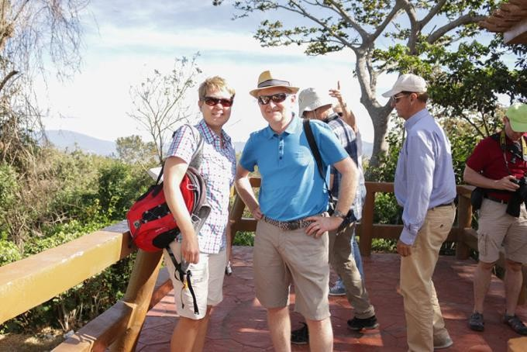
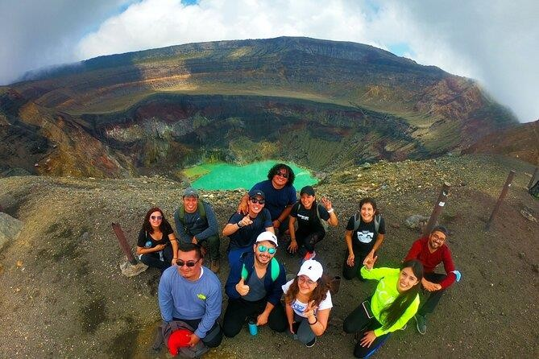
ANNEX 1

Figure 1 Tourist activity in El Salvador. Source: Ministry of Tourism of El Salvador (2020).
Figure 2 Tourist activity in El Salvador. Source: Tickets2Cities (n.d.).

Example of target audience, foreigners and nationals.
ANNEX 2
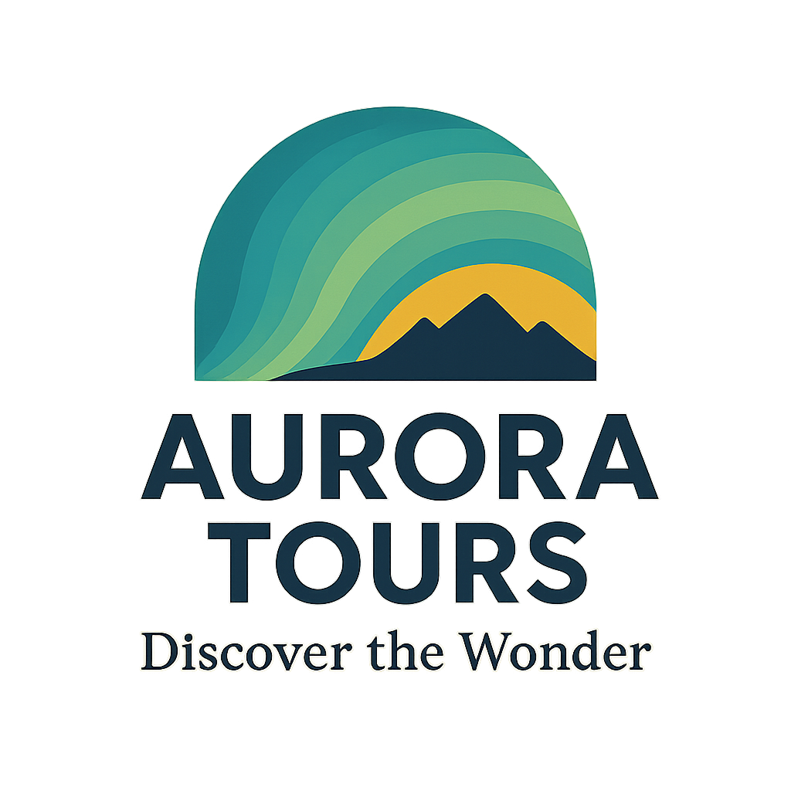
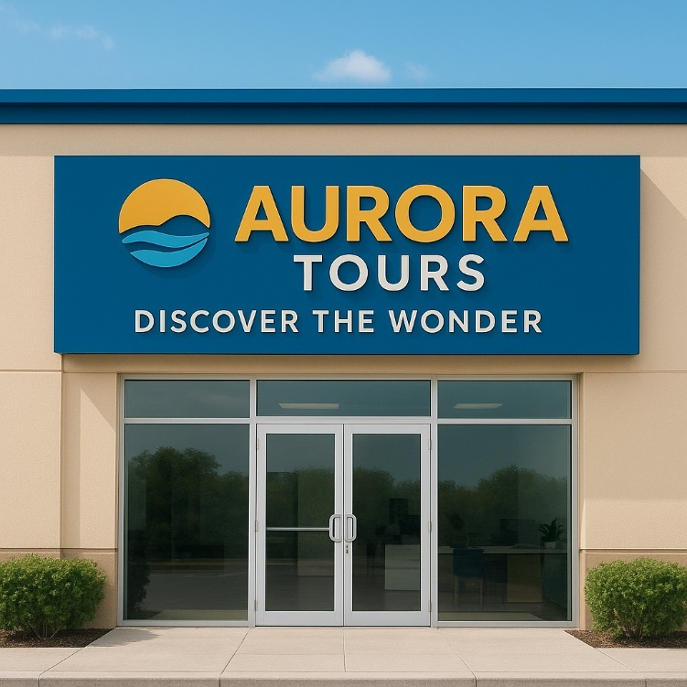
Figure 3 Official logo of Aurora Tours. Source: Own elaboration.

Figure 4 Official logo of Aurora Tours. Source: Own elaboration.

Marca de nuestra Tour operadora ‘’Aurora Tours’’

CHAPTER II
Elements For The Design Of The Tourism Product

2.1 HISTORY OF TOURISM

Tourism has been one of the oldest human activities, although its modern perception emerged much later. Since ancient times, people have traveled for various reasons, whether for trade, religion, education, or simple recreation. For example, civilizations such as the Egyptian and Roman civilizations developed road systems, inns, and structures that facilitated the movement of people and goods throughout their territory. Religious pilgrimages such as the Camino de Santiago (Way of St. James) were a growing type of tourism during the Middle Ages. As an example, we can see the different and most important stages that tourism had to go through to reach the point we know it today:

Ancient civilizations (Egypt, Greece, and Rome)
More than 4,000 years ago, the ancient Egyptians were already making trips for religious or commercial reasons, and some elites traveled to visit temples or historical monuments, such as the pyramids. In Greece, there are records of Greeks traveling to participate in sporting events such as the Olympic Games and to visit the sanctuaries of their gods. These trips had a strong cultural and religious component. It should also be noted that in Rome, they developed a vast network of roads that facilitated travel throughout the Empire. Wealthy Romans made pleasure trips to the Mediterranean coasts, to spas and villas, which could be considered a precursor to leisure tourism. (Esneca Business School, 2024).

Medieval Tourism (5th-15th Centuries)
During the Middle Ages, religious travel was one of the first types of tourism to exist. In this case, pilgrimages to sacred sites, such as Jerusalem, Rome, or Santiago de Compostela, were common. These were also common caravans and trade routes. Apart from pilgrimages, these trade caravans connected Europe, Asia, and Africa, facilitating the exchange of products, ideas, and customs. (Esneca Business School, 2024).
The Grand Tour (17th-18th Century)
The Grand Tour was a common practice among aristocrats, especially the British, who traveled across the continent to further their education. They visited cities such as Paris, Rome, Venice, and Florence to study art, history, philosophy, and classical culture. This was a precursor to cultural tourism. (Esneca Business School, 2024).
Contemporary Tourism (19th Century)
During the Industrial Revolution, with the arrival of railroads and steamships in the 19th century, travel became much more accessible, allowing the middle class to begin traveling for pleasure. Like Thomas Cook, who organized the first group tour in 1841, taking passengers by train to a religious event in England. From there, Cook began organizing longer, more popular tourist trips. During the Victorian era, the wealthy began traveling to seaside resorts and beach destinations. (Esneca Business School, 2024).

Mass Tourism (20th Century onward)
With the invention of commercial airplanes after World War II, international tourism exploded. Airlines allowed people from all over the world to travel to distant destinations quickly and relatively affordably, boosting mass tourism. Globalization and technology have led to millions of tourists traveling each year, exploring destinations around the world. (Esneca Business School, 2024).

For this reason, the development of tourism was also closely linked to globalization and the opening of borders, as well as the creation of international organizations, such as the World Tourism Organization, which enabled the establishment of standards, the promotion of public policies, and the fostering of sustainable development in the sector. Today, tourism is considered one of the most important industries in the world, due to its ability to generate income and jobs, and its ability to promote cultural exchange worldwide.
Furthermore, tourism currently faces major challenges stemming from overtourism, which affects iconic cities and destinations by causing damage to cultural heritage, straining infrastructure, and causing unrest in local communities. This situation has forced a rethinking of how visitor flows are managed to ensure better coexistence between residents and tourists.
Added to this is the impact of the COVID-19 pandemic, which halted global tourism activity and marked a gradual recovery with new trends: more local travel and travel to less crowded places.

2.2 HISTORY OF TOURISM IN EL SALVADOR
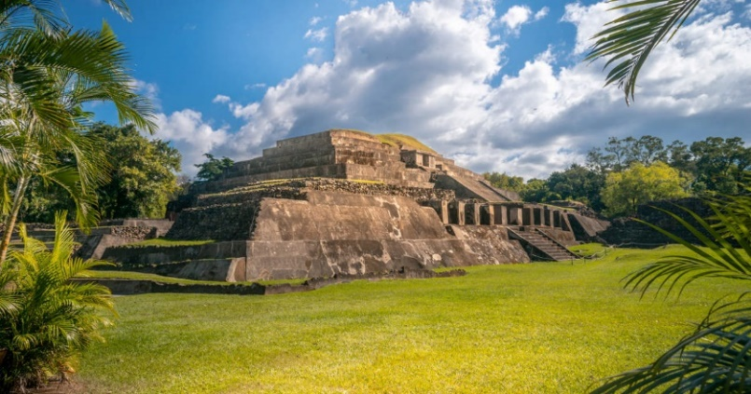
Tourism is one of the greatest resources for El Salvador's economic development, primarily due to the country's excellent natural attractions, with paradisiacal beaches, a tropical climate, and fascinating landscapes, as well as its significant archaeological heritage with colonial and pre-Columbian remains, as well as its national reserves.

Figure 5 Tourist activity in El Salvador. Source: Civitatis (n.d.).
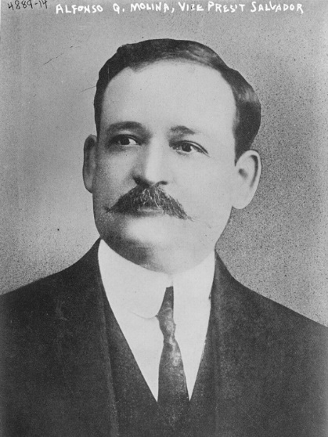
As part of its history, the first initiative to promote tourism in El Salvador took place in 1924, under the government of President Alfonso Quiñones Molina, with the creation of the Tourism and Agricultural and Industrial Propaganda Board, which aimed to promote national and foreign tourism. In 1946, the National Department of Tourism was created as a section of the Ministry of Foreign Affairs. EcuRed. (2025).

Figure 6 Alfonso Quiñónez Molina. Source: Harris & Ewing, Library of Congress (1915).
In 1961, the Salvadoran Tourism Institute (ISTU) was created as the governing government body. Its main responsibilities were the development of projects for the promotion and development of the sector, the regulation of tourism businesses, the management of tourism assets, and the presentation of regular reports on the sector's evolution. Monitoring of the sector became easier in 1968, when the ISTU began publishing detailed statistical bulletins on the flow of tourists to El Salvador. (Salvadoran Tourism Institute, n.d.). In 1967, the institutional framework for tourism was strengthened with the creation of the Tourism Industry Promotion Law, which offered tax incentives to companies that joined the national system. This effort was complemented by the opening of credit lines to boost investment in the sector, backed by the Central Reserve Bank's Economic Development Fund, which was created in 1966 and financed tourism infrastructure projects. Despite these initiatives, the results were limited, as by 1969 the country's hotel offering barely reached 320 rooms, distributed primarily across three locations: the Hotel El Salvador Intercontinental, the Gran Hotel San Salvador, and the Parker House. (Barraza Ibarra, 2010, p. 109).
And by the 1970s, the golden age of tourism in El Salvador began, as it experienced a surge thanks to relative economic and political stability. Important projects were promoted, such as the construction of hotels in San Salvador and the launch of the Cerro Verde mountain hotel. (Barraza Ibarra, 2010, p. 109). This growth was reflected in the arrival of tourists in 1978, partly fueled by the 1975 Miss Universe pageant, which positioned the country internationally and placed it in the spotlight as a future tourist attraction. However, in the 1980s, tourism in El Salvador suffered a sharp decline due to the armed conflict caused by the civil war, prompting international warnings against visiting the country and leading to stagnation in the sector. Following the Peace Accords, efforts were made to recover tourism, but the aftermath of the war has hampered the process (crime). Consequently, in the 1990s, tourism in El Salvador began to recover following the presence of the United Nations and the Peace Accords in 1992. Visitor numbers increased from 125,000 in 1991 to more than 300,000 in 1993. Although there was a slight decline afterward, tourist arrivals continued to rise, reaching nearly 800,000 in 2000. Thus, a recovery began in 2002 with a 29.4% increase in tourist arrivals after a slight decline during the 2000s. According to data from CORSATUR, 957,500 people entered that year, generating more foreign currency and consolidating tourism as a strategic area for the national economy. (Reyes, E. (2021, March 2). History of tourism in El Salvador, typology of tourism. SlideShare).
Between 2020 and 2025, tourism in El Salvador went from a sharp decline due to the pandemic to becoming one of the fastest-growing sectors. In just a few years, the country managed to recover and achieve record visitor numbers, driven by projects such as Surf City, infrastructure improvements, and a perception of greater safety.
Main institutions with specific functions within the sector were created:

1. Ministry of Tourism (MITUR)
Created in 2004, this is the governing institution for tourism in the country. Its main function is to design and implement public policies for the development of the sector, promote domestic and international tourism, and coordinate actions with other state entities. It also promotes strategic projects such as Surf City and investment programs in tourism infrastructure. (Ministry of Tourism [MITUR], n.d.)

Figure 7 Official logo of the Ministry of Tourism of El Salvador. Source: Ministry of Tourism of El Salvador (MITUR, 2019).
2. Salvadoran Tourism Corporation (CORSATUR)
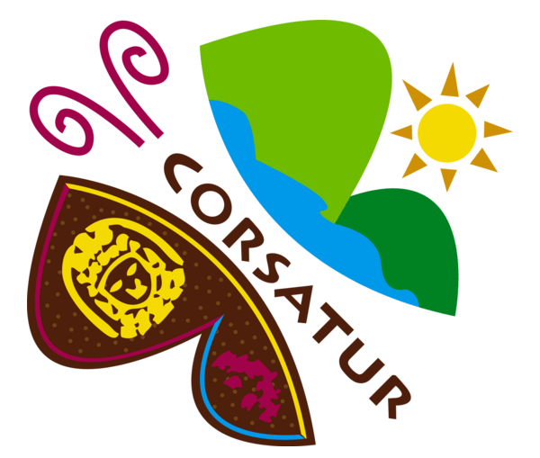
This is the operating entity attached to MITUR, responsible for implementing tourism promotion and marketing strategies at the national and international levels. It was established in 2000 and since then has organized campaigns, participated in international fairs, and supported tourism entrepreneurs in promoting the country's offerings. (Salvadoran Tourism Corporation [CORSATUR], n.d.)

Figure 8 Official logo of CORSATUR. Source: Salvadoran Tourism Corporation (2016).
3. Salvadoran Tourism Institute (ISTU)

Founded in 1958, it specializes in the management of recreational parks and state-owned tourist areas, such as water parks, natural areas, and recreation centers. Its function is to promote social and accessible tourism, guaranteeing recreational options for the Salvadoran population at affordable prices. (Salvadoran Tourism Institute, n.d.)

Figure 9 Logo of the Salvadoran Institute of Tourism (ISTU). Source: Salvadoran Institute of Tourism (2009).
2.3 NATURAL RESOURCES IN DESTINATION AREAS, LOCATION ON THE TOURIST MAP OF EL SALVADOR

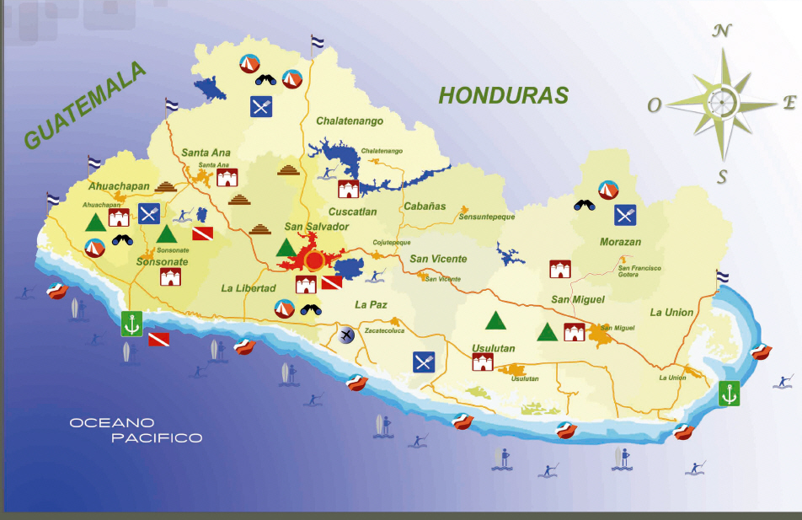
El Salvador has many natural sites, such as volcanoes, mountains, lakes, beaches, and mangroves, that attract domestic and international tourists. These resources are not only part of the landscape but also help preserve biodiversity and generate income for nearby communities. Thanks to them, tourism can offer activities such as hiking, wildlife watching, and water sports, while promoting environmental protection and strengthening the local economy.

Figure 10 Map of El Salvador. Source: El Salvador Turismo (n.d.).

WESTERN ZONE
Mountain
In the western zone, there are natural parks such as Montecristo and El Imposible. Montecristo National Park, located in Metapán, was the first protected area in the country and is part of the Trifinio Biosphere Reserve, which includes areas of El Salvador, Guatemala, and Honduras. It is characterized by its cloud forest, cool climate, and biological diversity.
El Imposible National Park, created in 1987, covers approximately 5,000 hectares of forest and is home to more than 500 plant species, 100 mammal species, and 285 bird species, making it essential for national hydrology. (El Salvador Travel, n.d.)
Volcanoes
The Apaneca-Ilamatepec mountain range is home to the Santa Ana Volcano, the Izalco Volcano, and Cerro Verde, which make up an important group of natural parks with great ecological and tourist value.
Lakes
This area is home to Lake Coatepeque, a volcanic crater lake known for its hot springs and water sports. This lake occasionally changes color to turquoise due to natural phenomena.
Beaches
Although the greatest concentration of beaches is in the central and eastern regions, the western region also offers access to coastal areas that are part of the tourist experience linked to the Ruta de Las Flores (Flower Route) and the mountainous landscapes that connect colonial towns.

CENTRAL ZONE
Mountain
In the central area, El Boquerón Park stands out, located in the crater of the San Salvador Volcano. This site offers interpretive trails and wildlife observation, such as raccoons, deer, and armadillos. There are also parks such as the El Espino Ecopark and the Plan de la Laguna Botanical Garden, which combine nature and urban accessibility.
Volcanoes
The San Salvador Volcano is one of the most emblematic volcanoes in the central zone, surrounded by protected natural areas that facilitate recreational and educational activities.
Lakes
Lake Ilopango, also of volcanic origin, is located in this area and is recognized for its potential for water activities and scenic views.
Beaches
In this area, the coastline offers internationally renowned beaches such as El Tunco and El Sunzal, part of the Surf City circuit, known for its quality waves for surfers from around the world.

EASTERN ZONE
Mountain
In the eastern zone, natural areas such as Chaguantique are located, which allow for ecotourism in mountainous and forested settings, away from the busiest tourist routes.
Volcanoes
The Conchagua Volcano is one of the main attractions of this region. Its location near the Gulf of Fonseca offers spectacular landscapes and hiking opportunities.

Lakes
In this area, lakes are less prevalent, but important lagoons are included, such as Laguna del Jocotal, recognized for its biodiversity and its designation as a Ramsar site.
Mangroves
The eastern zone has extensive mangrove systems that serve as habitat for diverse species and are essential for ecological balance. These areas allow for ecotourism and wildlife observation.
Beaches
The eastern coast includes less-visited areas that are equally attractive to tourists. Its coastline is interspersed with mangrove areas and natural parks, creating an ideal environment for nature activities and water recreation.

2.4 SOIL TYPES IN EL SALVADOR
2.4.1 Volcanic Soils
Also known as Andisols, these soils were formed from ash, sand, and materials ejected by the numerous volcanoes that cross the country. They are very common in areas such as the Cordillera del Bálsamo, the Valle de las Hamacas, and areas near active or extinct volcanoes. They are among the most productive soils in the country and support much of Salvadoran agriculture.
Characteristics:
• They have a loose and porous texture.
• They are dark and deep.
• They have a high mineral content, especially phosphorus and potassium.
• Good water retention capacity.
• Highly fertile, ideal for crops such as coffee, corn, beans, and vegetables.

2.4.2 Alluvial Soils
These are found in the lowlands of the country, especially in river valleys and coastal plains, where rivers have deposited sediments over time. They are common around the Lempa, Grande de San Miguel, and Paz rivers. They are ideal for growing rice, sugarcane, vegetables, and fruit trees. They are also suitable for livestock and urban development.
Characteristics:
• Variable texture (sand, silt, clay).
• Easy to work and well aerated.
• Generally fertile due to the accumulation of organic and inorganic materials.
• They are naturally renewed with each river flood.

2.4.3 Residual Soils
These soils have formed from the weathering of parent rocks, such as granite, basalt, or schist. They predominate in mountainous areas such as Chalatenango, Morazán, and La Unión. They can be used for hardy crops and fruit trees, but often require special management such as fertilization and erosion control.
Characteristics:
• Their composition depends on the type of original rock.
• Shallower in depth compared to alluvial or volcanic soils.
• Its fertility varies: it can be high or low.
• Its structure is more compact.

2.4.4 Organic Soils
They grow in humid, poorly drained environments, such as mangrove areas, swamps, and areas near coastal lagoons (for example, Jiquilisco Bay or Barra de Santiago). They are not widely used in conventional agriculture, but they have great ecological value, as they sustain biodiversity and protect against flooding. Some are used for specialty crops such as rice.
Characteristics:
• High content of decomposing organic matter.
• Very dark or black in color.
• They are usually saturated with water for long periods.
• Low bearing capacity for construction.
2.4.5 Saline and Sodic Soils
They are mainly found in coastal areas and valleys where seawater or saline groundwater have influenced the soil composition.
Characteristics:
• High concentration of soluble salts (chlorides, sulfates, carbonates).
• Loose or brittle structure.
• Poor drainage.
• Low natural fertility and difficult plant development.
2.5 CULTURAL IDENTITY, INTANGIBLE TOURISM RESOURCES
Western Zone
The western zone of El Salvador is characterized by strong roots in traditions that reflect historical processes of cultural fusion. In Ahuachapán, the Festival of the Lanterns, celebrated on September 7, is an example of living heritage that combines Catholic religious elements and community expressions of identity. The Fiestas Julias de Santa Ana, meanwhile, are representative of the fusion of patron saint celebrations and modern popular expressions, integrating processions, dances, and recreational activities that attract national and international visitors.
Religious syncretism is particularly evident in the Danzas de Historiantes (Historical Dances) in Sonsonate, which reenact episodes of the Spanish conquest, symbolizing cultural resistance and the indigenous reinterpretation of colonial history.
The local cuisine, with dishes such as fried yuca with chicharrón, riguas, and Apaneca highland coffee, constitutes an intangible resource of identity and economic value. At the same time, legends such as La Cuyancúa and El Cadejo are part of the popular imagination, transmitting moral values ​​and ancestral worldviews.

Central Region
In the central region, cultural identity is marked by major religious and civic events. The August Festivals of San Salvador, celebrated from August 1 to 6 in honor of the Divine Savior of the World, are the greatest exponent of Salvadoran religious syncretism. The Transfiguration procession combines Christian symbolism and ceremonial practices inherited from indigenous tradition.
Traditional cuisine, led by pupusas, is accompanied by tamales, atol shuco, and other dishes that are part of the intangible cultural heritage.
In the narrative realm, legends such as The Squealing Cart and The Fleshless Woman express the moralizing nature of local folklore, serving as cultural tourism resources in festivals and historical tours.

Eastern Zone
The eastern zone is distinguished by the magnitude of its celebrations and the persistence of oral stories linked to regional identity. The San Miguel Carnival, held in November, is recognized as one of the largest festivals in Central America and constitutes a space where musical expressions, dances, and elements of contemporary cultural commerce converge.
The gastronomy stands out for the variety of seafood in La Unión, the Indian chicken soup in Usulután, and the typical sweets of San Miguel, which are consumed both during festivities and in everyday life.
The narrative heritage includes stories such as The Woman of the Plains and The Headless Father, which reflect popular beliefs about lost souls and hidden treasures, maintaining a link between the colonial past and the tourist present.
2.6 SUSTAINABLE DEVELOPMENT GOALS
Goal 1: End Poverty.
The primary goal is to eradicate extreme poverty by 2030, taking into account that the COVID-19 pandemic has increased the number of people in poverty by almost 90 million, and that in 2022, 8.4% of the world's population was living in this condition. By 2030, the figure could still be 7%, especially in sub-Saharan Africa. The main causes are unemployment, social exclusion, and vulnerability to disasters, in addition to rising food prices. Furthermore, 55% of the world's population, or 4 billion people, lack social protection, making it urgent to create universal and sustainable systems. (United Nations, n.d.).

Goal 2: Zero Hunger.
Hunger is expected to be eradicated by 2030, but since 2015 it has increased alarmingly due to the pandemic, conflict, climate change, and inequality. In 2022, 9.2% of the world's population suffered from chronic hunger, while 2.4 billion people suffered from food insecurity, an increase of 391 million compared to 2019. Furthermore, 2 billion people lack regular access to safe and nutritious food, 148 million children are stunted, and 45 million children under 5 are wasted. More than 600 million people are expected to continue suffering from hunger in 2030. The main causes are high food prices, conflict, and the climate crisis. Achieving zero hunger requires sustainable food systems, investments in agriculture, social protection, and ensuring access to adequate food for the poorest people. (United Nations, n.d.).

Goal 3: Good Health and Well-being.
It seeks to ensure healthy lives and promote well-being for all. Significant progress has been made, such as a 52% reduction in AIDS-related deaths since 2010, the elimination of at least one tropical disease in 47 countries, and the achievement of child mortality targets in 146 of 200 countries. However, despite all this, inequalities in access to health persist, which were exacerbated by COVID-19, causing the largest drop in childhood vaccinations in 30 years and increases in deaths from tuberculosis and malaria. By 2030, the goal is to end epidemics such as AIDS, malaria, and tuberculosis, guarantee universal health coverage, and access to safe medicines and vaccines. Achieving this goal requires greater investment in health systems, reducing disparities, and protecting the most vulnerable groups. (United Nations, n.d.).

Goal 4: Quality Education.
The goal is to achieve inclusive, equitable, and quality education. However, the pandemic has exacerbated already slow progress, causing learning losses in four out of five countries. It is estimated that by 2030, 84 million children and young people will be out of school. The main challenges include a lack of resources in sub-Saharan Africa, the digital divide, and economic and gender inequalities, as nearly 40% of countries fail to achieve primary education. To achieve this goal, it is necessary to prioritize education financing, guarantee free and compulsory education, train more teachers, improve infrastructure, and take advantage of the digital transformation. (United Nations, n.d.).

Goal 5: Gender Equality
Although there has been progress, the gap remains wide: women earn on average 23% less than men, spend three times more time on unpaid domestic and care work, and face violence, discrimination, and underrepresentation in positions of power. The pandemic exacerbated these inequalities, increasing gender-based violence and the burden of care, despite the fact that 70% of health and social care workers are women. At the current rate, it will take centuries to eradicate practices such as child marriage and inequality in political and workplace leadership. Although female genital mutilation and child marriage have been reduced, challenges persist: 35% of women aged 15 to 49 have experienced physical or sexual violence, and almost half lack control over their health and reproductive rights. Achieving this goal requires policy reforms, investments, and leadership to ensure full and sustained equality. (United Nations, n.d.).

Goal 6: Clean Water and Sanitation.
Seeks to achieve safe drinking water, sanitation, and hygiene for all. Despite progress, in 2022, 2.2 billion people still lacked access to safe drinking water and 3.5 billion lacked adequate sanitation. Population growth, urbanization, and climate change are increasing pressure on water resources, causing scarcity and pollution. Achieving the goal by 2030 requires investment in infrastructure, sustainable management, ecosystem protection, and hygiene education. Water is vital not only for health, but also for food, energy, and environmental security, and is also a key strategy against climate change. (United Nations, n.d.-a).

Goal 7: Affordable and Clean Energy.
The goal of universal access to affordable, reliable, sustainable, and modern energy. Although global access to electricity increased from 87% in 2015 to 91% in 2021, it is projected that by 2030, 660 million people will still lack this service and 2 billion will still use polluting fuels for cooking. Energy is essential for health, education, agriculture, and the economy, but the energy sector generates nearly 60% of global emissions. Meeting this goal requires investments in renewable energy, energy efficiency, and clean technologies; failure to do so condemns us to perpetual inequality and harmful effects on the environment and human health. (United Nations, n.d.-b).

Goal 8: Decent Work and Economic Growth.
Promotes inclusive and sustainable economic growth, along with decent employment for all. Despite the reduction in global unemployment to 5.4% in 2022, high levels of informality, wage inequality, and hardships for youth persist. Decent work implies a decent income, job security, social protection, and equal opportunities. However, crises such as the pandemic, debt, and trade tensions limit progress. An estimated 192 million people were unemployed in 2022, with young people and women being the most affected. Achieving this goal requires investment in education, training, social protection systems, and sustainable and innovative economies. (United Nations, n.d.-c).
Goal 9: Industry, innovation, and infrastructure.
The goal is to create resilient infrastructure, sustainable industrialization, and technological innovation. The global manufacturing industry has been affected by trade tensions, inflation, and the pandemic, although high-tech sectors showed growth. In 2022, 95% of the population had mobile broadband coverage, but inequalities persist, especially in least developed countries in Africa. Investment in research, innovation, and connectivity is essential for economic and social development, as well as for reducing emissions and promoting sustainability. Without innovation and infrastructure improvements, eradicating poverty and providing access to basic services such as health, sanitation, and education would be more difficult. (United Nations, n.d.-d.)

Goal 10: Reduction of Inequalities.
Inequality limits economic and social development, affecting the stability of countries and the opportunities of millions of people. Although progress has been made in the income of the poorest 40%, the COVID-19 pandemic has widened gaps, both within and between nations. Reducing inequality requires redistributive policies, equitable access to education and health, the elimination of discriminatory barriers, and international cooperation that guarantees opportunities for all. (United Nations, n.d.-d).

Goal 11: Sustainable Cities and Communities.
More than half of the world's population lives in cities, placing significant pressure on infrastructure, transportation, and basic services. Cities account for 60-80% of energy consumption and 75% of carbon emissions, making them key to addressing climate change. Sustainable cities require equal access to housing, basic services, efficient transportation, and disaster resilience, thus ensuring social cohesion and quality of life. (United Nations, n.d.-d.)

Goal 12: Responsible Consumption and Production.
Excessive consumption and unsustainable production are depleting natural resources and increasing pollution. To reverse this, we must address efficient resource management, reduce food waste, promote clean energy, and responsible business practices. Adopting sustainable habits not only protects the environment but also ensures the well-being of future generations. (United Nations, n.d.-d.)

Goal 13: Climate Action.
Climate change is one of the greatest current threats, causing extreme events, rising sea levels, and biodiversity loss. Despite international agreements, greenhouse gas emissions keep at critical levels. Addressing this challenge requires policies to reduce emissions, transition to clean energy, climate finance, and adaptation in vulnerable communities. (United Nations, n.d.-d).

Goal 14: Life Below Water.
The oceans cover more than 70% of the planet and are vital to life, regulating the climate, producing most of the oxygen, and providing an essential source of food and employment. However, they face serious threats such as overfishing, plastic pollution, acidification, and the destruction of coastal ecosystems. These pressures affect both marine biodiversity and the communities that depend on marine resources for survival. (United Nations, n.d.-d).

Goal 15: Life on Land.
Terrestrial ecosystems are essential for human life, providing food, water, medicine, and regulating natural cycles. Despite their importance, deforestation, desertification, soil degradation, and biodiversity loss are advancing at an alarming rate. Millions of hectares of forests disappear each year, and more than 10% of animal and plant species are at risk of extinction. These processes are being halted through ecosystem restoration, sustainable forest management, and biodiversity protection. (United Nations, n.d.-d).

Goal 16: Peace, Justice, and Strong Institutions.
Sustainable development cannot be achieved without peace, justice, and the strengthening of transparent and accountable institutions. Today, millions of people continue to be victims of violence, corruption, and lack of access to justice, which weakens trust in governments and blocks progress and the serious goal of reducing violence in all its forms and ensuring human rights. (United Nations, n.d.-d).

Goal 17: Partnerships to achieve the goals.
The achievement of the 2030 Agenda depends on international cooperation and the strengthening of partnerships between governments, the private sector, and civil society. Similarly, no country can address global challenges such as poverty, climate change, and inequality alone. This promotes the mobilization of financial resources, the transfer of technology, the strengthening of global trade, and support for developing countries. It also highlights the importance of sharing knowledge and fostering inclusive partnerships at the international level. (United Nations, n.d.-d.)

2.7 STRATEGIC PLAN: QUALITY CONTROL, CUSTOMER SATISFACTION
2.7.1 Strategic quality plan
1. Customer Experience: Surveys and interviews are implemented to measure customer satisfaction. Innovation in tourism activities is also promoted, seeking to offer unique experiences.
2. Continuous Improvement: Customer comments and suggestions are analyzed monthly, and the necessary improvements are swiftly implemented to optimize the tourist experience.
3. Staff Training: A continuous training program is developed in customer service, language proficiency, and cultural awareness. Periodic evaluations are conducted to measure staff performance and ensure the quality of the service offered.
4. Partnerships with Local Businesses: Aurora Tours collaborates with restaurants, accommodations, and suppliers previously selected for their reliability, hygiene standards, quality, and fair prices. This allows for a comprehensive and safe experience for customers.
5.Operational Safety: Clear first aid protocols, safe routes, and constant equipment maintenance have been established. Staff receive ongoing training in risk prevention and emergency management, ensuring the protection of all participants during activities.
6. Sustainability and Environmental Care: Responsible practices that promote environmental stewardship are implemented, such as reducing single-use plastics and protecting beaches and local ecosystems.
7. Clear and Transparent Communication: Customers are guaranteed to receive accurate and complete information about itineraries, prices, and conditions before booking the service. Contact channels are maintained before, during, and after the tour.
8. Use of Social Media and Technology
Social media is used to promote tours through engaging visual content. Online booking and payment systems are offered for convenience, and the customer experience is digitally monitored to implement improvements based on feedback.
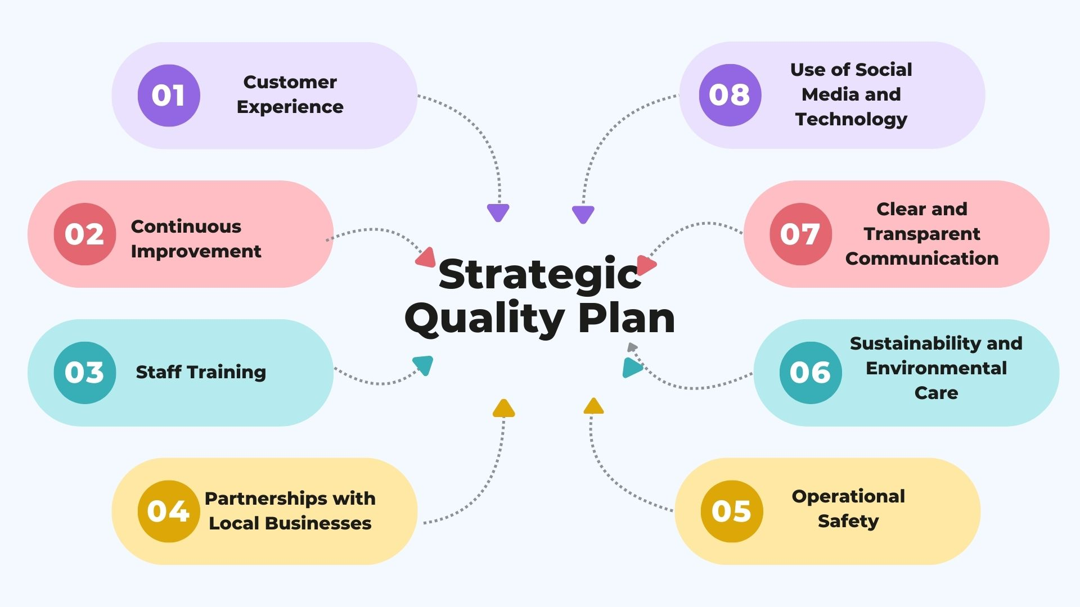

Strategic action plan

Figure 11 Strategic Quality Plan. Source: Own elaboration (2025).

2.7.2 Strategic Action Plan
To make Aurora Tours more visible and attract future clients, a simple digital promotion plan has been created. Social networks will be our main tool. Facebook will share general information about our services and tour packages. Instagram will show photos, reels, and short videos of the experiences we offer in beaches, viewpoints, and cultural spots. TikTok will help us upload dynamic videos that highlight the fun and unique moments of each tour.
Aurora Tours will also have a website where visitors can check itineraries, promotions, discounts, and available dates. For direct communication, clients will be able to contact us through email, phone calls, or WhatsApp.
These actions will be organized by the Aurora Tours team, making sure that social media is updated regularly and that all messages are answered clearly and on time. Finally, special promotions will be offered depending on the tour package, including student discounts, price reductions for tour operators, and small complimentary snacks to thank clients for choosing our services.

Below is better detailed the actions and their respective managers for a better service to our clients:
ACTION | ROLE | IMPROVEMENTS
Maintain fast and clear communication with clients through WhatsApp, Instagram, and email. Also, create attractive visual content for social media (especially TikTok and Instagram) and encourage clients to share their experience. | Andy Jiménez  Founder and Tour Operator  In charge of managing direct communication with clients, creating simple social media advertising campaigns, and following up on interactions and trends on TikTok. | Clients who book one week in advance receive a free local welcome drink at the beginning of the tour.  Exclusive discount for active TikTok users:  - 10% discount for showing a 100-day streak on TikTok.  - 20% discount for a 200-day streak.  - 28% discount if they have more than 250 consecutive days.
Design fun, flexible, and safe itineraries and publish them on social media to be done at beaches, viewpoints, and cultural sites. Personalize the tour according to the needs of the group to ensure a unique experience. | Andy Jiménez  Experience Designer  Responsible for planning and personally guiding the tours, adapting to the clients' interests to make each tour memorable and special. | themed tours such as Surf Day or Pupusa Route, depending on the theme a meaningful free souvenir is given. For the Pupusa Route, a T shirt and a pupusa shaped hat, and for Surf Day, sunglasses and a cap.  • Clients get 2 points for every dollar spent:  200 points equal a 10 percent discount  350 points equal a 15 percent discount  500 points equal a 25 percent discount
Organize during each tour a brief cultural or ecological activity corresponding to each place, such as beach cleanup or trash collection in forests. | Andy Jiménez  Cultural and Sustainability Ambassador  In charge of guiding the activities and connecting clients with the local community. | • Free snack for those who participate in the activity.  • Free access to an extra activity not normally included, such as a free turn on the canopy or a free boat ride.
Figure 12 Aurora Tours Action, Roles, and Improvements Table. Source: Own elaboration (2025).

CHAPTER III
LOCAL DEVELOPMENT THROUGH A TOURISTIC PRODUCT OR SERVICE
3.1 PROFILE OF THE ENTREPRENEUR
As aurora tours, it is important to know the basic information about the profile of the entrepreneur as objectives, definitions and interests.
3.1.1 Definition of entrepreneur
To understand the concept of the entrepreneur, it is essential to analyze both its linguistic origin and its conceptual evolution throughout history. According to the Oxford English Dictionary (OED, 2024), the term entrepreneur refers to “a person who sets up a business or businesses, taking on financial risks in the hope of profit.” This definition emphasizes two fundamental aspects that characterize the entrepreneurial spirit: initiative and risk-taking. Entrepreneurs are not merely individuals who start projects; they are people who identify opportunities, confront uncertainty, and assume responsibility for the outcomes of their decisions.
The concept of entrepreneurship comes from the French word entreprendre, meaning "to undertake" (Hébert & Link, 2006; Islam, 2012). This etymology reflects the essence of entrepreneurship as a process of exploration and innovation, where individuals venture into uncharted territories whether in business, technology, or society to create something new. For Guy Kawasaki (2007), “being an entrepreneur is not a job position but a state of mind of those who want to change the future.” In this sense, entrepreneurship is more than a profession; it is an attitude toward life that involves transforming ideas into tangible realities through initiative and perseverance.
Similarly, Trias de Bes (2007) describes entrepreneurship as “a way of facing life in which the person enjoys uncertainty of what will happen tomorrow.” This perspective underlines one of the most important psychological aspects of the entrepreneur: the ability to find motivation in instability. Causse at the end of the day entrepreneurs are people that perceive uncertainty not as a threat more like an opportunity to test their creativity, adaptability, and resilience.
From a behavioral standpoint, the entrepreneur can be seen as someone who transforms opportunities into value. Whether the motivation is economic independence, personal fulfillment, or social improvement, entrepreneurship always implies the willingness to take risks, make sacrifices, and learn from mistakes. Alcaraz Rodríguez (2011) emphasizes that entrepreneurs must possess creativity, innovation, perseverance, and the capacity to manage problems. These traits allow them not only to start projects but also to sustain them successfully over time.
In addition, Porter (2006) identifies innovation as the main driver of competitiveness and differentiation in the market. Entrepreneurs create value not only by inventing new products but also by improving existing processes, redefining experiences, or discovering better ways to meet people’s needs. In this regard, entrepreneurship becomes a continuous process of renewal and adaptation, in which persistence and long-term vision are indispensable.
According to the analysis presented by Mario J. Abambari Arévalo (2016), an entrepreneur is characterized by a series of interrelated attributes that form the foundation of the entrepreneurial profile. Among the most relevant are passion, which fuels motivation and commitment; vision, which provides clarity of purpose and direction; and learning ability, which allows constant improvement through experience. These are accompanied by determination and courage, essential for facing the difficulties inherent in every business endeavor, and by creativity and innovation, which serve as the sources of differentiation and growth.
Equally important are persistence, understood as the capacity to continue despite obstacles, and the sense of opportunity, which enables entrepreneurs to identify needs or problems that can be transformed into viable projects. Furthermore, strategic long-term planning allows them to anticipate changes in their environment, make informed decisions, and ensure the sustainability of their ventures (Abambari Arévalo, 2016).
In conclusion, the profile of the entrepreneur is not defined solely by the possession of technical skills or financial resources but by a particular mindset: one that combines creativity, courage, resilience, and vision. And the greatest strength we find is in their ability to create challenges into opportunities and to see beyond what already exists, creating progress and innovation.
And currently entrepreneurship has gained an important role in the economy and, therefore, in society. This trend is mainly driven by three fundamental factors:
- The need to achieve economic independence and stability.
- The high levels of unemployment.
- The low quality of existing jobs.
These conditions have encouraged many people to look for new ways to improve their quality of life by creating their own sources of income. Starting a business allows individuals to develop their ideas, generate employment, and contribute to local economic growth. However, this process requires an entrepreneurial mindset, since it takes courage and determination to give up the apparent “stability” of a regular job and take the risk of becoming a business owner. Unlike salaried workers who receive a fixed income, entrepreneurs face uncertainty and must rely on their skills, creativity, and persistence to succeed (Hisrich et al., 2017).
In this context, entrepreneurship is highly significant because of its positive impact on individuals, their communities, and society as a whole. In many countries, governments have recognized this importance and have created support programs to encourage new business creation. These initiatives include financial aid, training opportunities, and specialized institutions dedicated to promoting entrepreneurship and helping new entrepreneurs develop their projects successfully (Kuratko & Hodgetts, 2007; Drucker, 2015).
3.1.2 Attributes of entrepreneurs
Each author from their perspective highlights the main attributes that entrepreneurs should have:
- Passion: Entrepreneurs dedicate themselves fully, with both body and soul, to achieving the goals and objectives they have set. Passion is a core component that drives other behaviors and enables them to endure the sacrifices and challenges that running a business entail. It also fuels resilience during difficult times and inspires others around them to remain committed.
- Vision: Successful entrepreneurial work begins with defining strategic steps that will lead to the desired results. By establishing clear goals, an entrepreneur gains a broader perspective on immediate priorities and current needs. Vision helps in mapping a clear route to success; however, it must be accompanied by action because a vision without execution holds no value, as Mark Hurd, director executive of Hewlett-Packard, pointed out (Syrett, 2010). Vision also allows entrepreneurs to anticipate future opportunities and adapt to changes in the environment.
- Learning Ability: Refusing to listen or learn is to deny oneself many opportunities. A successful entrepreneur recognizes that learning is a continuous process and that valuable lessons can be gained from every experience and from every person they meet. This openness to learning fosters adaptability and growth over time.
- Determination and Courage: Entrepreneurs must anticipate challenges and have the ability to identify problems early to correct them effectively. They face difficulties head-on, absorb setbacks, and make firm, timely decisions to resolve issues efficiently. Courage allows them to take risks while determination ensures they stay the course despite obstacles.
- Creativity and Innovation: Creativity is the process through which ideas are generated, developed, and transformed into added value. Entrepreneurs do not need to reinvent what already exists, but they must identify new ways to do things and ensure differentiation from competitors. Innovation is not the same as short-term competitiveness (Porter, 2006), as it involves applying creative ideas in practical ways to produce unique solutions and long-term value.
- Persistence: Any entrepreneurial initiative requires persistence. Attempting something only once and giving up is never enough. Entrepreneurs take one step at a time, refining their methods creatively and systematically if results are not achieved on the first try. Persistence, when combined with good judgment, ensures steady progress toward objectives.
- Sense of Opportunity: Entrepreneurs are able to identify the needs, problems, and trends in the environment around them. They conceive alternatives and solutions to meet these needs, often seeing opportunities where others see obstacles. This skill allows them to create value and gain a competitive advantage.
- Teamwork: An entrepreneur’s leadership seeks to unify ideas and build consensus when problems arise, ensuring that the team involved in the project works harmoniously. Strong teamwork fosters collaboration, shared responsibility, and a sense of purpose within the business.
- Self-esteem and Confidence: Entrepreneurs are optimistic and self-assured. Confidence in one’s own skills and abilities creates a positive mindset that attracts success and inspires others. This self-belief enables entrepreneurs to take calculated risks and pursue goals even in uncertain circumstances.
- Assertiveness: Being direct and clear about what one thinks, feels, and wants, without harming others, is an essential characteristic for achieving objectives. Assertiveness helps entrepreneurs communicate effectively, negotiate successfully, and resolve conflicts efficiently.
- Long-term Strategic Planning: Entrepreneurs should not merely react to changes; they must anticipate shifts in the market and the environment, making timely and appropriate decisions. Effective long-term planning ensures that the business can survive and thrive despite uncertainties, giving it a competitive edge.
- Organization: Establishing a structured schedule of activities while remaining flexible enough to accommodate necessary adjustments is essential. This short-term planning derives from the broader strategic plan and is continuously refined through feedback. Good organization maximizes efficiency and ensures that goals are systematically pursued.
3.1.3 Key Entrepreneurial Attributes at Aurora Tours
Passion: We devote ourselves completely to our project, driven by our love for tourism and our desire to promote the natural beauty of El Salvador. Our passion motivates us to offer unforgettable experiences and to constantly improve the quality of our services.
Vision: We define clear goals and strategic steps to position Aurora Tours as a leading tour operator both nationally and regionally. Our vision gives us perspective on where we want to go and how to achieve sustainable growth through dedication and innovation.
Learning Ability: We believe that every experience and every traveler teach us something new. We stay open to learning from our clients, collaborators, and the tourism industry itself, allowing us to adapt, grow, and improve continuously.
Determination and Courage: We face challenges with strength and confidence. We make firm decisions, overcome obstacles, and remain committed to our objectives, even in the face of uncertainty or economic difficulties.
Creativity and Innovation: We constantly generate new ideas to design original and meaningful tourism experiences. Through creativity and innovation, we add value to our services by showcasing the culture, nature, and authenticity of El Salvador.
Persistence: We know that success requires effort and time. We keep moving forward with consistency, learning from each experience, and improving step by step to reach our long-term goals.
Sense of Opportunity: We identify opportunities around us such as emerging destinations, ecotourism ideas, and cultural activities, that we can pass them into memorable experiences that attract both local and international travelers.
Long-Term Strategic Planning: We anticipate changes in the tourism sector and make timely decisions to ensure our continued success. Our strategic planning focuses on sustainable growth, service excellence, and customer satisfaction as the foundation of Aurora Tours’ future.

3.2 MARKET NICHE.
3.2.1 Definition
A market niche is a specific part of a broader market, made up of consumers with unique needs, preferences, or problems. Unlike general markets, niches allow businesses to offer highly tailored products or services to clearly defined audiences (Kotler & Keller, 2016). Companies that successfully identify and serve these niches can gain a competitive advantage, build customer loyalty, and achieve profitability even with a smaller audience.
3.2.2 Characteristics of a Strong Market Niche
A niche market is attractive to a business if it has the following characteristics:
- A clearly defined and highly segmented audience.
- A size large enough to be profitable, with clients interested in and able to pay for the product or service.
- A specialization of an existing profitable segment.
- A focus on solving a specific need that few other companies address.
- A market with room for competition but not oversaturated (Lamb et al., 2020).
3.2.3 Types of Market Niches
By Age: Products for toddlers, adults, or seniors, such as toys for young children or skincare for older women.
Special Conditions: Products for people with unique needs, such as left-handed tools, anti-bedsore products for seniors, or sugar-free foods for diabetics.
Gender: Products for different gender identities, including transgender or non-binary individuals. Examples include specialized makeup, clothing, or puberty blockers.
Occupation: Tools or services for professionals, such as stethoscopes for doctors, stationery for architects, or platforms for journalists.
Values and Ideology: Products that align with customers’ social or environmental values, such as vegan restaurants, eco-friendly personal care, or brands supporting indigenous communities (Kotler & Keller, 2016; Lamb et al., 2020).
3.2.4 Niche Market Strategies
A niche market strategy involves exploring a specific market segment, identifying an unmet need, and developing a business or product to meet that need. This strategy also includes planning, marketing, and growing the business within that niche (Lamb, Hair, & McDaniel, 2020).
Also, we have the difference between Market Segment and Market Niche because market segment is a broad group of consumers with shared characteristics, such as age, income, or interests. A market niche is a smaller subset of that segment with more specific and unmet needs (Kotler & Keller, 2016).
Even though niches are profitable, they present challenges:
- Finding the right niche: The most valuable niches are often small and not obvious.
- Making the idea a reality: Hyper-segmented markets may lack suppliers or infrastructure.
- Reaching the audience: Targeted advertising, especially online through tools like Facebook Ads or Instagram Ads, is essential for reaching highly specialized audiences.
There are some steps that we have to follow to identify our own niche which are the following:
- Identify your passions or areas of expertise.
- Look for unmet problems in that sector.
- Check if there is enough audience interest.
- Analyze competitors to find gaps in the market.
- Test your idea with surveys or pilot programs.
Combining what you love, what you can do well, and what people need is often the key to a successful niche (Kotler & Keller, 2016).
Market niches offer businesses a chance to focus on highly specific audiences and create tailored products or services. By identifying an unmet need, understanding the audience, and using precise marketing strategies, companies can gain loyal clients, reduce competition, and achieve profitability. Whether by age, condition, gender, occupation, or values, niches allow businesses to specialize and grow while delivering real value to their customers.
3.2.5 Market Segments and Niches for Aurora Tours
Market Segment: Adventure Travelers
These are national and international tourists who love excitement, nature, and exploring new places. They enjoy outdoor activities like hiking, surfing, and visiting natural reserves.
Market Niche: Coastal Adventure Lovers
Aurora Tours focuses on travelers who want adventure by the sea, like surfing in El Tunco or kayaking in Jiquilisco Bay. They look for fun and safe guided experiences that mix adrenaline with beautiful natural views.
Market Segment: Cultural and Experiential Tourists
This group wants to learn about the history, traditions, and real life of each place they visit. They enjoy connecting with local people and discovering new cultures.
Market Niche: Art and Heritage Fans
Within this group, Aurora Tours works with visitors who love art, crafts, and historic towns. The company offers tours that include visits to artisan workshops, local festivals, and cultural sites in places like Suchitoto and Concepción de Ataco.
Market Segment: Relaxation and Leisure Tourists
These travelers want to take a break from their daily routine and relax in peaceful, beautiful places. They look for comfort, good service, and rest.
Market Niche: Wellness and Nature Retreat Seekers
Aurora Tours focuses on people who want to recharge and find peace in nature. They offer beach yoga, meditation, massages, and eco-lodges surrounded by tropical scenery, perfect for relaxing and feeling good.
3.3.1 LOGO
Is a visual symbol or graphic mark that identifies a company, product, or brand. It can include images, shapes, colors, and stylized text designed to create recognition among consumers, works as a company’s identity, helps to distinguish it from competitors, and according to Kotler and Keller (2016), is a fundamental component because it helps to create connections with clients and builds long-term loyalty.
Our logo represents the beauty and diversity of El Salvador. The colorful shapes at the top symbolize the aurora, the light, and the desire to explore new places.
They also reflect the landscapes of our country: mountains, forests, and beaches, the volcano silhouette shows the strength and energy of our land, while the golden color represents the sun, joy, and adventure., the blue and green tones express calmness, trust, and a connection with nature, inviting our travelers to relax and explore. The tagline “Discover the Wonder” reflects our mission that is show the best of El Salvador and make every trip a unique experience.

Figure 13 Official logo of Aurora Tours. Source: Own elaboration.
- The Aurora Waves: The layered green and teal waves symbolize wonder, movement and discovery, representing the magical travel experiences Aurora Tours aims to provide.
- The Mountains: The mountain silhouette reflects adventure, strength and the natural beauty of El Salvador, reinforcing the company’s commitment to sustainability and outdoor exploration.
- The Golden Horizon: The golden curve suggests sunrise and new beginnings, highlighting warmth, optimism and the excitement of starting a new journey.
- Color Palette (Greens & Teals): These colors evoke nature, balance and peace, reinforcing the idea of safe, memorable and refreshing travel experiences.
- Navy Blue: Associated with trust and professionalism, it strengthens the agency’s identity as a reliable and organized tour operator.
- Gold/Yellow: Represents joy, energy and the vibrant spirit of El Salvador, aligning with Aurora Tours’ focus on warm, welcoming adventures.
3.4.1 SLOGAN
Is a phrase that is short and easy to remember which expresses what a company wants to communicate to its audience. It usually shows the company’s main idea, values, or promise. Armstrong and Kotler (2017) explain that a good slogan should be short, clear, and attractive to the people it wants to reach, for example Nike’s “Just Do It,” McDonald’s “I’m Lovin’ It,”.

Why our slogan “Discover the Wonder.”?

- Sense of discovery: “Discover the Wonder” invites travelers to explore and enjoy the beauty of El Salvador. Each tour is made to spark curiosity and help people connect with the country’s nature, culture, and history.
- Connection with nature and culture: Our tours let visitors see volcanoes, beaches, forests, and towns full of tradition. The slogan shows our goal to share the real side of El Salvador, where culture and nature come together.
- Memorable experiences: Traveling with us is not just about visiting places. It is about creating special memories filled with excitement, peace, and joy.
- More than a tour: Aurora Tours offers more than a trip. It is an experience to enjoy with all the senses: the views, the sounds, the people, and the feeling of adventure that makes El Salvador unique.
3.5.1 MISSION
A company's mission are the ethical principles that guide the performance of the organization and the behavior of its members. Defining specific values helps create a corporate identity aligned with the company's mission (Concepto.de, n.d.). Although values are influenced by the beliefs and customs of each society, there are universal values such as transparency, honesty, innovation, and commitment
The mission for Aurora Tours is to offer the best unique tourist experiences that can be
provided for travel and adventure lovers in El Salvador, especially on its beaches, highland areas
of the country, and its most emblematic places. Our main goal is that every visitor, whether
national or foreign, can get to know and enjoy the natural beauty, culture, and hospitality of our
country through organized tours with quality, safety, personalized attention, and inclusivity.
Many of our tours are also designed for people with disabilities who, just like everyone else,
want to experience the magic of exploring beautiful places in our country. Furthermore, as a tour
operator, we are committed to work sustainably, respecting the environment, and supporting
local people so that they can also obtain additional benefits generated by tourism.
3.6.1 VISION
The vision represents what a company aims to achieve in the future. It should be an ambitious yet attainable goal. The vision provides a clear path to follow, enabling the organization to fulfill its mission, and is expressed in a concise and direct statement (Concepto.de, n.d.).
Our vision is for Aurora Tours to become the leading tour operator par excellence in El
Salvador, recognized both regionally and internationally for providing authentic, responsible, and
safe experiences. In the future, we want our company to be a benchmark for sustainable tourism,
where travelers not only enjoy their visit but also take with them learning experiences and
positive memories of the country, its people, and its culture. Furthermore, we want them to
encourage more travelers and adventure lovers to visit our country and request our services, just
as they enjoyed their tours
3.7.1 VALUES
Organizational values refer to the shared principles and beliefs that guide a company’s actions and decisions, shaping its culture and influencing employee behavior (Robbins & Coulter, 2018). In business values are the ones that leads an organization’s behavior and operations, along with the mission and vision, they help define its identity, set strategies, and build its institutional image.
Common examples include trust, transparency, innovation, and social responsibility. Their importance lies in distinguishing the company from others, guiding internal policies, maintaining consistency in actions, and creating a positive impact on society.
A company’s values determine the traits that set it apart from others in its industry. Defining these values helps to:
- Establish internal rules and policies that shape the company’s identity.
- Develop strategies to achieve its goals.
- Maintain a clear direction in daily operations.
- Create a positive impact on society and consumers.
The values that guide Aurora Tours are the foundation of everything we do and represent our commitment to our customers and the environment:
- Commitment to the client: Offer a close, friendly, and high-quality service, always listening to the needs of each traveler.
- Sustainability: Promote tourism that protects nature, reduces negative impacts, and contributes to the well-being of local communities.
- Innovation: Design creative and different experiences so that each tour is special and unique.
- Teamwork: Collaborate with respect, responsibility, and clear communication, both with my team and with suppliers and local partners.
- Nationalism: Proudly showcase the cultural, historical, and natural wealth of the country to all visitors.
- Safety: Ensure that every activity is carried out with measures that protect the integrity and well-being of tourists.

CHAPTER IV
REFERENCES

4.1 REFERENCES
Alcaraz Rodríguez, R. (2011). Emprendimiento y creatividad en los negocios. McGraw-Hill.
Armstrong, G., & Kotler, P. (2017). Marketing: An introduction (13th ed.). Pearson Education.
Aurora Tours. (2025). Official logo of Aurora Tours [Image]. Personal archive.
Barraza Ibarra, J. (2010). Perspectivas y tendencias del turismo en El Salvador: 1930–2008. UFG Editores. https://icti.ufg.edu.sv/doc/14501perspectivas.pdf
Civitatis. (n.d.). Tourist activity in El Salvador [Image]. https://www.civitatis.com/es/san salvador/excursion-ruta-maya/
Corporación Salvadoreña de Turismo. (2016). Guía institucional de archivo [PDF document]. https://drive.google.com/file/d/1LDbvVgTs9GmeR_jT6cTV6PdJD3dYU378/view?usp=drive_link
Corporación Salvadoreña de Turismo. (n.d.). History. https://corsatur.gob.sv/historia/
Drucker, P. F. (2015). Innovation and entrepreneurship: Practice and principles. Routledge.
EcuRed. (2025). Instituto Salvadoreño de Turismo. https://www.ecured.cu/Instituto_Salvadore%C3%B1o_de_Turismo
El Salvador Travel. (n.d.). Do you know why it’s called El Imposible? https://elsalvador.travel/article/do-you-know-why-its-called-el-imposible/
El Salvador Turismo. (n.d.). Map of El Salvador [Map]. https://www.elsalvadorturismo.com.sv/viajeelsalvador/mapaelsalvador/index.html
Esneca Business School. (2024, October 16). What is the history of tourism? Hospitality and Tourism. https://www.esneca.com/blog/origen-historia-turismo/
Harris & Ewing. (1915). Alfonso Quiñónez Molina, president of El Salvador [Photograph]. Wikimedia Commons. https://commons.wikimedia.org/wiki/File:Alfonso_Qui%C3%B1%C3%B3nez_Molina_1915.jpg
Hébert, R. F., & Link, A. N. (2006). Historical perspectives on the entrepreneur. Foundations and Trends in Entrepreneurship, 2(4), 261–408.
Hisrich, R. D., Peters, M. P., & Shepherd, D. A. (2017). Entrepreneurship (10th ed.). McGraw-Hill Education.
Instituto Salvadoreño de Turismo. (2009). Manual de reclutamiento y selección de personal [PDF document]. https://drive.google.com/file/d/1aSXovpStybRAsSJTzoF5O-OlwmAP8eBn/view?usp=drive_link
Instituto Salvadoreño de Turismo. (n.d.). Institutional framework. https://istu.gob.sv/marco-institucional
Kawasaki, G. (2007). The art of the start 2.0: The time-tested, battle-hardened guide for anyone starting anything. Penguin.
Kotler, P., & Keller, K. L. (2016). Marketing management (15th ed.). Pearson Education.
Kuratko, D. F., & Hodgetts, R. M. (2007). Entrepreneurship: Theory, process, and practice (7th ed.). South-Western Cengage Learning.
Lamb, C. W., Hair, J. F., & McDaniel, C. (2020). MKTG 13: Principles of marketing. Cengage Learning.
Ministerio de Turismo de El Salvador. (2019, June 1). Official logo of the Ministry of Tourism of El Salvador [Image]. Wikimedia Commons. https://commons.wikimedia.org/wiki/File:Logo_oficial_del_Ministerio_de_Turismo_de_El_Salvador.png
Ministerio de Turismo de El Salvador. (2020, February 24). Tourist activity in El Salvador [Image]. https://www.mitur.gob.sv/turismo-en-el-salvador-crece-14-7-en-enero-2020-y-supera-los-169-millones/
Ministerio de Turismo. (n.d.). History. https://www.mitur.gob.sv/historia/
Naciones Unidas. (2022, May 24). Sustainable development goals and targets. https://www.un.org/sustainabledevelopment/es/objetivos-de-desarrollo-sostenible/
Own elaboration. (2025). Aurora Tours Action, Roles, and Improvements Table [Table created by the author].
Own elaboration. (2025). Strategic Quality Plan [Image created in Canva].
Oxford English Dictionary. (2024). Entrepreneur. Oxford University Press.
Porter, M. E. (2006). Competitiveness and strategy. Harvard Business Review Press.
Tickets2Cities. (n.d.). Tourist activity in El Salvador [Image]. https://tickets2cities.com/activiteiten/wat-te-doen-in-san-salvador/transport-to-volcano-santa-ana-izalco-and-cerro-verde/?lang=es
Trias de Bes, F. (2007). El libro negro del emprendedor. Empresa Activa.

