UNIVERSITY OF EL SALVADOR
SCHOOL OF ARTS AND SCIENCES
DEPARTMENT OF FOREIGN LANGUAGES


TOPIC:
THE IMPORTANCE OF COLLABORATIVE LEARNING IN ONLINE EDUCATION
PRESENTED BY: CARNÉ:
BR. SOFÍA LORENA VARGAS DE MARTINEZ (VG14022)
BR. DENNIS JOSUÉ CAMPOS MORALES (CM18027)
BR. CELINA ESMERALDA SÁNCHES SALMERÓN (SS16015)
BR. KARLA RAQUEL RAMIREZ HERNÁNDEZ (RH18038)

INFORME FINAL DE CURSO DE ESPECIALIZACIÓN ADMINISTRACIÓN DE AMBIENTES VIRTUALES PARA LA ENSEÑANZA Y APRENDIZAJE DE IDIOMAS EXTRANJEROS.

TO OBTAIN THE DEGREE OF:
BACHELOR OF ARTS IN ENGLISH WITH A MAJOR IN LANGUAGE TEACHING
AND
BACHELOR IN ENGLISH LANGUAGE TEACHING
SPECIALIZATION PROFESSOR
MAESTRA. SEY DANISIA NAJARRO DE ALVARADO
GENERAL COORDINATOR OF THE GRADUATION PROCESS
LICENCIADO. MIGUEL ÁNGEL CARRANZA CAMPOS

CIUDAD UNIVERSITARIA, DR. FABIO CASTILLO FIGUEROA, SAN SALVADOR, EL SALVADOR, CENTROAMÉRICA, OCTUBRE 2023.

AUTHORITIES OF THE UNIVERSITY OF EL SALVADOR
RECTOR
MAESTRO. JUAN ROSA QUINTANILLA
VICE-RECTOR
DOCTORA. EVELYN BEATRIZ FARFAN MATA
ADMINISTRATIVE VICE-RECTOR
MAESTRO. ROGER ARMANDO ARIAS ALVARADO
GENERAL SECRETARY
LICENCIADO. PEDRO ROSALIO ESCOBAR CASTANEDA
UES GENERAL ATTORNEY
LICENCIADO. CARLOS AMILCAR SERRANO RIVERA

AUTHORITIES OF THE SCHOOL OF ARTS AND SCIENCES
DEAN
MAESTRO. JULIO CÉSAR GRANDE RIVERA
VICE-DEAN
MAESTRA. MARIA BLAS CRUZ JURADO
GENERAL SECRETARY
MAESTRA. NATIVIDAD DE LAS MERCEDES TESHÉ PADILLA

AUTHORITIES OF THE DEPARTMENT OF FOREIGN LANGUAGES
HEAD OF THE FOREIGN LANGUAGES DEPARTMENT
MAESTRO. JOSÉ ISRAEL OLIVA
GENERAL COORDINATOR OF THE GRADUATION PROCESS
LICENCIADO. MIGUEL ÁNGEL CARRANZA CAMPOS
SPECIALIZATION PROFESSOR
MAESTRA. SEY DANISIA NAJARRO DE ALVARADO

Table of content

Importance of Collaborative Learning in Online Education 4
Abstract: 4
I. Introduction 5
II. Objectives 6
III. Theoretical Framework 7
IV. Description of Activities 13
V. Achievements 21
VI. Conclusions 23
VII. Recommendations 24
VIII Bibliography 25
IX. Appendixes 26

Abstract
The purpose of this report is aimed to know what the Importance of Collaborative Learning in Online Education is. Collaborative learning has changed the learning environment in many positive ways. Teamwork and collaboration are essential in Today´s School. The team used all the online tools in a collaborative process to achieve the objectives and applications used during the three modules developed in the specialization “Administration of Virtual Environments for Foreign Language Teaching and Learning”. An important aspect is that by working collaboratively, students have the opportunity to develop their own ideas, sharing their opinions and creating their own learning. During this specialization the team practiced with all the online tools and applications that were learned during every session besides the different activities that allowed to work collaboratively and, as a benefit, it allowed to better understand the use of each online tool. By practicing activities collaboratively students will be able to aim critical thinking and it will allow them to build their own criteria about different topics. Collaborative work brings many benefits for students and as teachers we must continue working hard in order to apply the best techniques that may benefit students' learning process. Based on the experience obtained during the three modules and after practicing and learning about each online tool, as well as the research done about the Importance of Collaborative Learning in Online Education, the team can assure that implementing collaborative activities and assignments in Online Education generate more student’s participation, motivation, and self-learning. Collaborative work brings many benefits to students and as future teachers we feel more than motivated to apply this important technique on each of our future classes.
Keywords: Environment, foreign, motivation, techniques, and technology.

I. Introduction
Collaborative learning in online education is key in order to make significant learning acquisition happen in our online classes. As a team we decided to investigate how collaborating work is happening in the learning environment and how its inclusion is impacting the studied language in a virtual environment. This report has been created with the purpose of researching how collaborative learning happens in the online learning environment; as well as studying the theories of collaborative learning and the importance for the teaching online world.
In addition, the team has included a recompilation of activities that the participants have carried out during the specialization course in the administration of virtual environments for foreign teaching and learning which has been developed in three modules. Every application participants have been using during the complete course has been included and its usage as well. The usage of these applications is key in order to have successful learning in a virtual environment; this is linked to collaborative learning as well since they are tools teachers will use to enhance students ´experiences.

II. Objectives
General objective:
To determinate how collaborative learning takes place in today´s virtual environment learning by the implementation of the usage of different tools.
Specific objectives:
- To describe the different collaborative theories that can be applied in online classes.
- To summarize the different activities done during the specialization course in the administration of virtual environments for foreign teaching and learning.
- To summarize the different learning applications to make a review of the complete specialization course.

III. Theoretical Framework
Over the past few years, online education has grown rapidly as a research community that uses the network for synchronous and asynchronous classes through the internet and computers. Digital education offers various programs that allow students flexibility and access to online courses or studies. Technological education has changed the curriculum and the way of teaching because technology and innovation integrate collaborative tools that go beyond traditional pedagogical practice for students around the world. Teachers can now share ideas and transfer knowledge with an innovative learning system that gives students the opportunity to develop their skills and cooperate with the participants, which has a positive impact for everyone. This approach supports effective tasks among students, who can share ideas with their peers in an interconnected world. This interactive practice encourages students to share their ideas in forums, virtual platforms, projects and virtual meetings. An important fact to mention is the experience everyone has with collaboration in the real world. When a group works together to solve a problem, students stay interested in exercising their own points of view. It is necessary to understand the importance of collaborative learning.
- Theories of collaborative learning
Theories offer models of learning, giving students’ active knowledge to solve and change states of mind. Students may learn collaborative learning methods and develop their communication team. This will determine the effectiveness of any assignment in class. A few researchers in the education field remarked on importance of the theories of cooperation. In essence, Vygotsky believes that progress is a social process that occurs in many contexts as schools and cannot be separate. Thus instructional practices that promote the master information exchange. In this case students work together to share findings.
Vygotsky proposed that learning is a naturally social act in which participants talk among themselves. It is through talk that learning occurs (Gerlach 1994). Learning also occurs because individuals interact with others who have different backgrounds, knowledge and experience. By engaging with others who may be more capable, learners operate within their zone of proximal development, defined as the distance between their actual and their potential development (Dillenborg et al.1996). (Robyn, 2005).
Moreover, collaborative learning should be an active and dynamic experience where students explore cognitive procedures.
Piaget considered the main goal of understanding the process to be when students discover their own separate experiences and those of their peers as well. Social variables play a significant part in understudy’s information development. Peer conversation creates mental report is views as a basic fact when students are in group.
Collaborative education theories teach that people probably don’t learn the same way, but the tutors must be able to encourage effective communication and support students in the learning process by giving them the opportunity to share ideas, work in groups, build relationships and be able to laugh at each other. All these tips will provide a solid experience for students and motivate interaction in online classes.
1.2. Collaborative Communication
For collaborative learning online, communication is the most important element because it empathizes the way students will work together. Communication skills establish how effectively students will contribute to any project at school, and all members take responsibilities. In the digital age, technological tools allow collaborative study using virtual calls, forums, messages, e-mail, audios, videos, etc. in a digital society. This might include the capacity to communicate with people, and receive and provide feedback, and share the correct information to recognize trends and ideas from the digital community.
Communication skills: as well as the traditional communication skills of reading, speaking and writing coherently and clearly, we need to add social media communication skills. This might include the ability to create a short You Tube video to capture the demonstration of a process or to make a sales pitch, the ability to reach out through the Internet to a wide community of people with one’s ideas, to receive and incorporate feedback, to share information appropriately, to identify trends and ideas from elsewhere; (Bates, 2019)
Furthermore, technology tools for learning are engaging students’ interest in order to improve interactive communication with teachers. The teachers help students by providing feedback and answering questions through virtual platforms. In connection with different apps, students can also learn lessons and visualize information in a collaborative way. Pupils participate in activities and exchange opinions, building their own knowledge.
1.3. Collaborative Critical Thinking
Critical thinking and collaborative work have benefits for students because they expose them to different points of view. It is necessary to understand the importance of this experience for students who are learning how to express their thoughts.
The objective for learners in today’s world is to understand and evaluate information. When students have cleared this ability, they will become successful students. Online collaboration requires thinking activities to increase critical competence. This practice makes students better in the future. After learners acquired critical thinking, they gain different advantages, including abilities to learn sympathy and points of view of others. If students have the capacity to improve their intelligent they will be easy to
The estimation of Anthony W. Bates about this theme is: A major challenge over a full program is to ensure a steady progression in the level of a skill, so, for instance, a student´s critical thinking skills are better when they graduate than when they started the program. This means identifying what level of skill they have before entering a course, as well as measuring it when they leave. (Bates, 2019)
In addition to the ability to critically think and make a variety of performances at the collaborative work, some people express their ideas making some arguments alike:
Reasoning. Requires perspectives for evaluating the evidence logically.
Criteria. Sometimes thinkers value evidence for a specific task using awareness, a different point of view from a general situation.
Inference. The ability to draw conclusions based on the information. Without inference, it can be difficult to take action once it is time to analyze the facts presented.
In fact, critical thinking in fact is important for students to investigate any assignment, and select the right information on, and analyze it with the group in the class.
1.4. Collaborative online engagement
Online education has the greatest impact around the world, most countries invest in school platforms to create an easy way of teaching for everyone. In our country, the Board of Education (MINEDUCYT) had implemented online teaching skills and activated strategies for educational purposes. In the last four years, the government of El Salvador has invested thousands of dollars in technological equipment for public school students.
In this context, engagement is a key to social impact among online communities, helping members have access to online platforms. The participation in and creation of learning communities display different roles, ideas and components of education.
At a personal level, acquiring new knowledge and making meaning of present situations is done within the context of one´s values and goals and one´s prior knowledge and history. Thus, constructivism and situated learning provide a plausible framework for designing web-based social learning contexts that support learner engagement. (Wankel, 2013)
Abilities in media communication includes the capacity to reach out to a large community of people online with many ideas and making them feel integrated and motivated.
1.5. Collaborative Creativity
Bringing students together to create is one of the biggest task the teachers have nowadays. This space allows the learners to apply cooperative skills and improve their imagination. Creative collaboration includes the selection of the idea and the designing process to get the product. For the interaction of the group, technology provides the tools to turn a simple idea into the most ingenious creation. Here are some of the technological tools used in online classes:
 Canva. It is a graphic design used to create contents, presentations, and animation material that can help classmates share ideas.
 Google Site. It is a collaborative workspace with a creative interface this technological tool is used to add members and work in the same place.
 FlipGrid. It is a discussion community uses by students to promote collaborating groups based in an efficiently management of questions and answers in video format.
Google Meet. It is a video videoconferencing communication tool where students can hold interact as a group in a simple workspace.
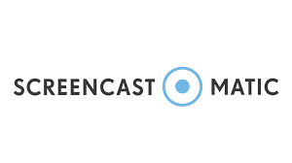 Screen-O-Matic. This is a screencast useful to record screens and using a webcam too. It has 15 minutes recording time limit and a small watermark when is recording.
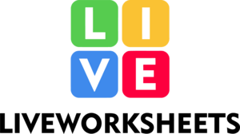 Liveworksheets.This is an educational platform that allows teachers and students share interactive worksheet and workbooks with millions interactive material and topics available.
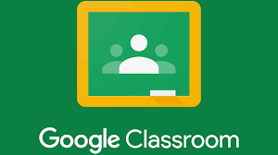 Google Classroom. This is a free web-based learning platform where teachers and students create and share assignments and educational material.

Genially. An interactive and visual online communication platform. It has infographics, gamification, quizzes, portfolios, etc. Supporting students and teachers in a collaborative way.

IV. Description of Activities
Module 1
In this module we started learning how to use Learning Management Systems, applying the theories of learning so the development of the teaching-learning process could be more effective while teaching online. The facilitator opened the door to give students the opportunity to experience at firsthand how it is to create and lead along with other students these type of systems, that is why the active participation of students was crucial during the module by practicing and going through the platforms we could gain significant knowledge, all of that by also discussing the use of them in social forums so we could receive feedback not only from the facilitator but also from our classmates.
The first two weeks of this module, the students started by learning theories of learning by watching some meaningful videos with explanations and examples. After that, a forum was conducted in order to engage and exchange ideas with the rest of our classmates. Of course, this activity was done online. By doing this we were able to interact with classmates and notice different opinions and examples that enrich our knowledge.
By the third and fourth week of this learning path, students were able to enter the LMS (Learning Management System) world. A class full of interesting explanations and discussion about this topic. We highlight that even if most students had used at least one system considered as LMS, they were not aware why this system is considered LMS. So, this class was so informative and full of knowledge for students. In order to add on the acquired knowledge, the facilitator assigned us an activity for us to identify the characteristics of LMS and be able to learn by doing. The team did an infographic making use of canvas to create it.
During the following class, on week five, we learned how to organize google classrooms. We were taught how to do this by a practice class in which we had a really good time with our classmates working in groups creating our classes in google classrooms. We interchanged ideas in order to create an organized lesson plan on the platform to present it to the rest of the class. In this way, students were assigned to design a virtual topic in Google Classroom, using different sources like videos, images, tasks, and material to review. With the full intent to practice and develop the skills in this tool which is one of the most used in the teaching field recently.
For next week, participants continued reviewing Google Classroom, but, in this case, we learned how to create quizzes from zero using this powerful tool. These two weeks of intensive collaborative work among students and facilitator contributed to students’ knowledge about in general.
During the last two weeks of module one, the objective was to learn how to properly manage video conference platforms and their features. People normally use just the basic elements of these platforms for our virtual classes. But after these two weeks of constant practice, the team recognized more features of these platforms that for sure help in creating the best virtual learning environments. To do this, a class was prepared to show these platforms features in a group presentation.
To summarize the first module was the beginning of this journey of learning. Students started by recalling the learning theories. And then we added on our knowledge by practicing and exploring new virtual environment tools and theories that will boost our knowledge and usage of the technological tools for us to be able to plan meaningful activities for students.
These are the tools we used during module one of the specialization course in the administration of virtual environments for foreign languages teaching and learning:
• Canvas. Used to create the infographic since this is a great tool with lots of temples to create amazing presentations, infographics, and letters, among others.
• Google Classroom. For having an organized virtual class. This LMS is used by a significant percentage of educators since it allows to have all the class activities, material, quizzes, even grades in the same system. For sure one of the best gifts for educators.
• Zoom. Videoconference tool to meet up with students to present a class. This famous tool has interactive features that helps to carry out a class by presenting content and interaction tools that will enhance collaborative learning.
• Google Meet. Videoconference tool from google which allows us to schedule meetings using google calendar. This benefit allows us to have a better control of future meetings.
• Microsoft Teams. Another good tool for meeting up with students. Used most likely in schools and corporations.

Module 2
The module II “Educational applications for learning a Foreign Language” was designed by the facilitator to show us how to use different types of technological tools in order to, in her own words, "to have a dynamic, meaningful online class”. The participants learned about the fundamentals of using technological tools and that there are many advantages to using them. There are some things that cannot be done in a regular face-to-face class but technology makes it possible in online environments, so it is really important to take advantage of all the resources available to the students as future professionals.
Through the 8 weeks duration of the module the students were able to become researchers at first by searching different technological tools to engage scholars in the class, but we also were able to learn how to use some of the most efficient in online learning.
There were 8 different tools that were taught and exercised in their majority two per session, the facilitator took the time to look for illustrative videos showing the use of each one of them along with some of her own creation so we could check step by step how the tool could be used, but also giving a lot of freedom to navigate them, learn about some of the most interesting features and also making sure to give enough time to get used to them so we could apply what we learned in the evaluated activities that also were carried out during the course.
The facilitator was very open to clarify doubts by creating forums where if it was necessary the participants of the course could leave their doubts most of all about the evaluated activities but also in the class.
All students had the chance to participate and see how our partners were able to utilize the tools in many different ways, some of them unknown to others so the ones involved in the module could take ideas to implement them in future classes but also learn about their mistakes to make sure that they are not repeated again. The facilitator took the time to divide the class in groups for some of the activities to also implement collaborative learning and also took the time to give constructive feedback not only per group but also individually about things that could be done better in the future. Students learned not only to use the technological tools but also to use them correctly due to there are some of them that are adequate for some activities and there are others that are not, for example, there are some that are really good to give welcome messages, there are some others that are very useful to exemplify things that are difficult to learn for students by caughting their attention, and there are some others that work really well to summarize or to make sure that students have really understood a topic as the case of tools that can be used to create interactive questions so students can challenge themselves and at the same time have fun, as the case of Kahoot.
Evaluations were a very important part of the module due to it was the way in which we could show what we had learned by using the tools and also a big opportunity to receive feedback not only from the facilitator but also from our partners who were also learning and of course to make sure that we were ready to move forward to the next module, evaluations were divided in four, making sure that the percentages were divided according to the activity to at the end get a 100% that was the maximum that could be obtained during the module.
Three of the evaluations were designed to not be presented in front of the whole class, but the last one was a live class using what was learned using the technological tools so we could feel how it would be to use them in a real environment. There were many tools that were used during the asynchronous sessions but the main ones were:

- Edpuzzle. This tool helps you to create interactive videos for your lessons that can also be integrated in LMS. No evaluated activity was conducted, but practice was made in groups during class time.
- Flipgrid. Another great tool to create interactive videos, but this one allows you to have more record time and even record your own screen. It was part of an evaluated activity, it was based on recording a video explaining the use of another tool
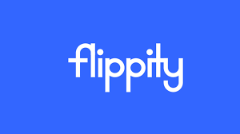

- Flippity. This is a tool that allows you to create flashcards, very useful for practice. There was no evaluation conducted with it, but the facilitator explained briefly how to use it.




- Liveworksheets. With this tool we take interactive activities to the next level with a variety of resources from simple flashcards to even quizzes. A lot of practice was made with it, it was also part of an integrated activity using Flipgrid where its functioning had to be explained.

- Nearpod. A great tool that makes learning fun by using gamification to magnify the teaching-learning process. Nearpod was presented by the facilitator as an alternative to create interactive presentations, there was also space to practice with it.

- Padlet. This tool allows students to collaborate in real time with others to obtain better results in their activities. It was one of the most used tools during the course due to many activities requiring collaborative work among the participants.
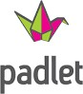

- Powtoon. Powtoon is a beautiful tool if you like to use animations to get your students engaged. An evaluated activity was performed with it which consisted in creating an interactive video.


- Kahoot. This is maybe one of the most used tools in order to make interactive quizzes due to it allows students to demonstrate their knowledge by competing in different types of questions. A tool very used during the module, many of the participants already had some basic knowledge about it was used for competition and recapitulation.
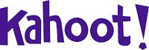

- Classroomscreen. A great tool that contains a lot of features to make classes more interactive and dynamic, it allows you to present videos, it has random selector, interactive questions, among others. Probably the most used tool by the facilitator due to its simplicity and usefulness, there was also time to practice with it working collaboratively during class time.

Module 3:
This module is one of the most important due to designing material is of the most fundamental parts of online learning, there are many online resources that can be found on the network but this module show us how to be autonomous and to take advantage of the resources available for our professional development and also to be innovative in our way of teaching.
The first part of the module was dedicated to audio learning, learning how to design audio contact for students is very important due to it is not just about recording our voice, we were taught how to add the proper tone of voice depending on who the content is for, is not just talking for talking, we were taught new ways to caught the attention of the students by adding effects to a podcast, music and some other things by using the tool “Audacity” which is a tool that is designed specifically to design audio content.
The second stage of the module was designed to focus on visual aids, we were taught how to get students engaged by using images, videos and other resources, we learned that is important to know how to choose the appropriate visual content and that it is ok to use content already designed on the web, but it is also crucial that we know how to design our own interactive content, it was done with some online resources to create collages, memes, welcome messages, among others, but the main one was “Genially” a great tool designed to create interactive presentations but it also has other uses and one of them is creating interactive images in which we can add another images, texts, videos and even audios to catch students attention.
The third part of the module is dedicated to more visual aids, but now if form of presentations, we have been used to the same presentations talking about PowerPoint, but we have many other options and the facilitator has taught us the fundamentals of creating online presentations by using “Google Slides” a great tool similar to PowerPoint but it is a lot more, it has many options to make interactive presentations, but the most important here is not the tool but the way we create the presentations, the facilitator has shown us how to create titles, how to add the right size of the letters, what colors are appropriate depending on the background, also the right way to paste images so the presentation can look professional and so many things.
The last part of the module has been created with the purpose of showing how to create interactive videos which can be used in many different ways, such as for welcome messages, explaining certain thing that are not clear enough for students and so on, all of this using “OpenShot” which is a tool to submit videos and the editate them in all ways possible, in there we can create animations, add great 3D animations, transitions and some other really good resources which can be used to engage students in a class or to raise expectations at the beginning of a course.
To summarize, creating content and not only that but knowing how to create it can give you amazing results which will result in students learning faster and better. As teachers we need to take advantage of all the resources available to us and even more in the online field where we have unlimited resources to teach in the best way possible to the students, it can be said that this is the main aim of the module, to teach how to take into consideration the resources available and not follow the same strategies that the majority of teachers use in day to day classes.
It is also very important to take the time to learn how to use the tools if we do not know how to use them, watch video tutorials, navigate them, or even ask to the facilitator so we can give the best of us due to that is what has been encouraged through the course, to become innovative and efficient in the teaching-learning process.

V. Achievements
Module 1:
In the first module students were able to learn about the different useful tools for online teaching:
- Students learned about the difference between Synchronous and Asynchronous Learning.
- What is an LMS (Learning Management System) and what are the best LMS to be used in online classes.
- How to organize a Google Classroom and what kind of activities and materials can be used.
- Students learned how to create Quizzes in Google Classroom.
- The use of different platforms for video conferences like: Zoom, Google Meet and Microsoft Teams.

Module 2:
During the second module students learned about educative applications that can be used for online teaching:
- Students learned about the different material that can be created using Canva, in this case an infographic was requested.
- The use of Flipgrid and how to record, edit and create discussions with students by recording videos as replies.
- Using Live Worksheets, this online tool allows teachers to create interactive material and quizzes. Students were able to practice during the online session.
- Students also learned to use EdPuzzle by creating interactive videos and practicing with their classmates.
- How to use Powtoon creating interactive videos with different features and animations.
- Students created a Padlet and worked collaboratively during the online class, each student was able to add information on the team Padlet.
- How to use Nearpod and creating interactive activities like quizzes, homework and assessments, students were able to practice with the tool.
- Students learned about the use of Flippity, which allows them to create quizzes, presentations or memory games. Students were able to practice this tool by developing exercise during the class.

Module 3:
In the last module students learned to design different didactic materials that can be used in virtual environments:
- Students learned about Audacity by recording a Podcast for an assessment.
- The use of Genially and how to create interactive images. Students were able to practice creating interactive images including audios, videos and links.
- Students also learned about Color Theory and how to properly combine the colors. Students worked collaboratively by creating presentation with adequate color combinations.
- Creating Google Site, students learned how to create a Google Site by adding the didactic material done during the previous weeks.
- Students learned to use the Video Editor Openshot, they practiced by recording themselves and editing the video including transition, images and audio background.

VI. Conclusions
In conclusion, students consider that it is crucial to implement collaborative learning in Online Education. As we know every student has different way of thinking, and different ways to see the world, by working collaboratively students will be able to share their ideas, every student will be able to think about their solutions and will be able to discover the different options to develop an activity during an online class or an assignment, and at the end the product is going to be positive for students and teachers. There is a significant value on practicing collaborative learning, it is important to include students participation in the learning process in this way students are going to feel motivated and they will be more active into the class. Thus, Collaborative work can turn an interesting activity for students, since they will learn about the acceptance of diverse opinions and will find out the best decisions for the group. Collaborative learning in online education allows students to respect other decisions and think for solutions that better suit their educational activities. In this way students become the main actors at the moment to present critical thinking and solutions to any mishap that may occur while working on an assignment during Synchronous or Asynchronous learning. By implementing collaborative activities in online classes students are going to show different abilities that will bring good things for their personal and professional development. In conclusion this research shows the relevance of Collaborative Learning and teachers must be always encouraging students to participate by practicing collaborative through different activities or assessments. This could be a little practice about what students will be facing for example in a job, since implementing teamwork and collaborative work is important for companies.

VII. Recommendations

- To the Foreign Language Department Coordinator, to provide teachers the best tools and materials that allows them to develop better teaching practices including the new technologies available. Also to encourage teachers to take advantage of the technology and its benefits for student´s learning process including more collaborative activities. Common ways of teaching are not bad but we need to understand that times are changing and with it also the students, so teachers need to adapt to the new ways of teaching and learning.

- To the teachers, to motivate students to be part of the learning process in every class, introducing more collaborative activities that will allow them to get to know their peers, accepting other´s opinions and building good connections on every online class. In this way students are going to be able to make the best decisions collaboratively and as a results they will enjoy comfortable environments in both Synchronous and Asynchronous learning.

- To the students, to not be afraid to practice collaborative learning as part of a student life. Taking the advantages of collaborative work students will be able to transform their character and criteria and will put it in practice at the moment to take important decisions. This will become a positive rehearsal in students learning process and future activities.

VIII Bibliography

Bates, A. (. (2019). Teaching in a Digital Age -Second Edition. Vancouver: Associates Ltd.
Ministerio de Educación, C. y. (2023). MINEDUCYT. Retrieved from https://www.mined.gob.sv/
Robyn, M. &. (2005). Co-operative Learning. London: Taylor and Francis e-Library.
Tecnology, M. d. (n.d.). Retrieved from https://www.mined.gob.sv/
Wankel, C. &. (2013). Incressing Student Engagement and Retention in e-Learning Enviroments: Web 2.0 and Blended Learning Technologies. UK: Emera Group Publishing.
Wool, M. (2022, 03 14). BetterUp. Retrieved from https://www.betterup.com/blog/critical-thinking-skills#:~:text=Critical%20thinking%20is%20the%20ability,and%20decision%2Dmaking%20more%20effectively
Wooll, M. (2022, 03 14). Berrer Up. Retrieved from https://www.betterup.com/blog/critical-thinking-skills#:~:text=Critical%20thinking%20is%20the%20ability,and%20decision%2Dmaking%20more%20effectively

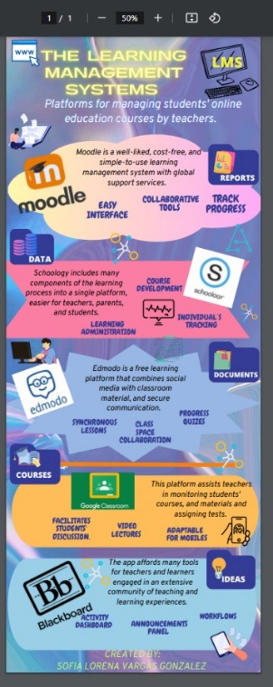
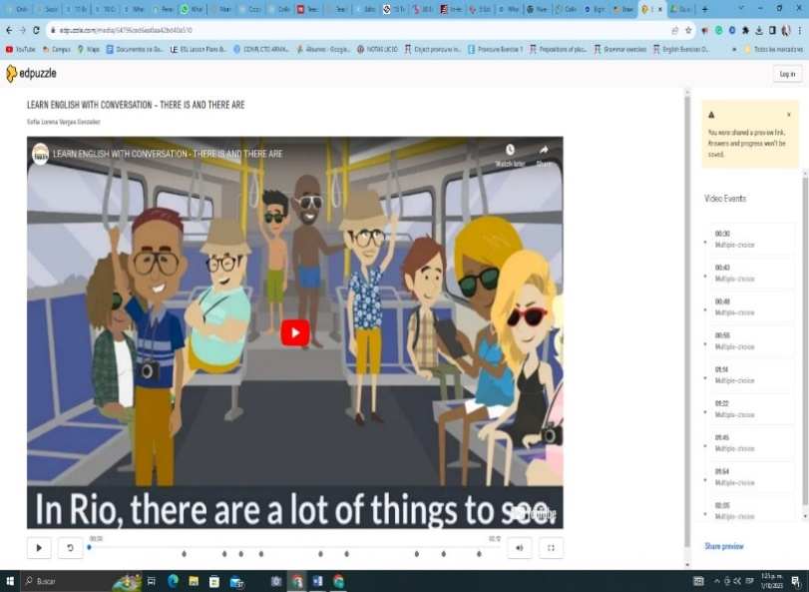
IX. Appendixes

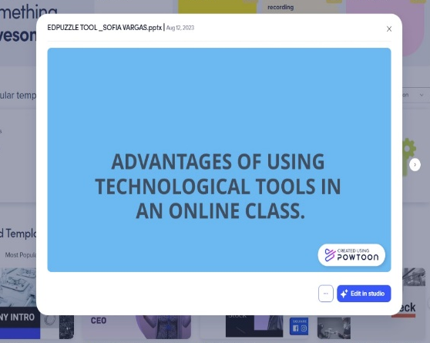

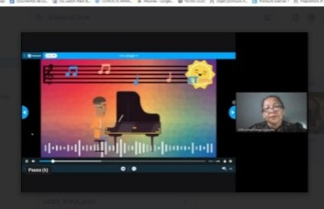

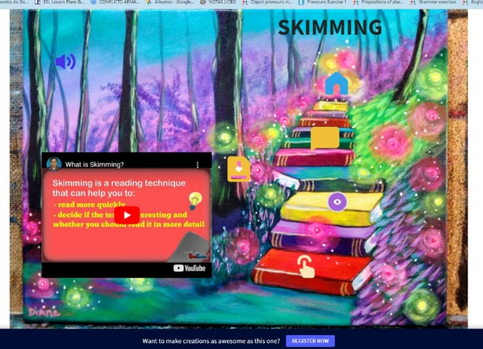

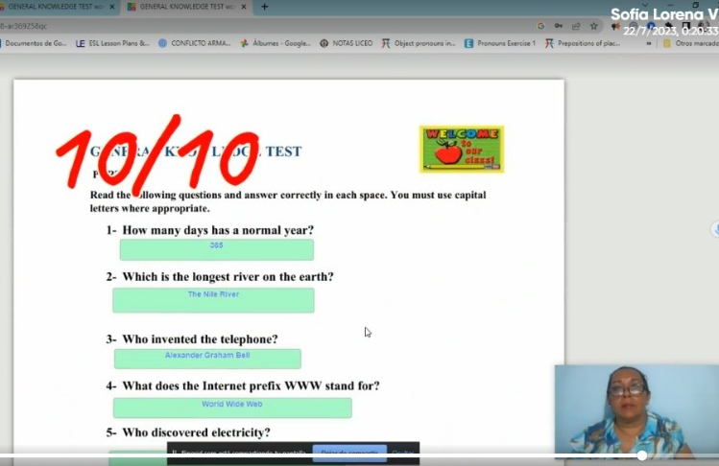

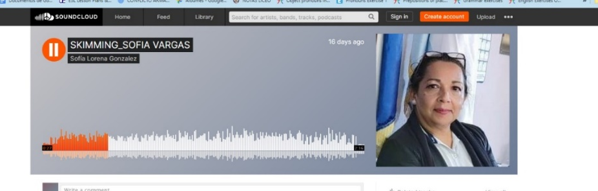

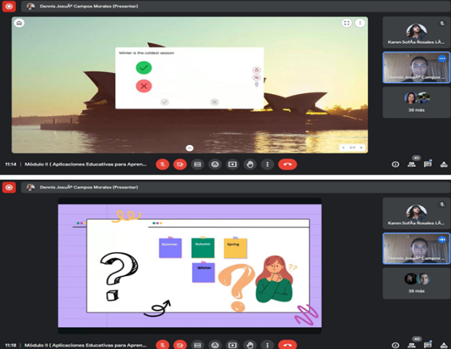

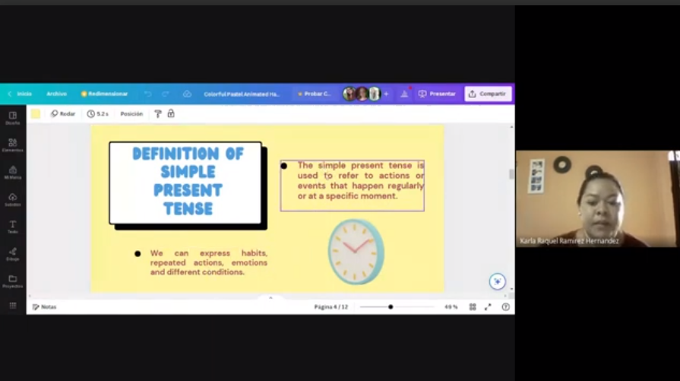

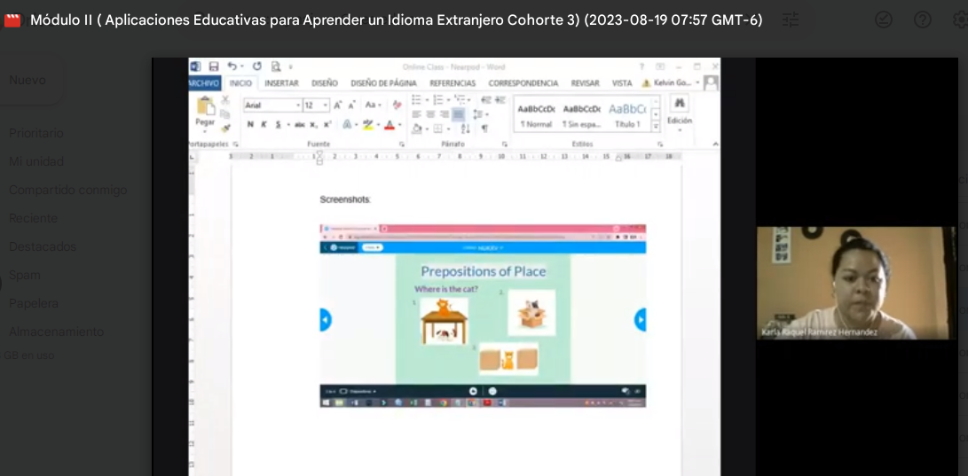

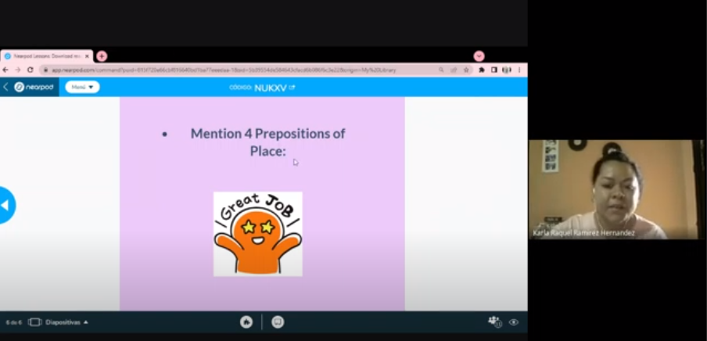
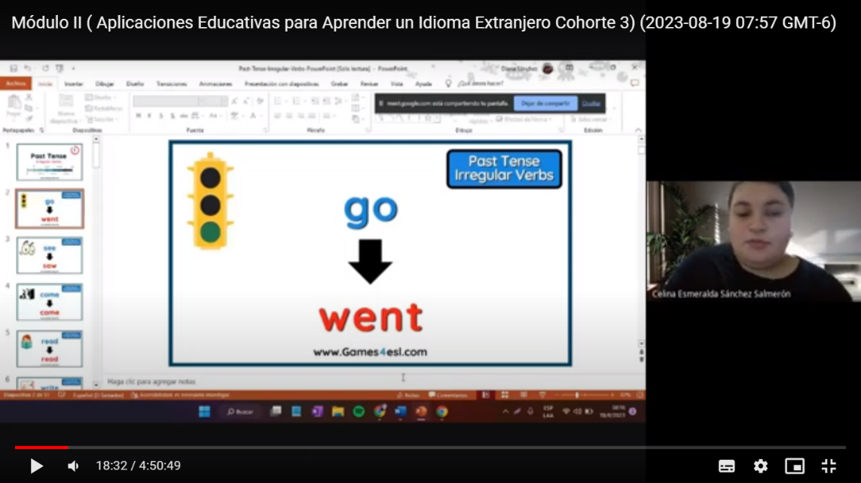
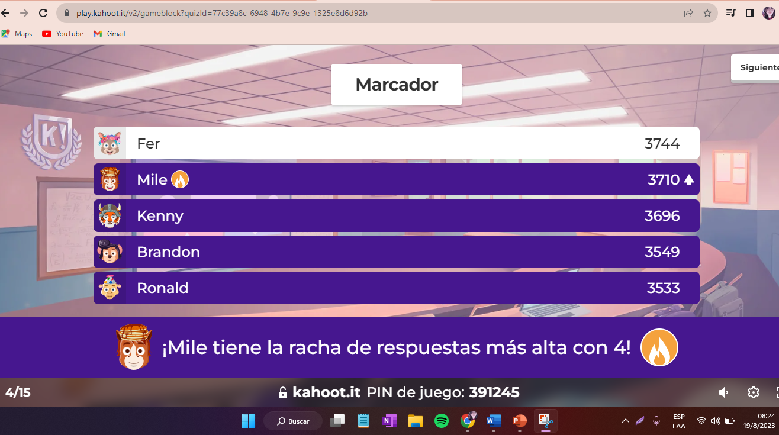

(Wool, 2022) “Inference is the ability of draw conclusions base in the information you have”
(Ministerio de Educación, 2023)” Ministry of Education (MINED) committed to providing tables to students at to the third grade and laptop to those who attend secondary school”.

